

City University of Hong Kong

Department of Computer Science

CS3343 Software Engineering Practice

2024 - 25 Semester A

**CityU Cinema System**

**Analysis & Design**

**Group 2**

**Name SID**

CHAN Ka Hong 57845658

FUNG Wing Ho 56755919

LAW Lok Hang 57842515

NG Ka Ho 56652261

WONG Tsz Kin 57847086

Contents

**1. Introduction** 5

**2. Design Constraints** 5

**3. Use Case Diagrams & Requirement Specifications** 7

**3.1 Registration** 7

**3.2 Log in** 8

**3.3 List Movie Sessions** 9

**3.4 List Snacks/Drinks** 10

**3.5 Search Movies** 10

**3.6 Buy Movie Tickets** 12

**3.7 Buy Snacks/Drinks** 13

**3.8 Make Payment** 15

**3.9 Personal Profile** 18

**3.10 List Payment Records** 19

**3.11 Reset Password** 20

**3.12 Log Out** 21

**3.13 List All Users** 22

**3.14 Search User** 23

**3.15 Add Users** 24

**3.16 Delete User** 26

**3.17 Add Movies** 27

**3.18 Schedule Movies** 28

**3.19 Add Snacks/Drinks** 29

**4. Class Diagrams** 30

**5. Sequence Diagrams** 31

**5.1 Registration** 31

**5.2 Log in** 32

**5.3 List Movie Sessions** 33

**5.4 List Snacks/Drinks** 34

**5.5 Search Movies** 34

**5.6 Buy Movie Tickets** 36

**5.7 Buy Snacks/Drinks** 37

**5.8 Do Payment** 37

**5.9 Personal Profile** 38

**5.10 List Payment Records** 38

**5.11 Reset Password** 39

**5.12 Log out** 40

**5.13 List All Users** 41

**5.14 Search Users** 42

**5.15 Add User** 43

**5.16 Delete User** 44

**5.17 Add Movies** 45

**5.18 Schedule Movies** 46

**5.19 Add Snacks/Drinks** 47

**6. Design Principles and Patterns** 48

**6.1 Design Principles** 48

**6.1.1 Single Responsibility Principle** 48

**6.1.2 Open-close Principle** 48

**6.1.3 Liskov Substitution Principle** 48

**6.1.4 Interface Segregation Principle** 49

**6.1.5 Dependency Inversion Principle** 49

**6.2 Design Patterns** 50

**6.2.1 Singleton Design Pattern** 50

**6.2.2 State Design Pattern** 50

**6.2.3 Command Design Pattern** 50

**6.2.4 Strategy Design Pattern** 51

**6.2.5 Factory Method Design Pattern** 51

# **1. Introduction**

The CityU Cinema System is a comprehensive movie ticketing and management system designed for various user groups, including guests, members, and administrators.

For guests, CityU Cinema System offers features such as listing available movies and their corresponding movie sessions, searching for movies, as well as displaying the available snacks and drinks. Additionally, they can register as members and log in to the system.

For members, the system extends the functionalities to include buying movie tickets and snacks/drinks, managing their shopping cart, making payments, viewing payment records, accessing and viewing their personal profile, and resetting their passwords. Members can also log out when they have completed the needed processes.

For system administrators, CityU Cinema System allows them to add movies, manage movie scheduling with different strategic algorithms, add snacks/drinks, as well as handle user accounts such as adding, deleting, listing and searching users. Administrators have access to most functionalities available to guests and members, as well as additional administrative capabilities.

The following table summarizes the key features and functionalities enjoyed by different groups of users:

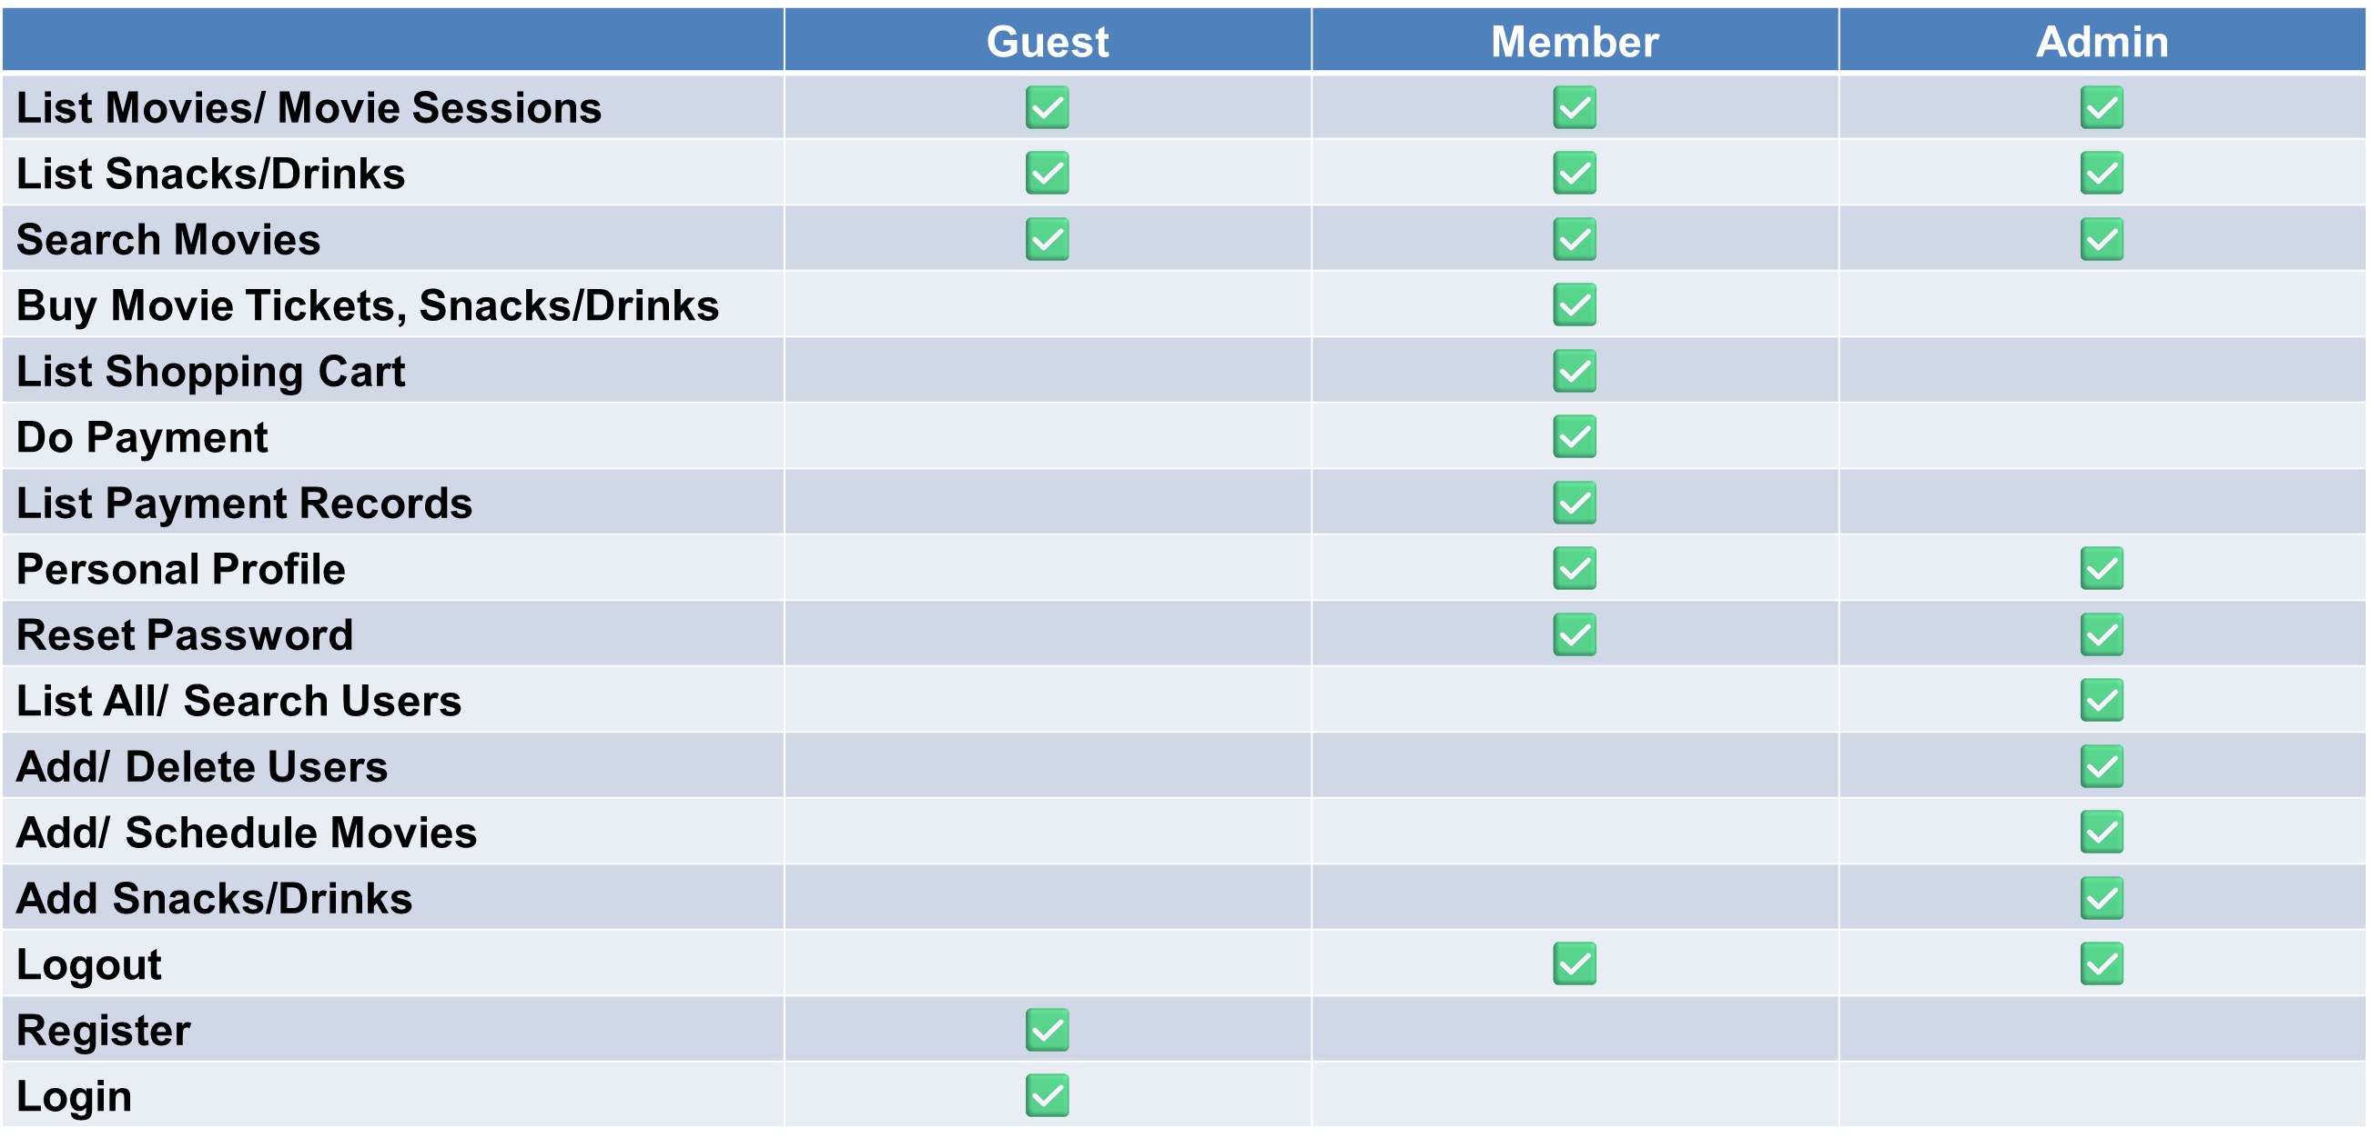

# **2. Design Constraints**

In view of the scope, requirements of this project and our team's technical experience and capabilities, several constraints have to be imposed during the initiation and design of this project in order to ensure smooth completion. The following are some constraints of the CityU Cinema System:

**Technical Constraint**

One of the major differences of our system as compared to other real-life movie ticketing systems is that no actual databases such as SQL is deployed. This has taken into consideration the fact that it is difficult for us to design and run junit test cases for the components associated with an actual, well-established database. As a remedy, we have designed a Database class to simulate the effect of a database, which primarily serves as an aggregate location for storing objects created from other classes and provides a central point of access, retrieval and dependency to the stored objects.

Moreover, in terms of feasibility and the intended features of our program, not all design patterns will be adopted. Although we can extend the functionalities in order to cater for the various design patterns, it is at the current development stage deemed unnecessary. Still, our team have done their utmost to adhere to suitable design patterns and programming best practices during planning and development.

**Usability Constraint**

Given that only Java, a programming language primarily used for backend development, is allowed for our program development, we have therefore considered not to create any frontend user interface. As such, to some users, this may not be in their best interest. Still, we try to make the default console input/output interface as user-friendly as possible.

In addition, in view of complexity and necessity, the current program is not intended as a multi-threaded design, meaning no concurrent user action is supported. Despite this, we have implemented log in and log out functions so that when the current user has logged out the system, another user can log in afterwards. With this, we hope to simulate the effect that multiple users can perform different operations with the system.

**Time Constraint**

The maximum possible time allowed for this project is approximately 3 months, which can be quite different from many real-life projects that can go from months to years, or even ongoing with no foreseeable deadline. As such, the scale of our system cannot be too big or else it will not be possible for our team to complete on time, especially when we also need to allocate time and resources for other equally important tasks such as documentation, testing, debugging, and refactoring. Under the limited time, still, our team try our utmost to apply as many software engineering best practices and people management principles as possible to realize the process of a software development project.

# **3. Use Case Diagrams & Requirement Specifications**

## **3.1 Registration**

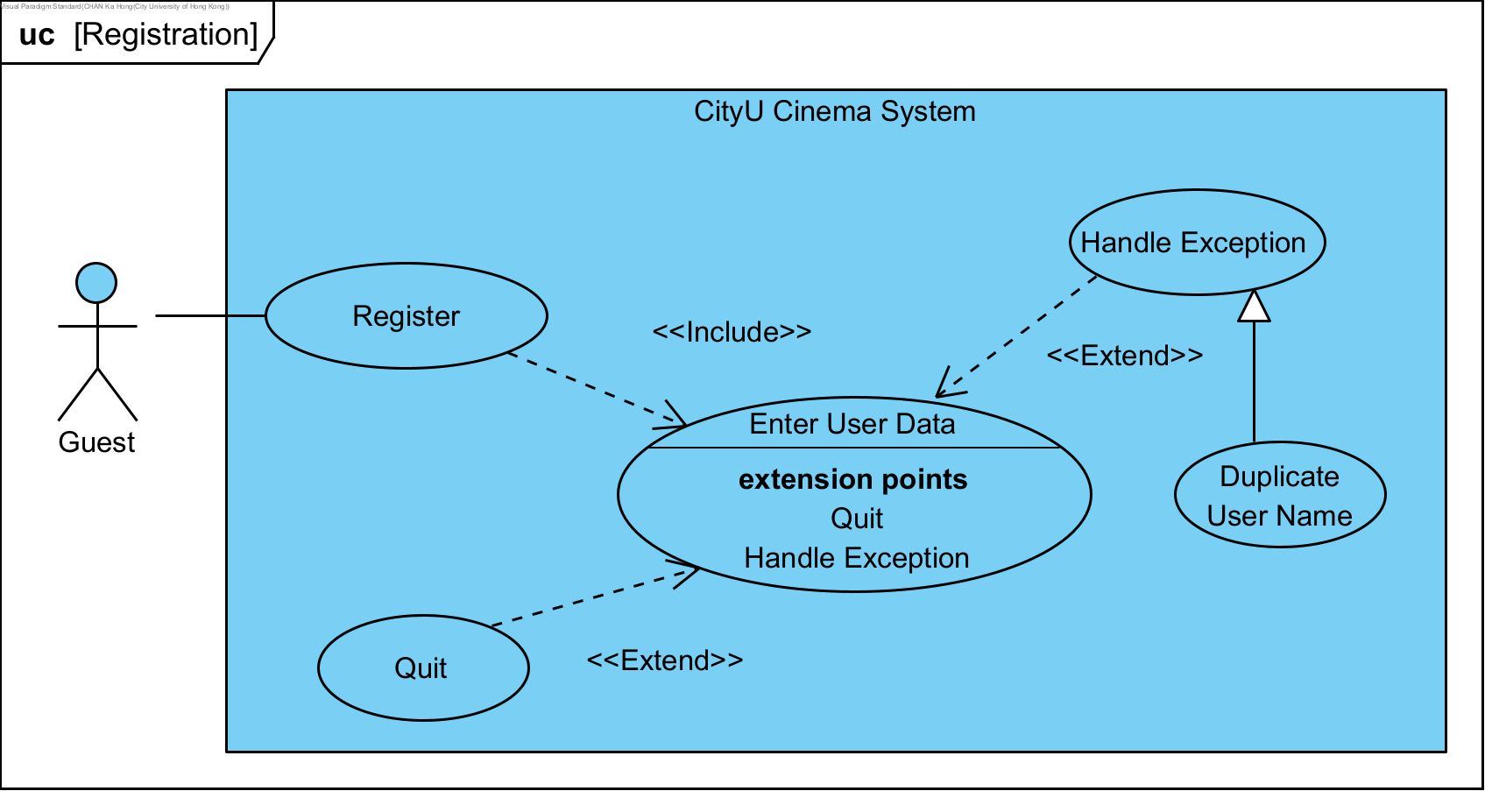

|  |  |  |
| --- | --- | --- |
| **Use Case Name:** | Registration | |
| **Actor(s):** | Guest | |
| **Description:** | This use case illustrates the course of events when a guest registers for an account. | |
| **Events:** | **Actor Action** | **System Response** |
|  | Step 1: This use case is initiated when guest registers for an account.  Step 3: Guest enters user data.  Step 6: Guest receives a confirmation message. | Step 2: The system prompts guest to enter user data.  Step 4: The system validates the entered user data.  Step 5: The system creates a new account for guest. |
| **Alternative Course of Events:** | Step 3a: [Extension Point] Guest can enter quit to exit this use case.  Step 4a: [Extension Point] If the entered user name is found to be a duplicate, the system throws an exception. The use case restarts at step 2. | |
| **Assumption:** | User has no account or has not logged in. | |
| **Precondition:** | The user account does not exist. | |
| **Postcondition:** | A new user account is created. | |

## **3.2 Log in**

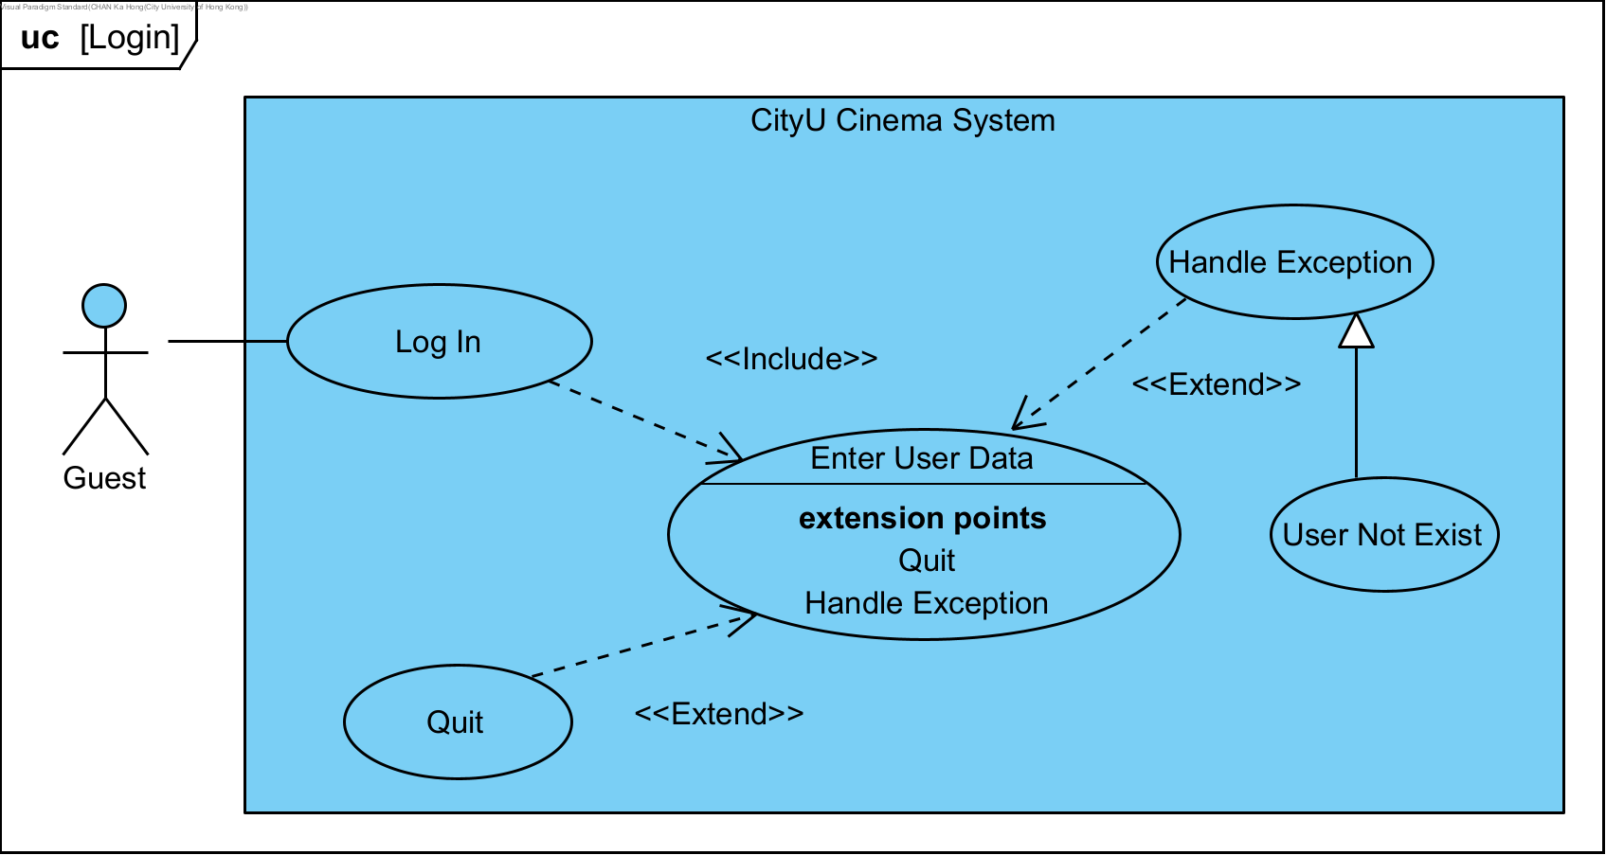

|  |  |  |
| --- | --- | --- |
| **Use Case Name:** | Log In | |
| **Actor(s):** | Guest | |
| **Description:** | This use case illustrates the course of events when a guest logs into the system. | |
| **Events:** | **Actor Action** | **System Response** |
|  | Step 1: This use case is initiated when guest logs into the system.  Step 3: Guest enters user data.  Step 5: Guest successfully logs in the system. | Step 2: The system prompts guest to enter user data.  Step 4: The system validates the entered user data. |
| **Alternative Course of Events:** | Step 3a: [Extension Point] Guest can enter quit to exit this use case.  Step 4a: [Extension Point] If the entered user data does not match any of the existing users, the system throws a user not exist exception. The use case restarts at step 2. | |
| **Assumption:** | User has previously registered. | |
| **Precondition:** | User has not logged in. | |
| **Postcondition:** | User has successfully logged in. | |

## **3.3 List Movie Sessions**

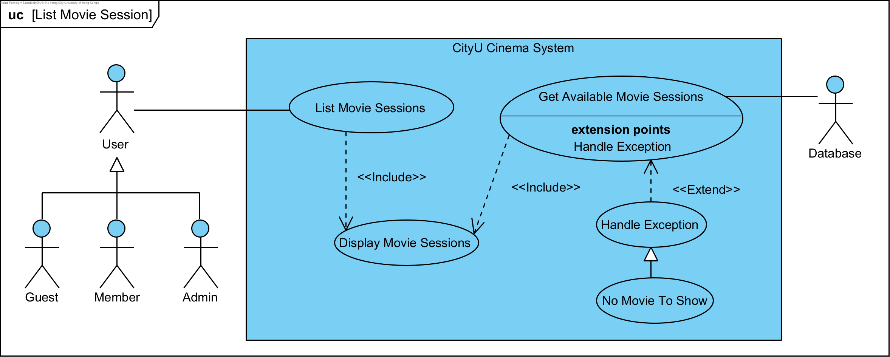

|  |  |  |
| --- | --- | --- |
| **Use Case Name:** | List Movie Sessions | |
| **Actor(s):** | User, Database | |
| **Description:** | This use case describes the course of actions when a user lists and displays available movie sessions. | |
| **Events:** | **Actor Action** | **System Response** |
|  | Step 1. This use case is initiated when a user would like to list available movie sessions.  Step 4. The user then views the listed movie sessions. This use case is concluded | Step 2. The system then calls the database to query available movie sessions.  Step 3. The system then passes the queried movie results to display them to the user. |
| **Alternative Course of Events:** | Step 2a: [Extension Point] If the database finds no available movie session after query, an exception will be thrown and no movie session will be shown. | |
| **Assumption** | In general, it is assumed that movies have already been added to the database and scheduled by the admin user before other users invoke this use case. | |
| **Precondition:** | N/A | |
| **Postcondition:** | Available movie sessions are displayed on the interface. | |

## **3.4 List Snacks/Drinks**

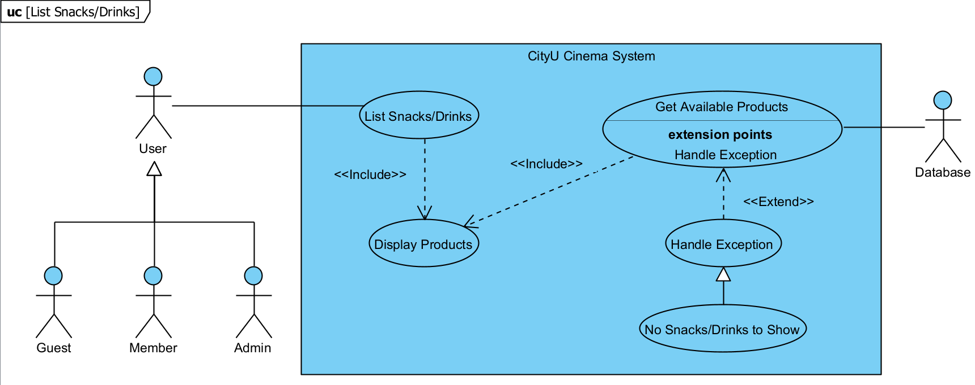

|  |  |  |
| --- | --- | --- |
| **Use Case Name:** | List Snacks/Drinks | |
| **Actor(s):** | User, Database | |
| **Description:** | This use case describes the course of actions when a user lists and displays available snacks/drinks. | |
| **Events:** | **Actor Action** | **System Response** |
|  | Step 1. This use case is initiated when a user would like to list available snacks/drinks.  Step 4. The user then views the listed products. This use case is concluded. | Step 2. The system then calls the database to query available products.  Step 3. The system then passes the queried product results to display them to the user. |
| **Alternative Course of Events:** | Step 2a: [Extension Point] If the database finds no available products after query, an exception message will be shown to indicate no products can be shown. | |
| **Assumption** | In general, it is assumed that products e.g. snacks/drinks have already been added to the database before other users invoke this use case. | |
| **Precondition:** | N/A | |
| **Postcondition:** | Available productss are displayed on the interface. | |

## **3.5 Search Movies**

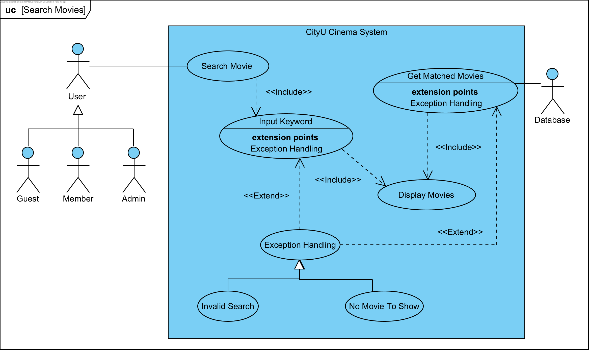

|  |  |  |
| --- | --- | --- |
| **Use Case Name:** | Search Movies | |
| **Actor(s):** | User, Database | |
| **Description:** | This use case describes the course of events when a user attempts to search for movies. | |
| **Events:** | **Actor Action** | **System Response** |
|  | 1. This use case is initiated when a user searches movies.  3. The user enters a keyword.  6. User views the movie results from the interface. The use case is concluded. | 2. The system prompts the user to input a keyword to search.  4. The system calls the database to query movies matching with the search keyword.  5. The system displays the movies based on the queried results. |
| **Alternative Course of Events:** | Step 4a: [Extension Point] An invalid search exception will be triggered if the keyword does not result in any matched movies  Step 5a: [Extension Point] A no movie to show exception will be triggered if an empty list of movie objects is put into the movie display function. | |
| **Assumption:** | In general, it is assumed that the database is loaded with at least one movie. Also, it is assumed that user will not input an empty string to search. | |
| **Precondition:** | N/A | |
| **Postcondition:** | List of movies matching the search keyword is displayed on the interface for users to view. | |

## **3.6 Buy Movie Tickets**

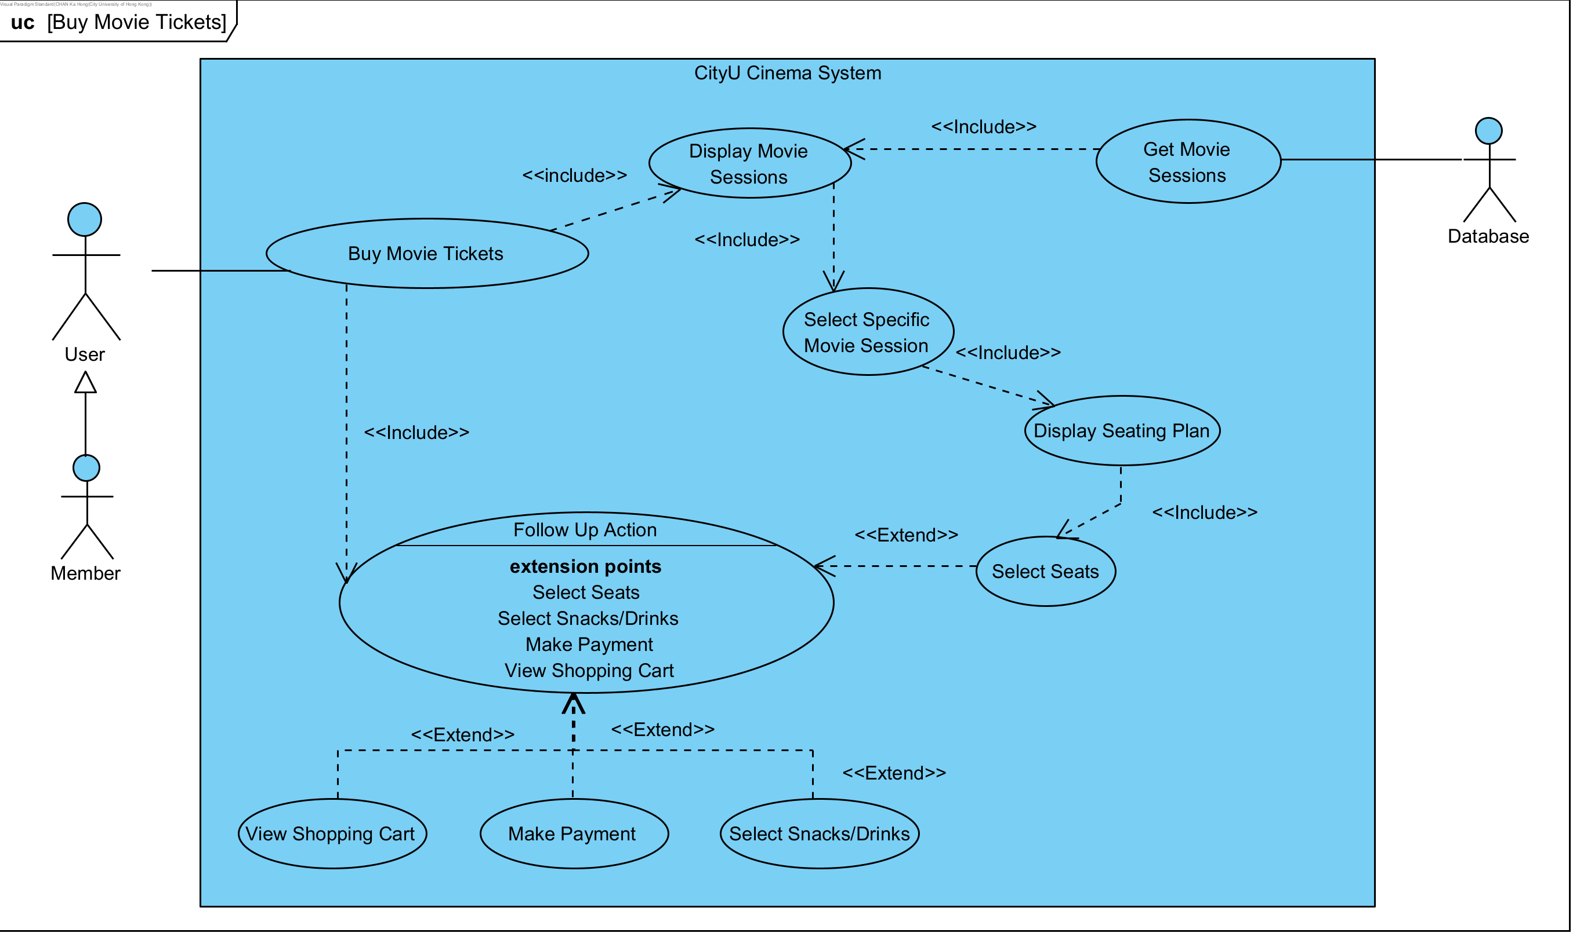

|  |  |  |
| --- | --- | --- |
| **Use Case Name:** | Buy Movie Tickets | |
| **Actor(s):** | Member, Database | |
| **Description:** | This use case details the course of event when a member attempts to buy movie tickets. | |
| **Events:** | **Actor Action** | **System Response** |
|  | 1. The use case is initiated when a registered member would like to buy movie tickets.  4. The member selects a specific movie session.  6. The member selects his/her preferred seat(s).  9. The member proceeds to payment. Invoke the use case, do payment. The current use case is concluded. | 2. The system calls the database to query scheduled movie sessions.  3. The system displays the queried movie sessions.  5. The system displays the seating plan for the selected movie session.  7. If the selected seats are available, the system shows that the seats are booked.  8. The system requests follow-up actions from the member. |
| **Alternative Course of Events:** | Step 9a: [Extension Point] If the member decides not to proceed to payment directly, he/she can choose to select seats again. The use case then restarts at step 5.  Step 9b: [Extension Point] If the member decides not to proceed to payment directly, he/she can choose to buy snacks and drinks.  Step 9c: [Extension Point] If the member decides not to proceed to payment directly, he/she can choose to view the shopping cart first. | |
| **Assumption:** | User has already logged in the system as a member; at least 5 movies have been added to the database and scheduled. | |
| **Precondition:** | There are movie ticket seats available for selection. | |
| **Postcondition:** | Selected movie seats will be marked as booked and added to the shopping cart. | |

## **3.7 Buy Snacks/Drinks**

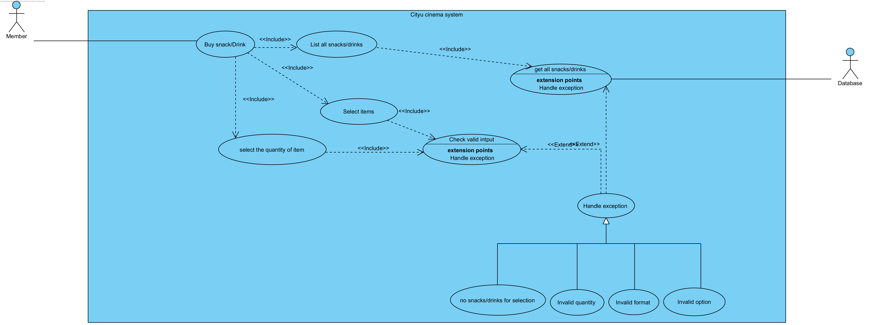

|  |  |  |
| --- | --- | --- |
| Use Case Name: | Buy Snack/Drink | |
| Actor(s): | Member, database | |
| Description: | This use case describes the process of buying snacks/drinks. | |
| Events: | Actor Action | System Response |
|  | 1. This use case is initiated when the member selects to buy snacks/drinks when the system requests follow-up actions  5. The member chooses their desired snacks and drinks by typing their corresponding number.  8. The member enters the quantity of snacks/drinks they want.  11. The selected snacks/drinks are added to the member’s shopping cart. The use case is concluded. | 2. The system loads all available snacks and drinks from the database.    3. The system lists all snacks and drinks available to the user.    4. The system asks members to choose the snacks/drinks they want.  6. The system checks whether the input from the user is valid.    7. The system asks members to input the quantity they want.  9. The system checks whether the quantity is valid, and the inputted quantity is between 1 and 10.    10. The system adds the chosen snacks/drinks into the shopping cart with their quantity. |
| Alternative Course of Events: | Step 2: If there are no snacks/drinks in the database, the system prints out “[Exception] There are no snacks/drinks for selection” and ends this use case.    Step 6 (a): If the member input is invalid, the system will print out “[Exception] Invalid input format” and return to step 4 until the member has a valid input.    Step 6 (b): If the member entered “q” or “quit”, the system prints out “[State] Leaving snacks/drinks selection menu” and ends the use case.    Step 7: If the member types in an option that does not exist, the system will print out “[Exception] No such option!” and return to step 4 until the member has input an option that exists.    Step 9 (a): If the input of the member is invalid, the system will print out “[Exception] Invalid input format” and return to step 7 until the member has a valid input.    Step 9 (b): If the number inputted by the user is not between 1 and 10, the system will print out “[Exception] Input quantity should be at least 1 and not more than 10” and return to step 7 until the member has inputted a valid number.    Step 9 (c): If the member enters “q” or “quit”, the system prints out “[State] You have early quit from payment menu without completing the process” and ends the use case. | |
| Assumption: | The user has logged in as a member. | |
| Precondition: | Member has booked the movie seats and added them to the shopping cart. | |
| Postcondition: | The snacks/drinks the member selects are stored in their shopping cart. | |

## **3.8 Make Payment**

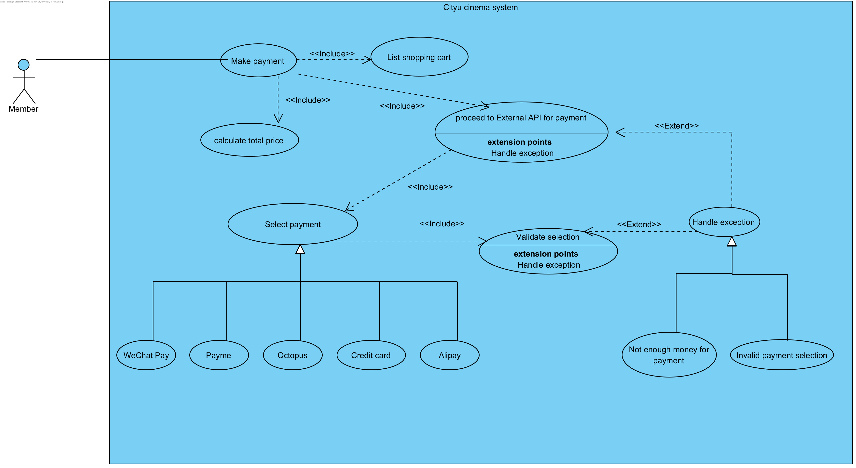

|  |  |  |
| --- | --- | --- |
| Use Case Name: | Make payment | |
| Actor(s): | Member, database | |
| Description: | This use case describes the process of making a payment. | |
| Events: | Actor Action | System Response |
|  | Step 1: This use case is initiated when the member selects to proceed with the payment.                Step 5: The member chooses their desired payment method to pay.                Step 9: The member does their payment successfully. The use case is concluded. | Step 2: The system lists all items in the shopping cart.    Step 3: The system calculates the payment's total price with the member's discount.    Step 4: The system asks members to choose one payment method.          Step 6: The system checks whether the input from the user is valid.    Step 7: The system proceeds to payment by calling the corresponding methods and external APIs.    Step 8: The system returns the payment result to the member. |
| Alternative Course of Events: | Step 6 (a): If the input of the member is invalid, the system will print out “[Exception] Selected payment option is invalid” and go back to step 4 again until the input is valid.    Step 6 (b): If the member enters “q” or “quit”, the system prints out “[State] You have early quit from payment menu without completing the process” and ends the use case.    Step 7 (a): If the payment is unsuccessful, the system will print out “[State] Sorry, you don't have enough money to pay with (payment method)”, where (payment method) is replaced by the payment method selected by the member. It will also be deleted from the selection list of payment methods so that the member cannot use the same method to make the payment again. Then, it will go back to step 4 to ask the user to select another payment method.    Step 7 (b): If all payment methods are used and they are unsuccessful, meaning that all payment methods are removed from the list, the system will print out “[Remind] Sorry, you have failed all payment options. Exiting the payment menu”. It releases the seats booked by the member and ends the test case. | |
| Assumption: | The user has logged in as a member. | |
| Precondition: | Member has booked and added movie seats to the shopping cart.  Member has added all the snacks and drinks they want to the shopping cart. | |
| Postcondition: | The payment for movie tickets, snacks, and drinks was made successfully. | |

## **3.9 Personal Profile**

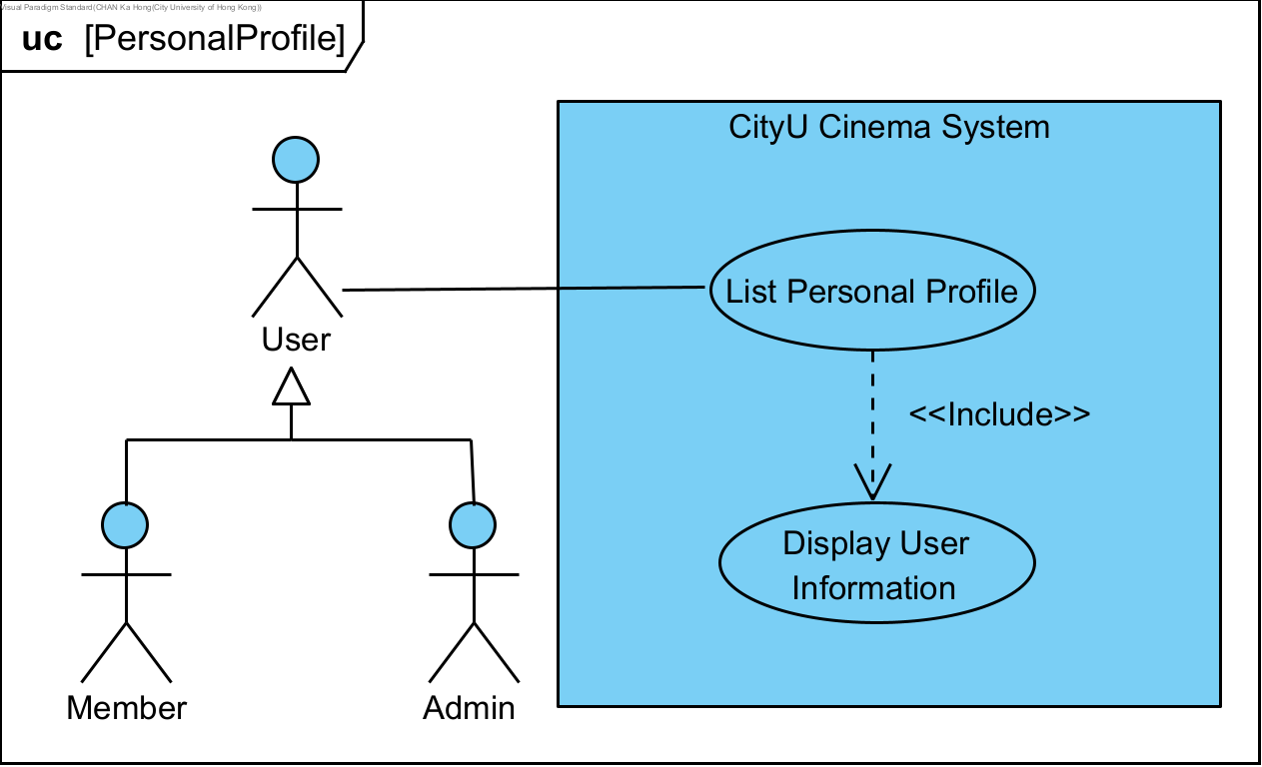

|  |  |  |
| --- | --- | --- |
| **Use Case Name:** | Log In | |
| **Actor(s):** | User (Member, Admin) | |
| **Description:** | This use case illustrates the course of events when a user lists his personal profile. | |
| **Events:** | **Actor Action** | **System Response** |
|  | Step 1: This use case is initiated when a user lists his personal profile.  Step 3: The user views the displayed information. This use case is completed. | Step 2: The system displays the user’s personal information |
| **Alternative Course of Events:** | N/A | |
| **Assumption:** | User has successfully logged in. | |
| **Precondition:** | N/A | |
| **Postcondition:** | User information is displayed. | |

## **3.10 List Payment Records**

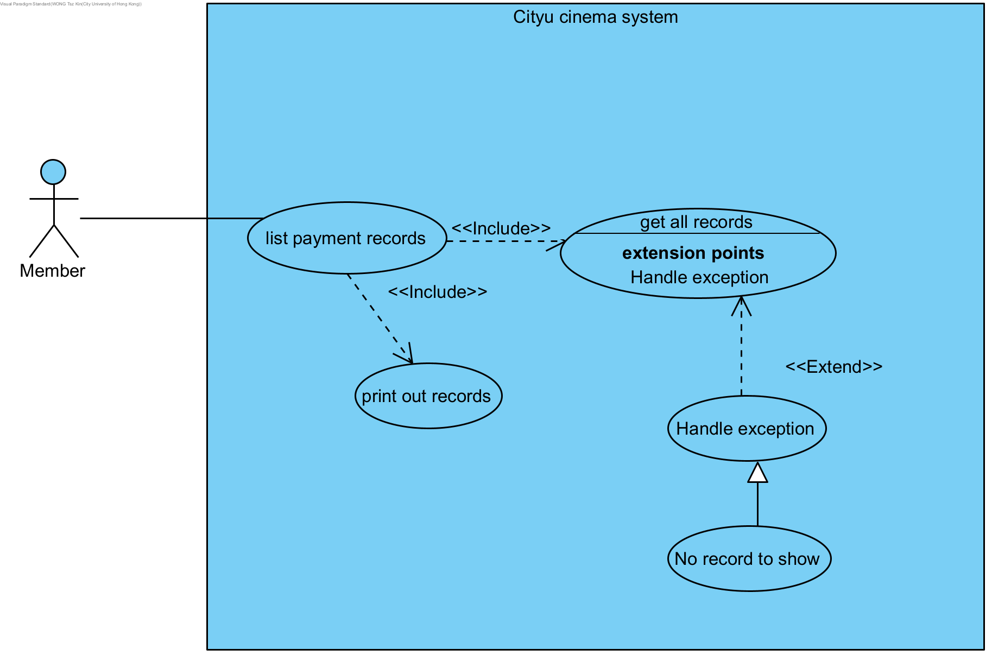

|  |  |  |
| --- | --- | --- |
| Use Case Name: | List payment record | |
| Actor(s): | Member, database | |
| Description: | This use case describes the process of listing a member's payment record. | |
| Events: | Actor Action | System Response |
|  | Step 1: This use case is initiated when the member selects to list their payment records.    Step 4: The member can review all their records. The use case is concluded. | Step 2: The system gets all the member's payment records.    Step 3: The system prints out all the member's payment records. |
| Alternative Course of Events: | Step 3: If the member has not made any payment yet and has no payment record, the system will print out “[Exception] There is no payment record to show” and end this use case. | |
| Assumption: | The user has logged in as a member. | |
| Precondition: | N/A | |
| Postcondition: | All member's payment records are listed. | |

## **3.11 Reset Password**

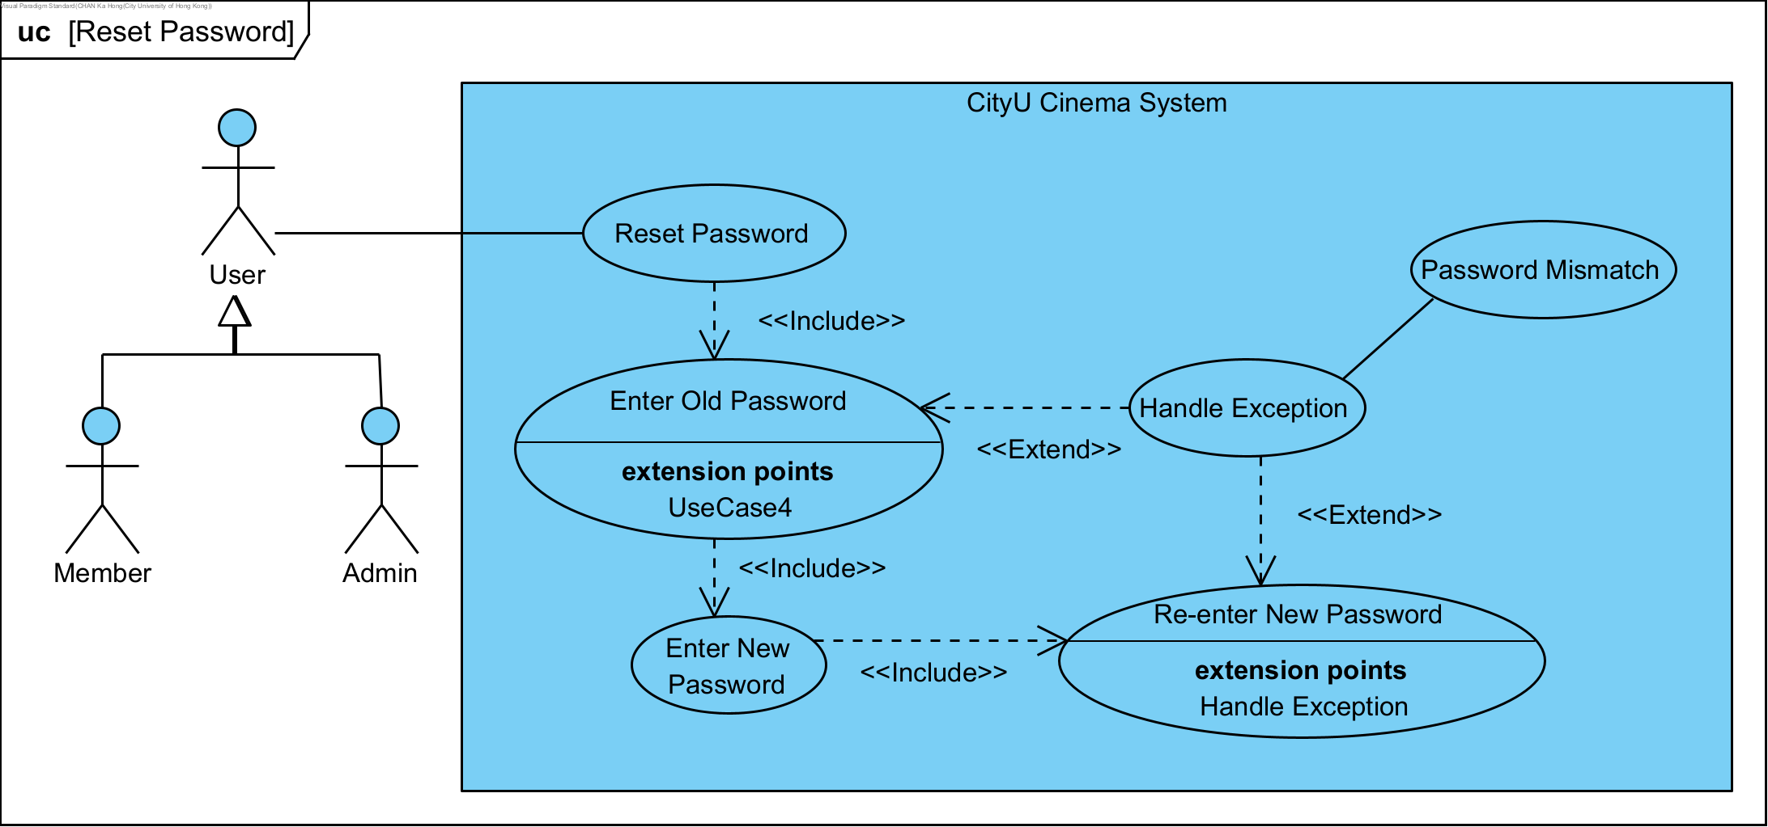

|  |  |  |
| --- | --- | --- |
| **Use Case Name:** | Reset Password | |
| **Actor(s):** | User (Member, Admin) | |
| **Description:** | This use case illustrates the course of events when a user resets his password. | |
| **Events:** | **Actor Action** | **System Response** |
|  | Step 1: This use case is initiated when a user resets his password.  Step 3: User enters old password.  Step 6: User enters new password.  Step 8: User enters new password again.  Step 10: User has reset his password. This use case is concluded. | Step 2: The system prompts user to enter old password.  Step 4: The system validates the entered old password.  Step 5: The system prompts user to enter new password.  Step 7: The system prompts user to re-enter the new password.  Step 9: The system validates the entered new password. |
| **Alternative Course of Events:** | Step 4a: [Extension Point] If the entered old password is incorrect, the system throws a password mismatch exception. The use case restarts at step 2.  Step 9a: [Extension Point] If the re-entered new password does not match the previously entered new password, the system throws a password mismatch exception. The use case restarts at step 5. | |
| **Assumption:** | User has logged in. | |
| **Precondition:** | The password has not been reset. | |
| **Postcondition:** | The password has been successfully reset. | |

## **3.12 Log Out**

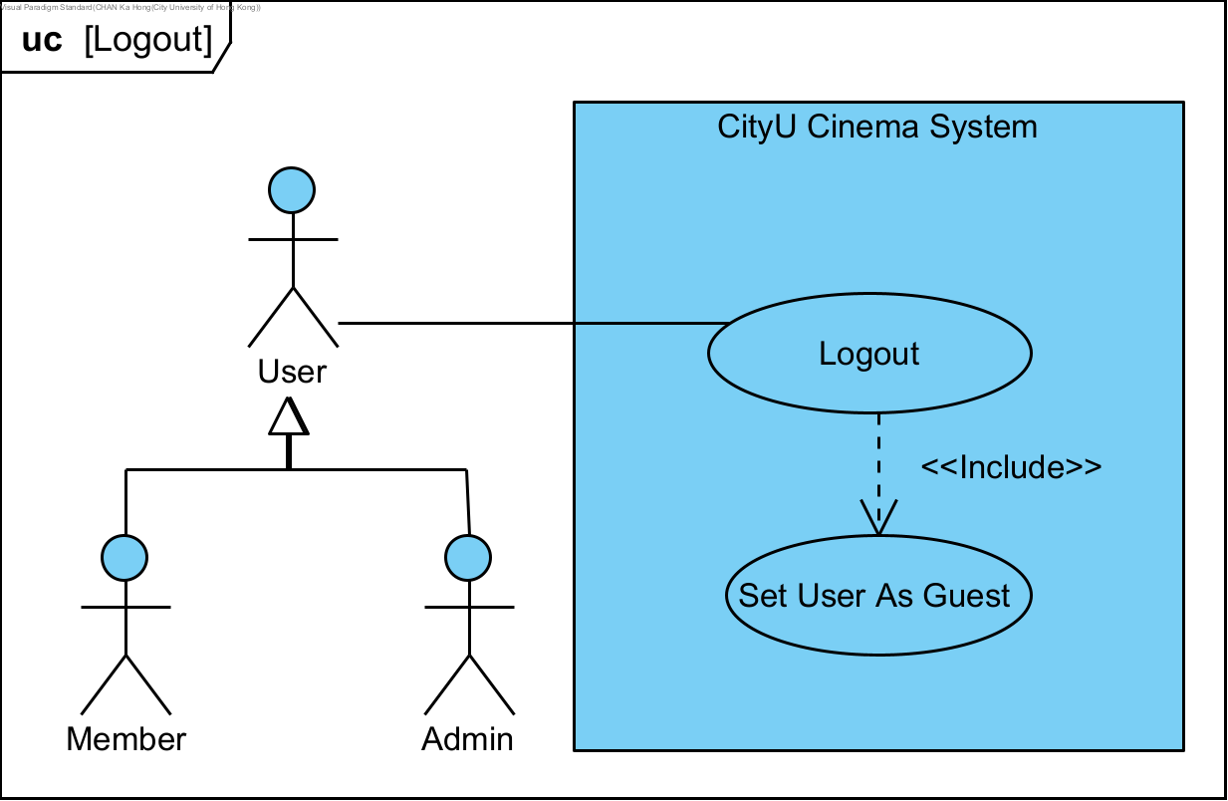

|  |  |  |
| --- | --- | --- |
| **Use Case Name:** | Log Out | |
| **Actor(s):** | User (Member, Admin) | |
| **Description:** | This use case illustrates the course of events when a user logs out the system. | |
| **Events:** | **Actor Action** | **System Response** |
|  | Step 1: This use case is initiated when a user logs out the system.  Step 3: The user becomes a guest. This use case is concluded. | Step 2: The system sets the user status as guest. |
| **Alternative Course of Events:** | N/A | |
| **Assumption:** | User has logged in. | |
| **Precondition:** | The password has not logged out. | |
| **Postcondition:** | The password has successfully logged out. | |

## **3.13 List All Users**

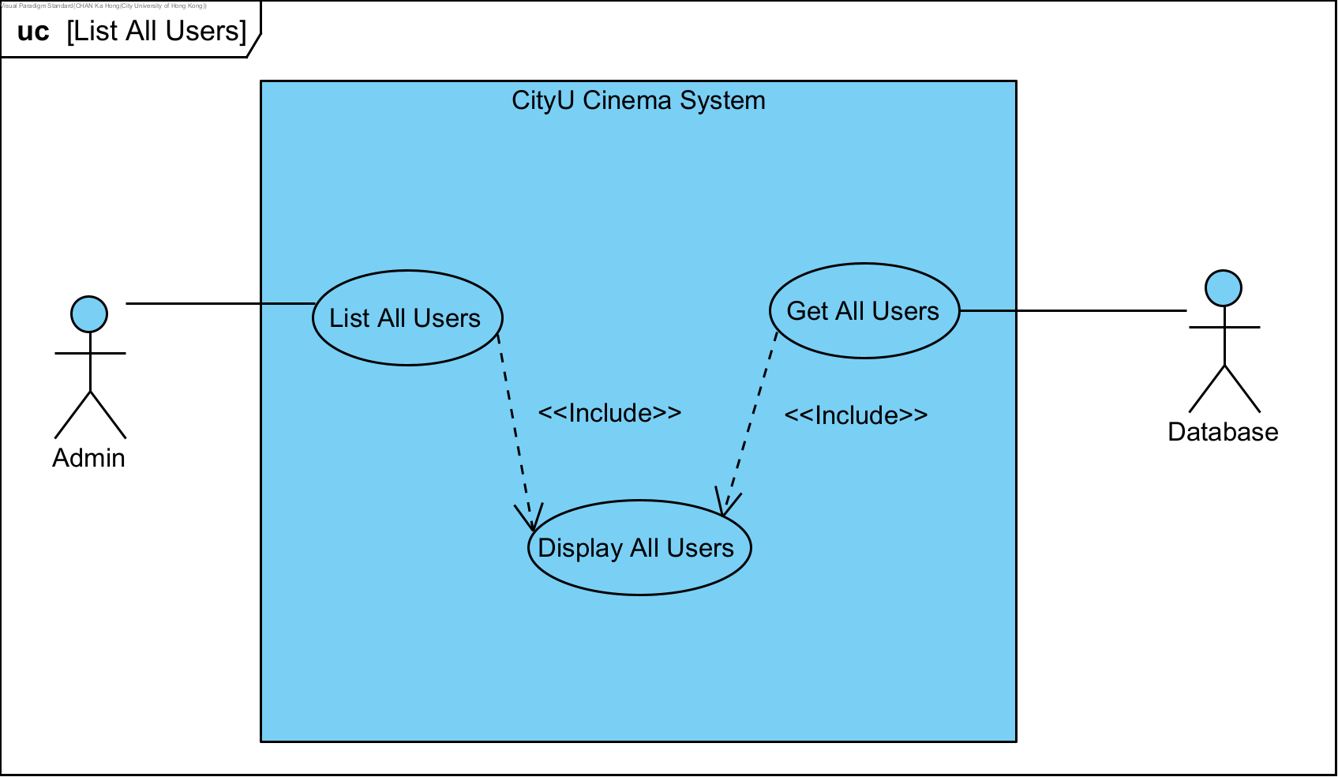

|  |  |  |
| --- | --- | --- |
| **Use Case Name:** | Log Out | |
| **Actor(s):** | Admin, Database | |
| **Description:** | This use case illustrates the course of events when admin lists all users. | |
| **Events:** | **Actor Action** | **System Response** |
|  | Step 1: This use case is initiated when admin lists all users.  Step 4: Admin views the displayed user information. This use is completed. | Step 2: The system query the database to get all registered users.  Step 3: The system display the queried user results. |
| **Alternative Course of Events:** | N/A | |
| **Assumption:** | User has logged in as admin. | |
| **Precondition:** | N/A | |
| **Postcondition:** | All registered user information is displayed. | |

## **3.14 Search User**

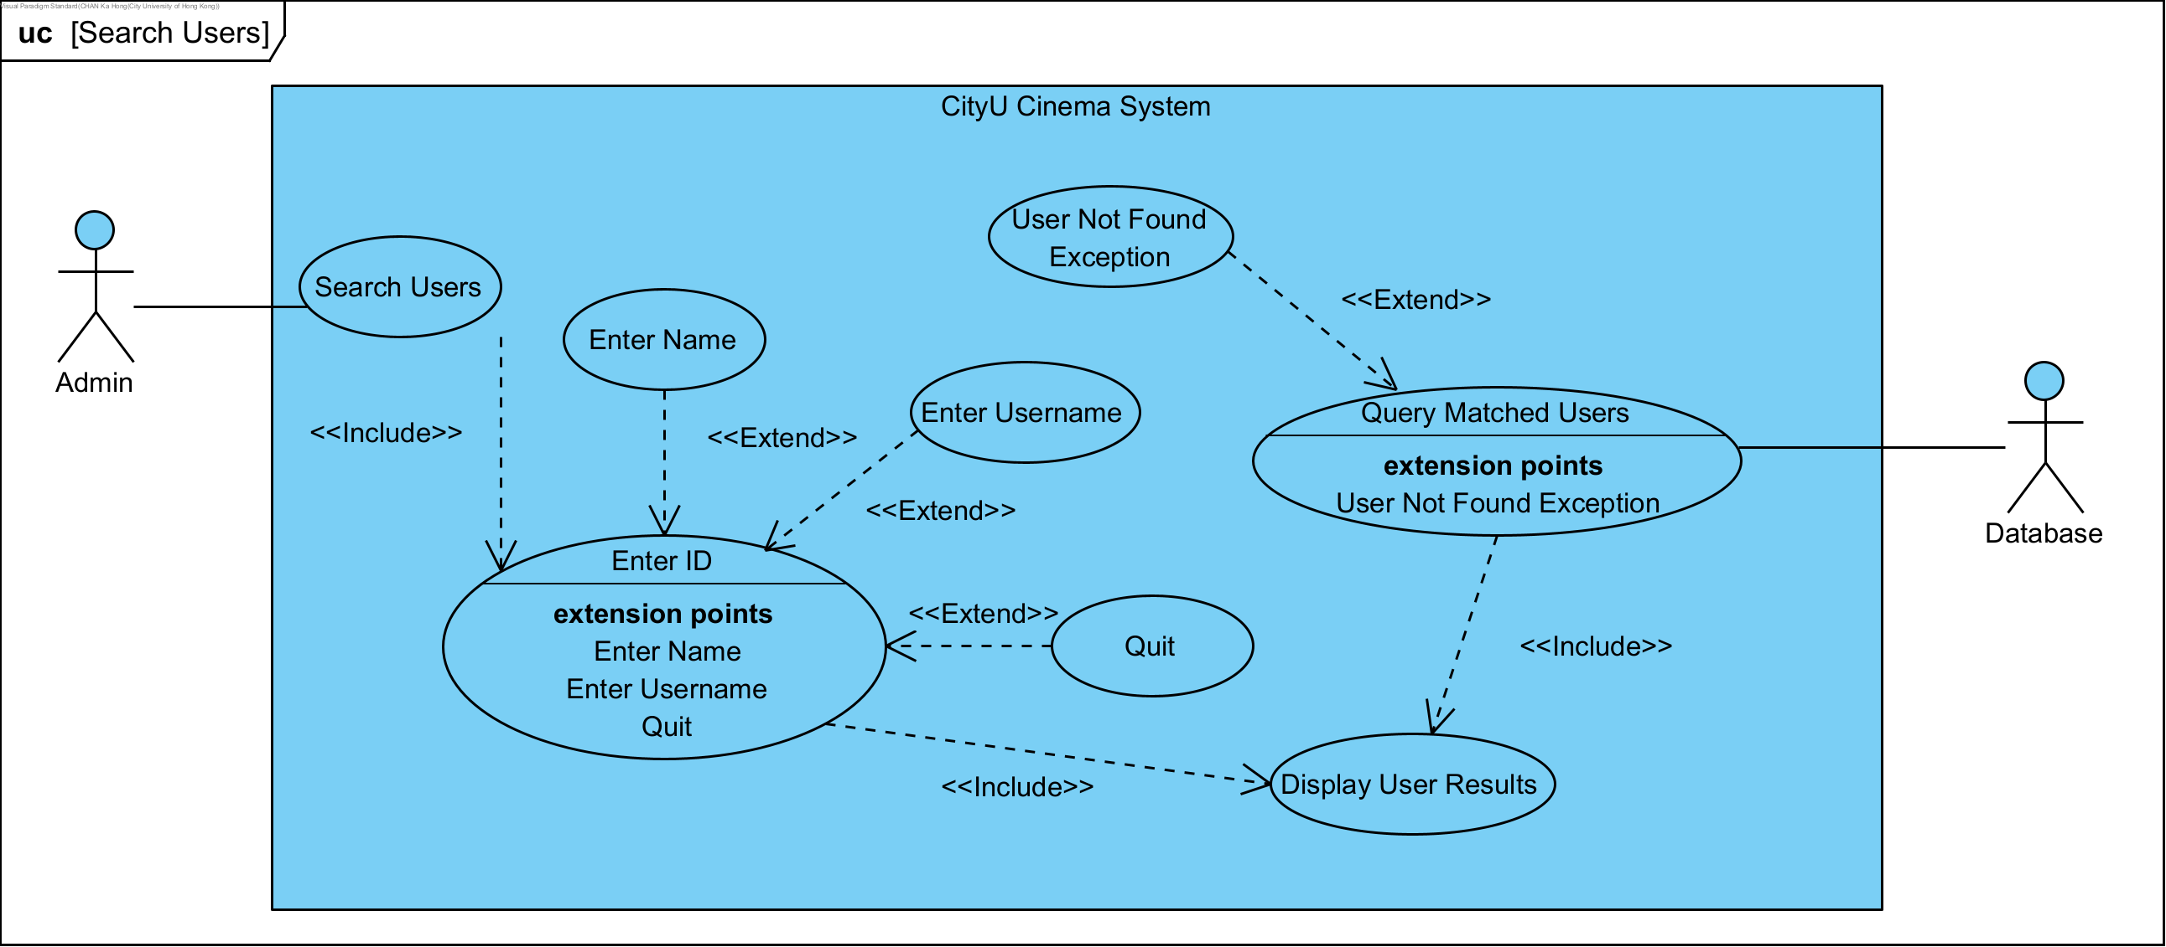

|  |  |  |
| --- | --- | --- |
| **Use Case Name:** | Search Users | |
| **Actor(s):** | Admin, Database | |
| **Description:** | This use case illustrates the course of events when an admin searches users | |
| **Events:** | **Actor Action** | **System Response** |
|  | Step 1: This use case is initiated when admin searches users.  Step 3: Admin enters ID to search.  Step 6: Admin views the displayed results. The use case restarts at step 1 to prepare for another search. | Step 2: The system prompts admin to enter search term.  Step 4: The system queries database to look for users with an ID matching the search term.  Step 5: The system displays the searched results. |
| **Alternative Course of Events:** | Step 3a: [Extension Point] If admin does not enter an ID to search, he can enter a name to search.  Step 3b: [Extension Point] If admin does not enter an ID to search, he can enter a user name to search.  Step 3c: [Extension Point] Admin can enter quit to exit this use case.  Step 4a: [Extension Point] If no matched results are found from the database, the system throws a user not found exception and restarts the use case at step 2. | |
| **Assumption:** | User has logged in as an admin user. | |
| **Precondition:** | N/A | |
| **Postcondition:** | Searched results or exception message is displayed. | |

## **3.15 Add Users**

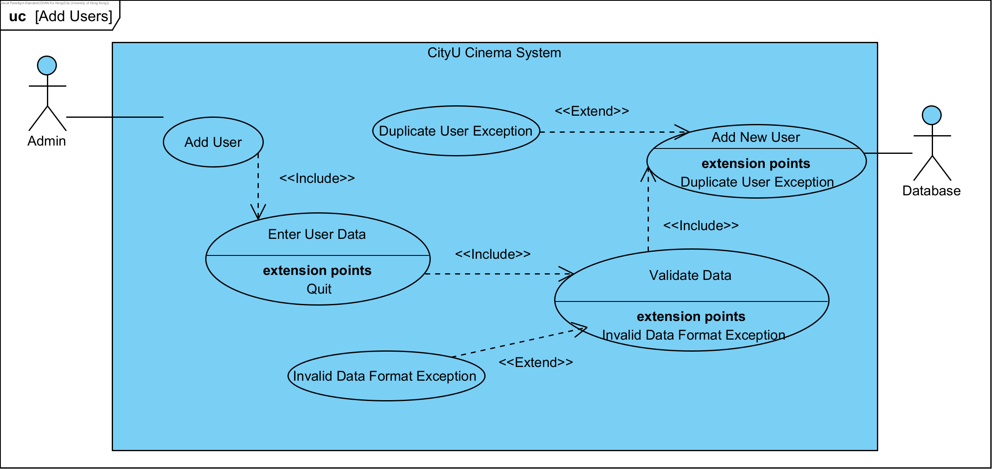

|  |  |  |
| --- | --- | --- |
| **Use Case Name:** | Add Users | |
| **Actor(s):** | Admin, Database | |
| **Description:** | This use case illustrates the course of events when an admin adds users | |
| **Events:** | **Actor Action** | **System Response** |
|  | Step 1: This use case is initiated when admin adds users.  Step 3: Admin enters user data.  Step 6: The use case restarts at step 2 to prepare for another user addition. | Step 2: The system prompts admin to enter user data.  Step 4: The system validates the entered user data.  Step 5: The system adds the new user to database. |
| **Alternative Course of Events:** | Step 3a: [Extension Point] Admin can enter quit to exit this use case.  Step 4a: [Extension Point] If any data invalidity is found, the system throws an exception. The use case restarts at step 2.  Step 5a: [Extension Point] If the user data results in a duplicate user, an exception is thrown from the database. The use case restarts at step 2. | |
| **Assumption:** | User has logged in as an admin user; the entered data is for a new user. | |
| **Precondition:** | The user to be added does not exist in the database. | |
| **Postcondition:** | A new user is created and added to the database. | |

## **3.16 Delete User**

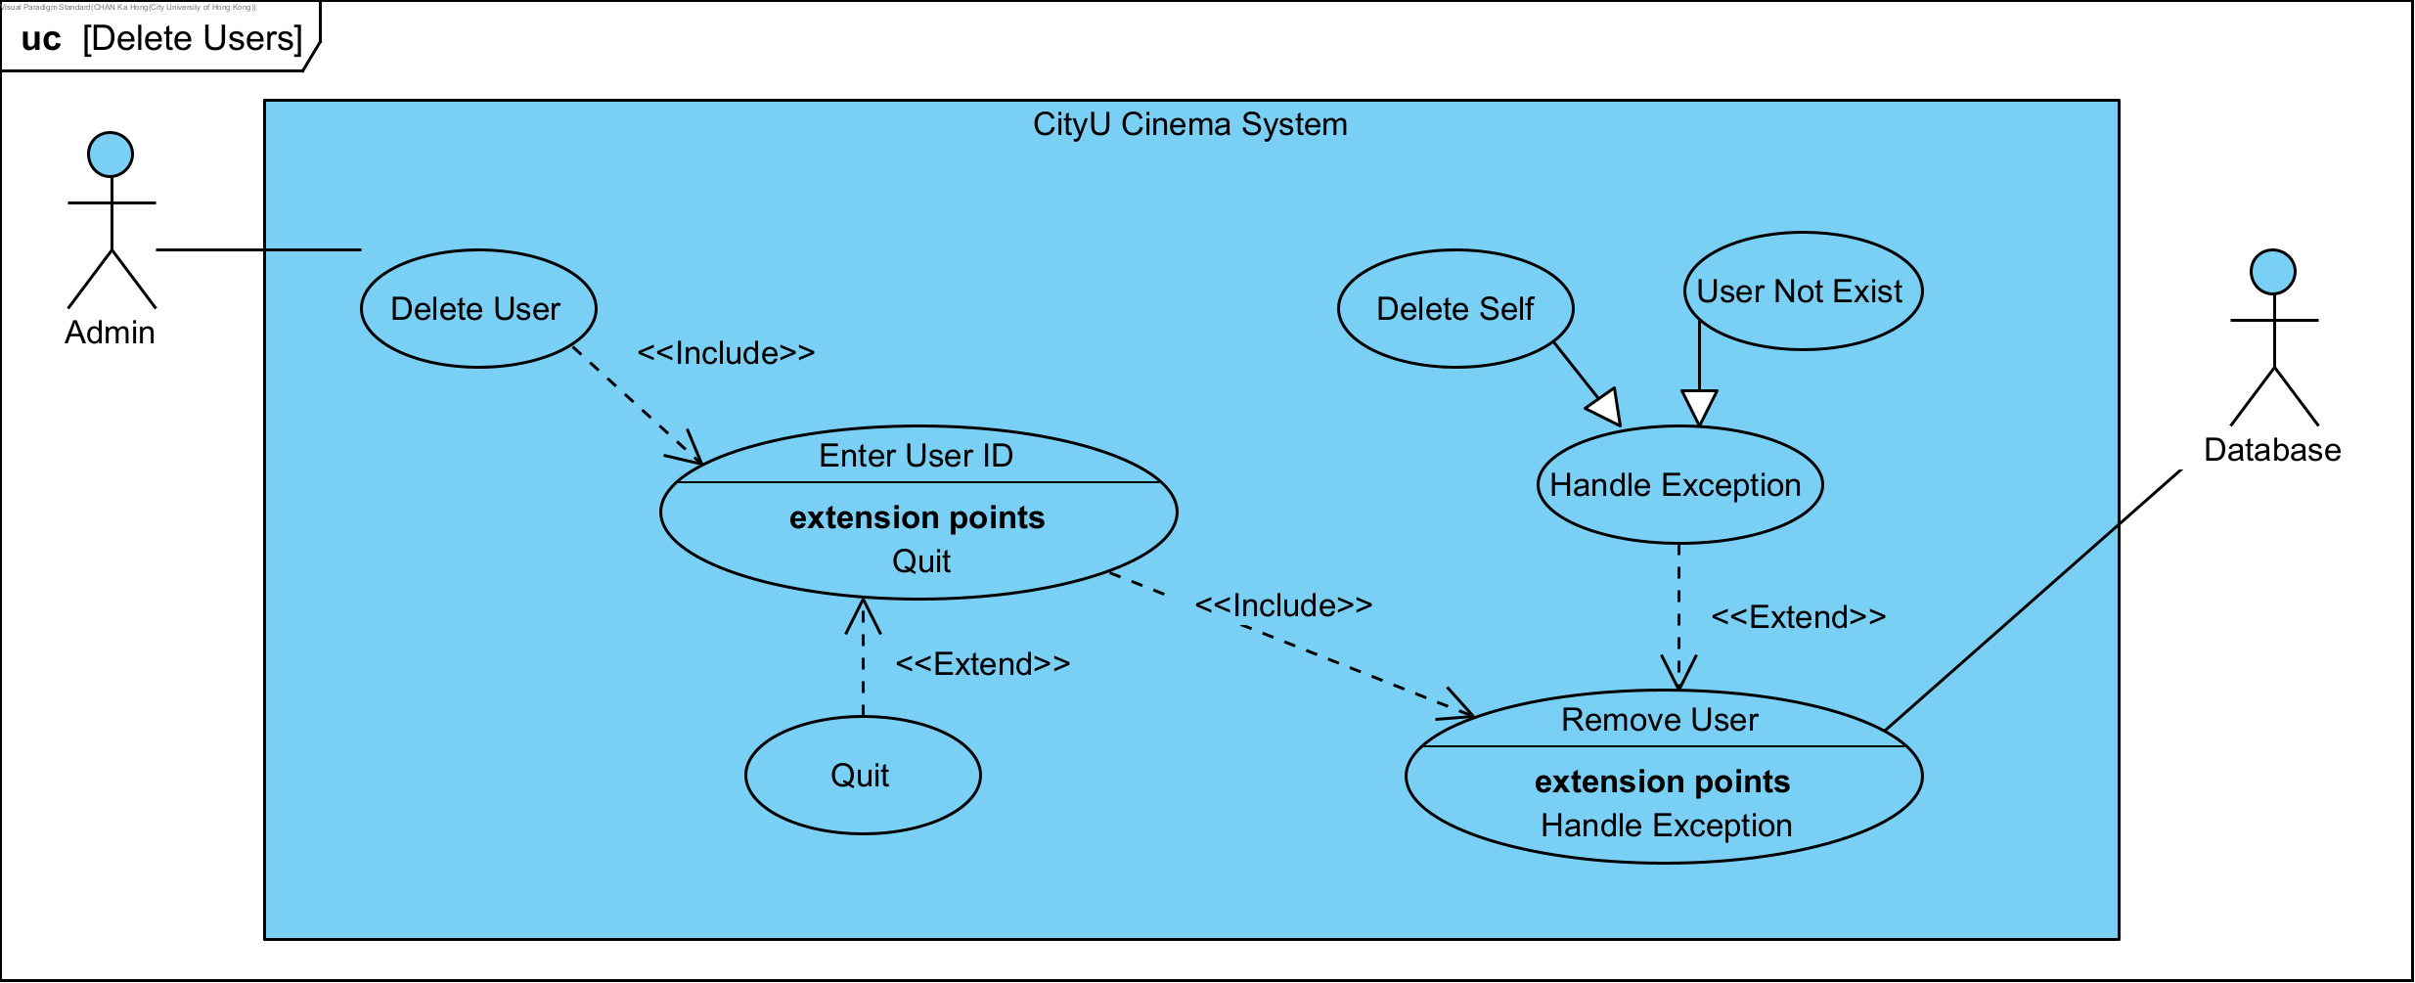

|  |  |  |
| --- | --- | --- |
| **Use Case Name:** | Delete Users | |
| **Actor(s):** | Admin, Database | |
| **Description:** | This use case illustrates the course of events when an admin deletes users | |
| **Events:** | **Actor Action** | **System Response** |
|  | Step 1: This use case is initiated when admin deletes users.  Step 3: Admin enters user ID.  Step 6: The use case restarts at step 2 to prepare for another user deletion. | Step 2: The system prompts admin to enter user ID.  Step 4: The system validates the entered user ID.  Step 5: The system removes the user from database. |
| **Alternative Course of Events:** | Step 3a: [Extension Point] Admin can enter quit to exit this use case.  Step 4a: [Extension Point] If any user ID invalidity is found, the system throws an exception, including self-deletion exception and user not found exception The use case restarts at step 2. | |
| **Assumption:** | User has logged in as an admin user; the entered user ID matches an existing user. | |
| **Precondition:** | The user to be deleted exists in the database. | |
| **Postcondition:** | A user is removed from the database. | |

## **3.17 Add Movies**

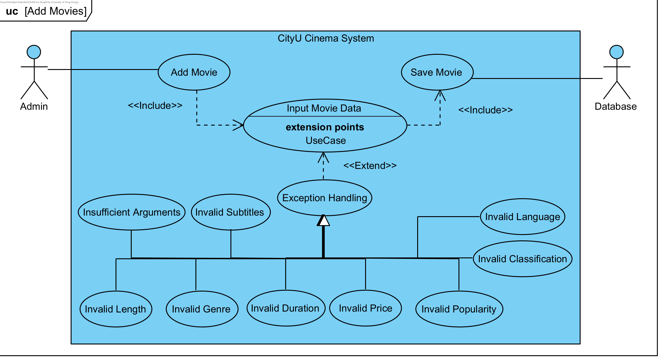

|  |  |  |
| --- | --- | --- |
| **Use Case Name:** | Add Movies | |
| **Actor(s):** | Admin, Database | |
| **Description:** | This use case illustrates the course of events when an admin user adds movies to the database. | |
| **Events:** | **Actor Action** | **System Response** |
|  | Step 1: This use case is initiated when admin adds movies to the database.  Step 3: Admin enters movie data one by one. | Step 2: The system prompts admin to enter movie data.  Step 4: The system saves the newly created movie to the database. This use case is concluded. |
| **Alternative Course of Events:** | Step 3a: [Extension Point] If any of the entered movie data is considered invalid, exception will be thrown, which can include insufficient arguments, invalid movie name’s length, invalid genre, invalid duration, invalid price, invalid popularity, invalid classification, invalid language, and invalid subtitles. | |
| **Assumption:** | User has logged in as admin; the same movie has not been previously added. | |
| **Precondition:** | The movie to be added does not exist in the database. | |
| **Postcondition:** | A new movie object is created and saved to the database. | |

## **3.18 Schedule Movies**

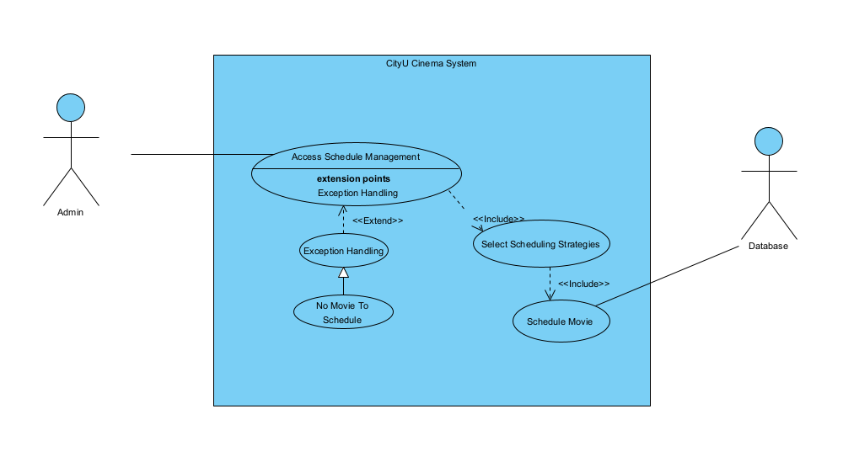

|  |  |  |
| --- | --- | --- |
| **Use Case Name** | ScheduleMangment | |
| **Actor(s)** | Admin | |
| **Description** | This use case describes the process of movies’ scheduling strategies management. | |
| **Typical Course of Events** | **Actor Action**  **Step 1:** This use case is initiated when the admin finishes adding all the movies to the database.    **Step 3:** Admin chooses the desired scheduling strategies. | **System Response**      **Step 2:** The system displays all the scheduling strategies options.    **Step 4:** The system queries its movie database and processes the scheduling with the scheduling strategies admin selected. This scheduled list of movies will be stored into movie session slot. |
| **Alternative Course** | **Step 1:** If admin didn’t add sufficient movies to the database or the system has already process scheduling before, the system notifies the admin of the scheduling unallowable. | |
| **Precondition** | The movie database contains a sufficient number of movies. | |
| **Postcondition** | A list of movies in the movie database has scheduled and store to the movie session slot. | |

## **3.19 Add Snacks/Drinks**

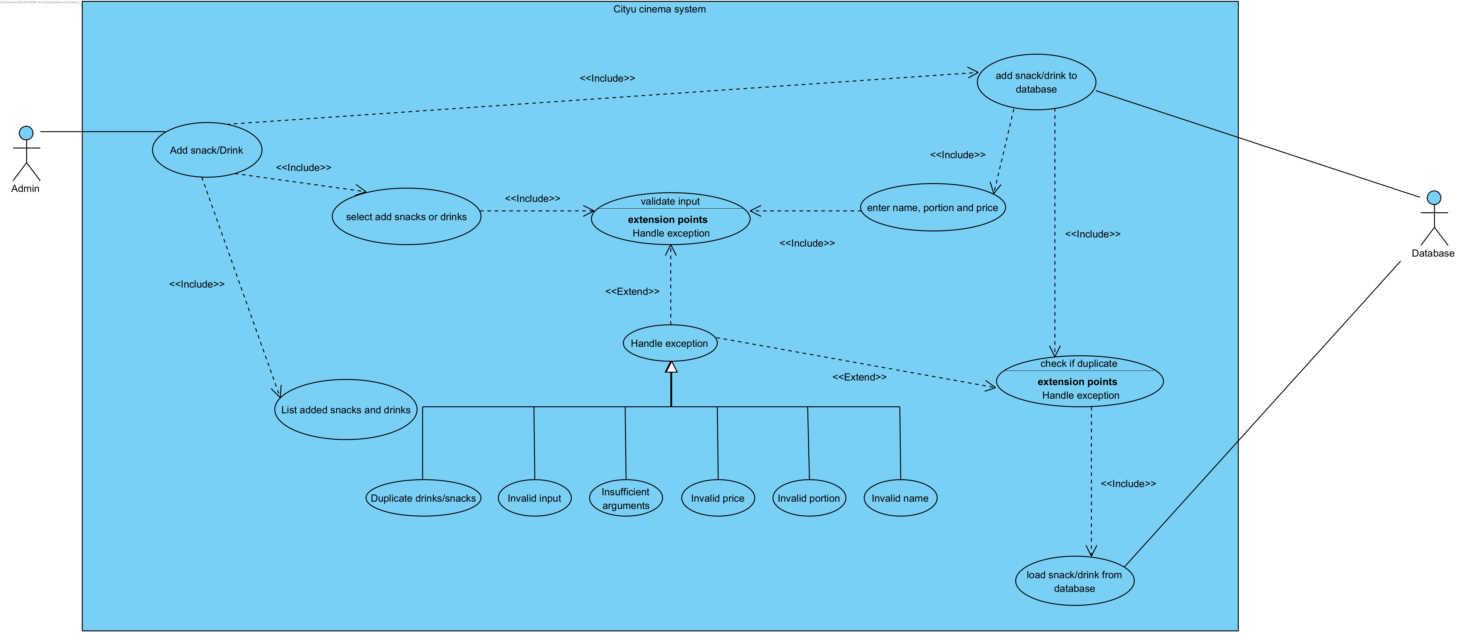

|  |  |  |
| --- | --- | --- |
| **Use Case Name:** | Add snacks/Drinks | |
| **Actor(s):** | Admin, database | |
| **Description:** | This use case describes the process of an admin adding snacks/drinks. | |
| **Events:** | **Actor Action** | **System Response** |
|  | Step 1: This use case is initiated when an admin selects to add snacks/drinks.  Step 3: The admin chooses to add snacks or drinks.  Step 6: The admin enters the name, portion and price of a snack/drink into the system.  Step 12: The admin entered “q” or “quit” to state that they have finished adding the snacks/drinks.  Step 15: The admin adds all snacks/drinks and can review all the snacks/drinks added. The use case is concluded. | Step 2: The system asks the admin to add snacks or drinks.  Step 4: The system validates the input from the admin.  Step 5: The system asks the admin to input the name, portion and price of a snack/drink in a specific format.  Step 7: The system validates the entered data by the admin.  Step 8: The system checks if there is a duplicate snack/drink in the database  Step 9: The system adds the new snack/drink to the database.  Step 10: The system prints the successfully added snack/drink message.  Step 11: The system returns to step 2 for the admin to add more snacks/drinks.  Step 13: The system validates the input by the admin  Step 14: The system lists all the information about snacks/drinks added by the admin. |
| **Alternative Course of Events:** | Step 4(a): If the admin entered some invalid input, the system prints out “[Exception] Invalid option, please try again” and back to step 2.  Step 4(b): If the admin entered “q” or “quit”, and no snacks/drinks are added, the system prints out “[State] Add snacks/drinks process terminated!” and ends this use case.  Step 7(a): If the admin entered less than 3 values, the system prints out “[Exception] 3 values must be provided” and back to step 2.  Step 7(b): If the length of the name of a snack/drink is not between 1 to 30 characters, the system prints out “[Exception] The product name should be 1 to 30 characters long” and back to step 2.  Step 7(c): If a snack/drink portion is not between 1 to 14 characters, the system prints out “[Exception] The portion should be 1 to 14 characters long” and back to step 2.  Step 7(d): If the price of a snack/drink is not between 1 and 500, the system prints out “[Exception] Snacks/drinks price must be between 1 and 500” and goes back to step 2.  Step 7(e): If the admin entered “q” or “quit”, and no snacks/drinks are added, the system prints out “[State] Add snacks/drinks process terminated!” and ends this use case.  Step 8: If there is a duplicate snack/drink in the database, the system prints out “[Exception] Duplicate product detected. Failed to add. Please try again” and return to step 2. | |
| **Assumption:** | The user has logged in as an admin. | |
| **Precondition:** | N/A | |
| **Postcondition:** | New snacks/drinks are added to the database. | |

# **4. Class Diagram**



Due to the large scale and complexity of the complete class diagram, please also refer to the source image for full details (**ClassDiagram_HighResolution.png**).

**The layout of the class diagram used later for elaborating the design principles/patterns we adopted may be different from the above one, for better explanation purposes.**

# **5. Sequence Diagrams**

## **5.1 Registration**

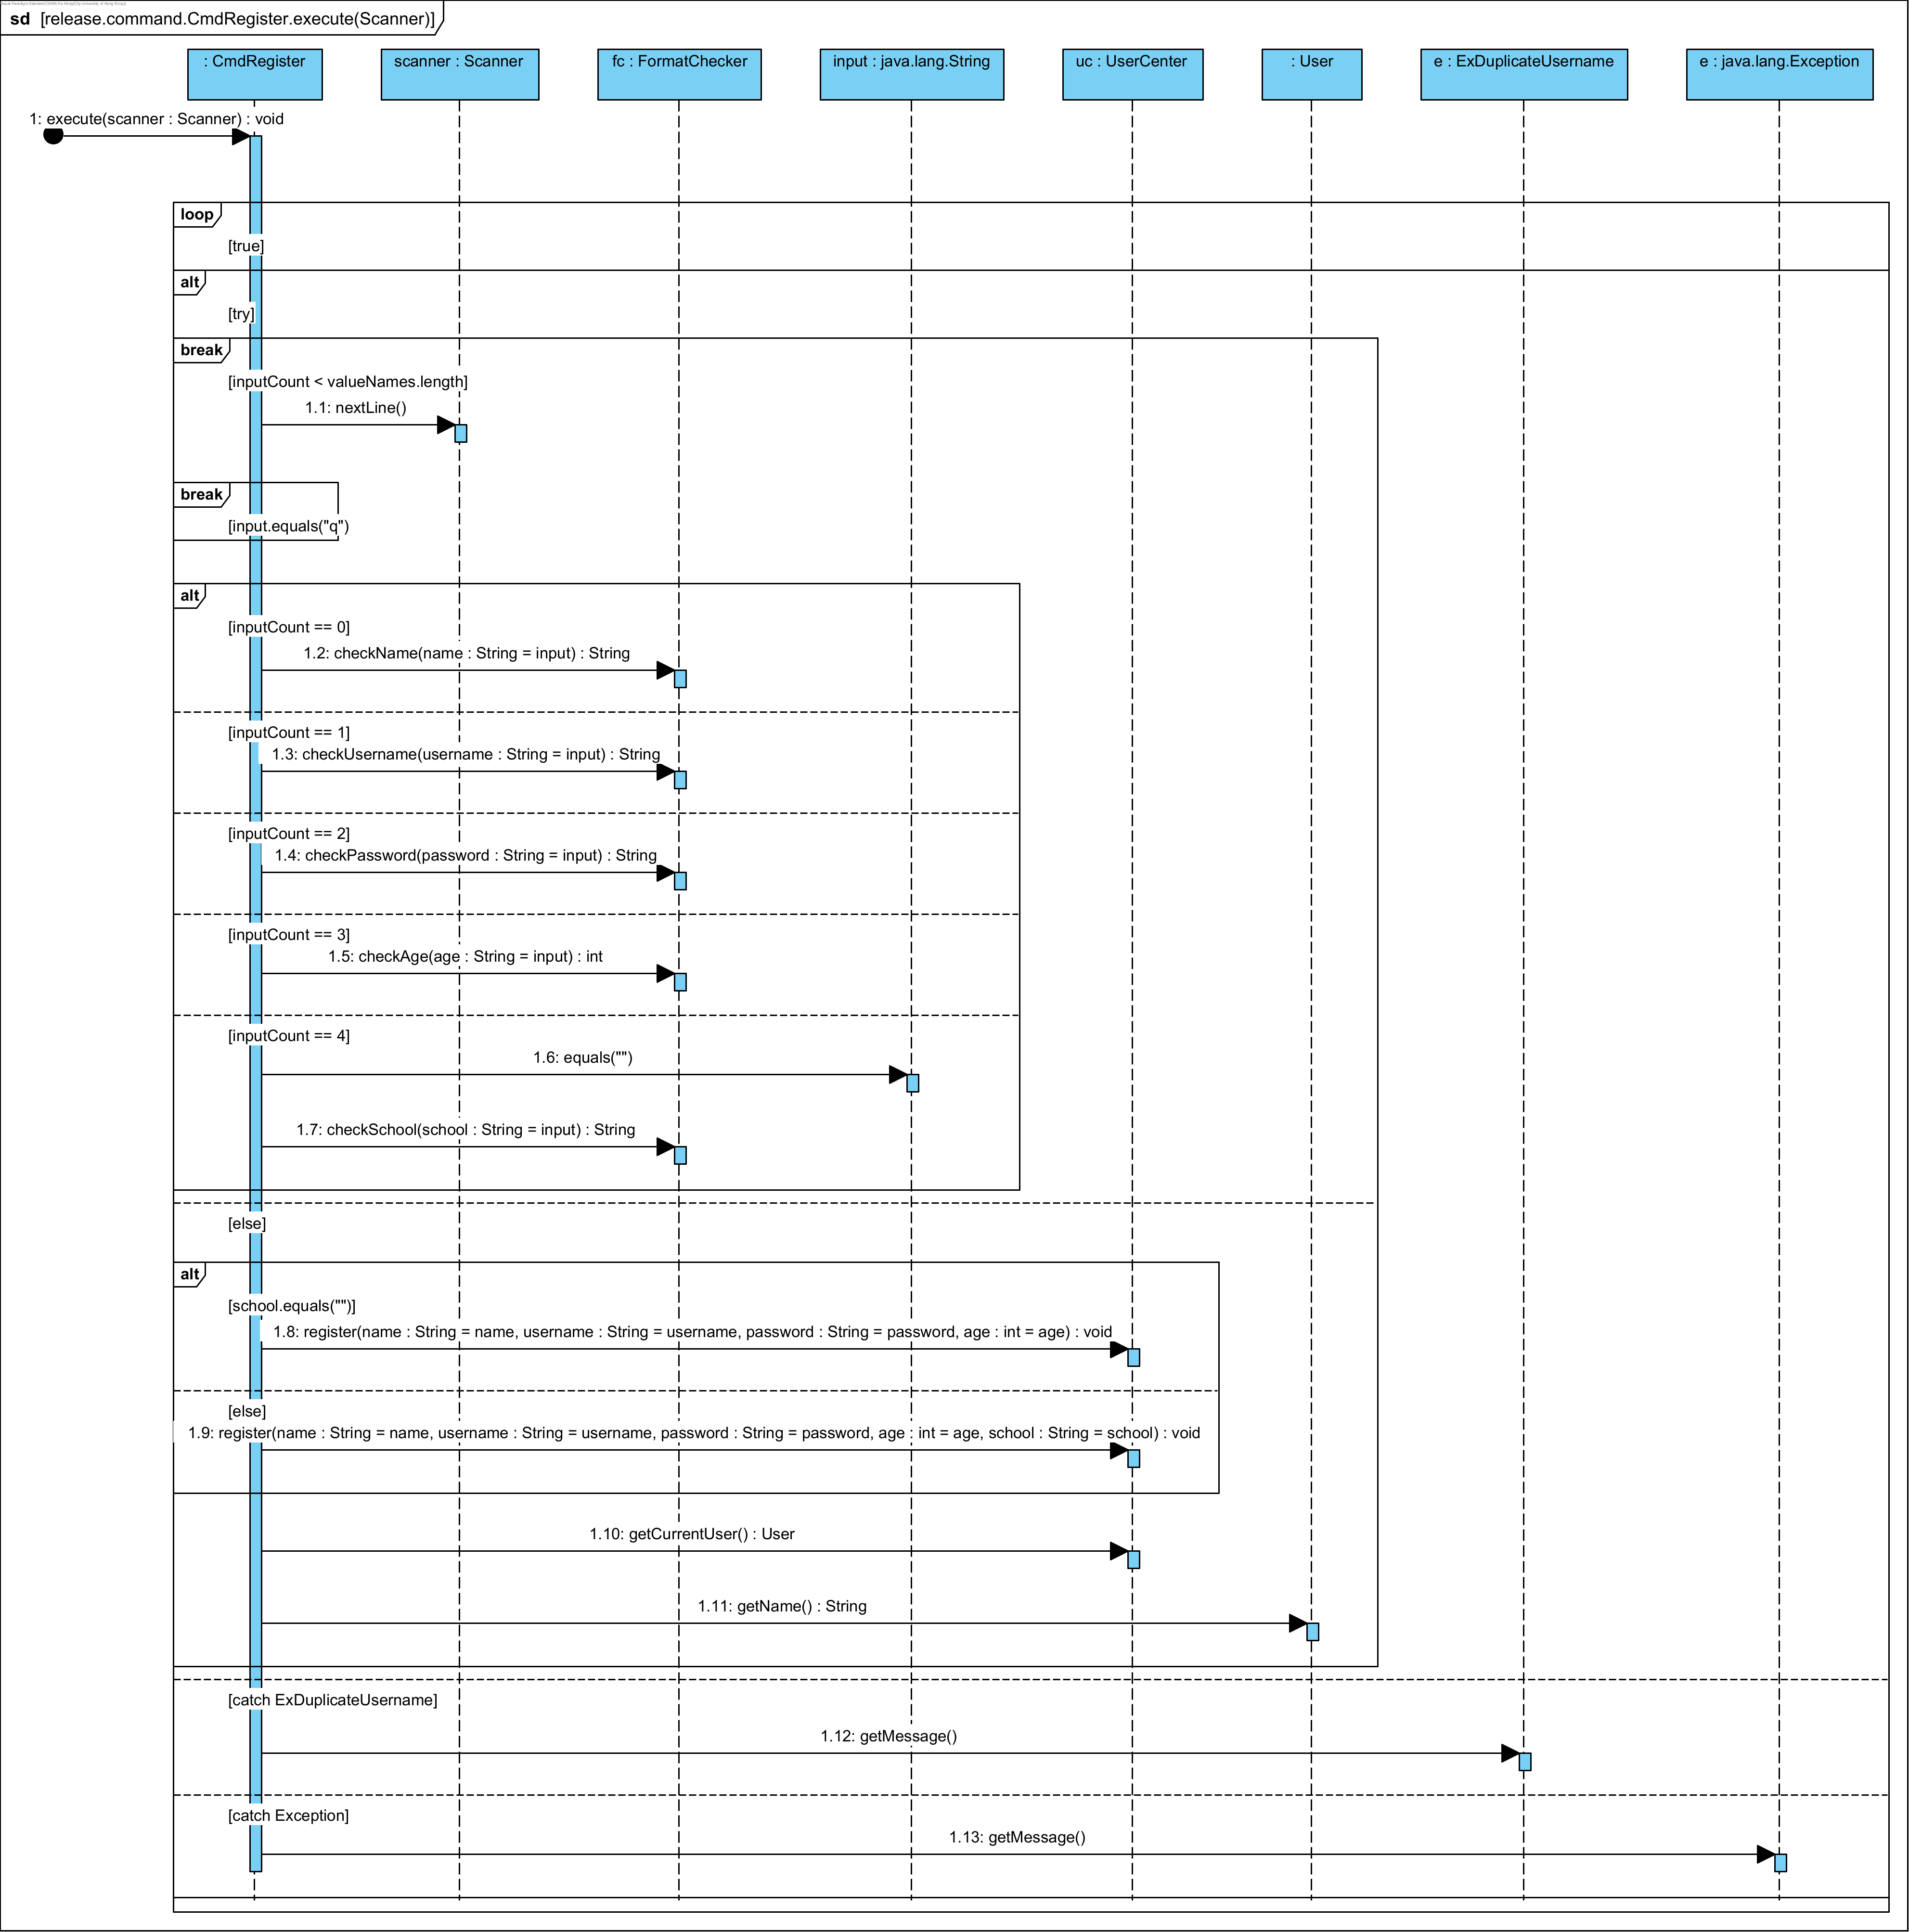

The sequence above illustrates the process of executing a command to register a user in a system. The sequence initiates with the execute(scanner: Scanner) method call. It involves a loop where scanner.nextLine() is repeatedly invoked to read input lines until an empty string "" is encountered. Within this loop, the input undergoes various checks based on the inputCount variable, which increments with each loop iteration.

* At inputCount 0, the method fc.checkName(name: String = input) is called to validate the name.
* At inputCount 1, the method fc.checkUsername(username: String = input) verifies the username.
* At inputCount 2, the method fc.checkPassword(password: String = input) checks the password.
* At inputCount 3, fc.checkAge(age: String = input) validates the age.
* At inputCount 4, the input is compared to an empty string "".
* At inputCount 5, fc.checkSchool(school: String = input) checks the school information.

Upon exiting the loop, the system evaluates whether the school variable is empty. If it does, uc.register(name, username, password, age) is invoked; otherwise, uc.register(name, username, password, age, school) is called. Following this, uc.getCurrentUser(): User is executed, succeeded by getName(): String to retrieve the current user's name.

If an ExDuplicateUsername exception arises, e.getMessage() is executed to fetch the error message.

## **5.2 Log in**

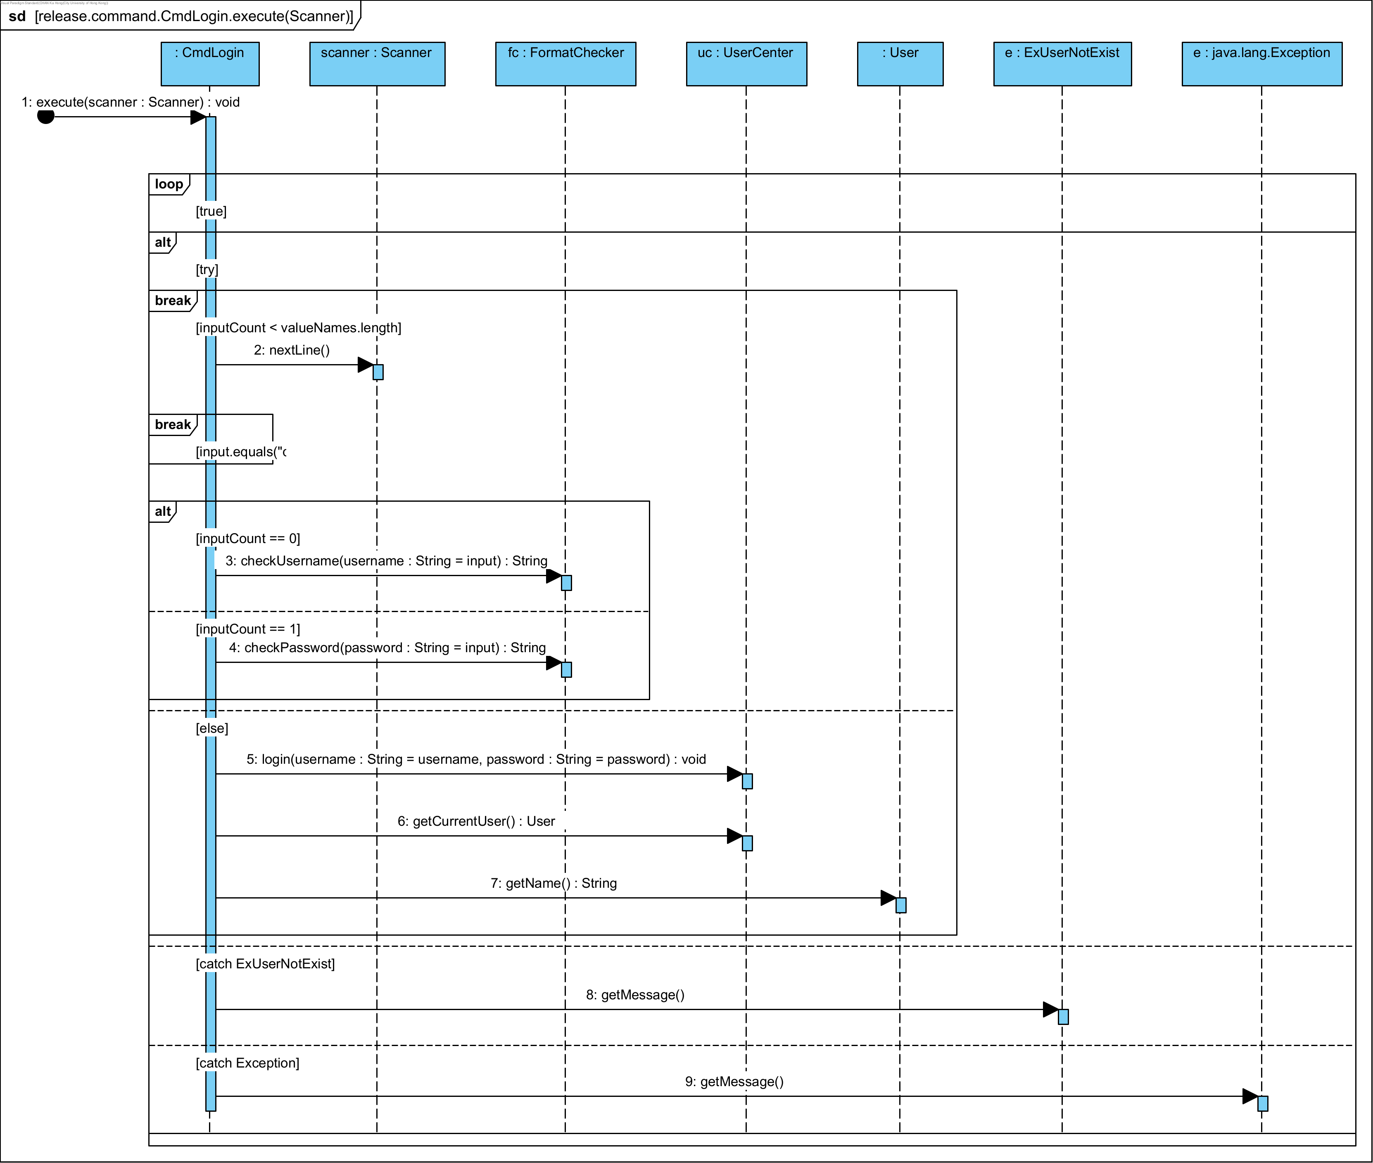

The above sequence begins with the CmdLogin object invoking the execute(scanner: Scanner) method. This method initializes a loop that continues as long as the condition [true] holds. Within this loop, an alternative (alt) block manages different scenarios. Initially, the Scanner.nextLine() method reads input. The loop persists if the input count is less than the length of valueNames. If the input is "q", the loop terminates.

Another alternative block evaluates inputCount. If inputCount is 0, the FormatChecker.checkUsername(username: String = input) method is called to validate the username. If inputCount is 1, FormatChecker.checkPassword(password: String = input) is invoked to validate the password. When both conditions are fulfilled, the UserCenter.login(username: String = username, password: String = password) method is executed for user authentication.

Upon a successful login, UserCenter.getCurrentUser() retrieves the current User object. Subsequently, User.getName() is called to obtain the user's name.

The diagram also addresses exception handling. If an ExUserNotExist exception occurs, getMessage() retrieves the corresponding error message. Similarly, for a general Exception, getMessage() is called to fetch the error message.

## **5.3 List Movie Sessions**

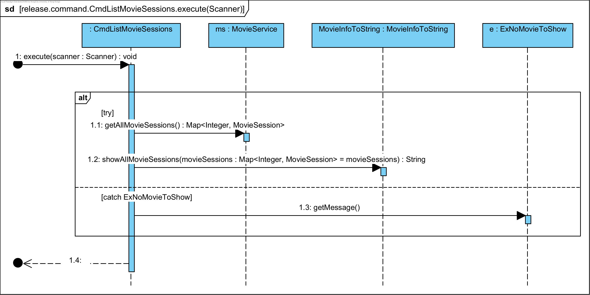The diagram showcases the interactions between different objects within a system during the execution of the execute method of the CmdListMovieSessions class. Initially, the CmdListMovieSessions object invokes the execute(Scanner scanner) method. This action triggers a series of steps encapsulated within a try-catch block. Within the try block, the first call is to the getAllMovieSessions() method on the MovieService object, referred to as ms. This method is expected to return a map containing movie sessions, denoted as Map<Integer, MovieSession>.

Following the retrieval of the movie sessions, the CmdListMovieSessions object proceeds to call the showAllMovieSessions(Map<Integer, MovieSession> movieSessions) method on the MovieInfoToString object. This method call is crucial as it converts the movie sessions into a string format for display purposes. The interactions between these objects are crucial for the proper functioning of the application, ensuring that the movie sessions are retrieved and displayed correctly.

However, in cases where no movie sessions are available, an exception of type ExNoMovieToShow is thrown. This exception is caught by the catch block, which then calls the getMessage() method on the ExNoMovieToShow object, referred to as e. This method retrieves the error message associated with the exception, allowing the application to handle the error correctly.

## **5.4 List Snacks/Drinks**

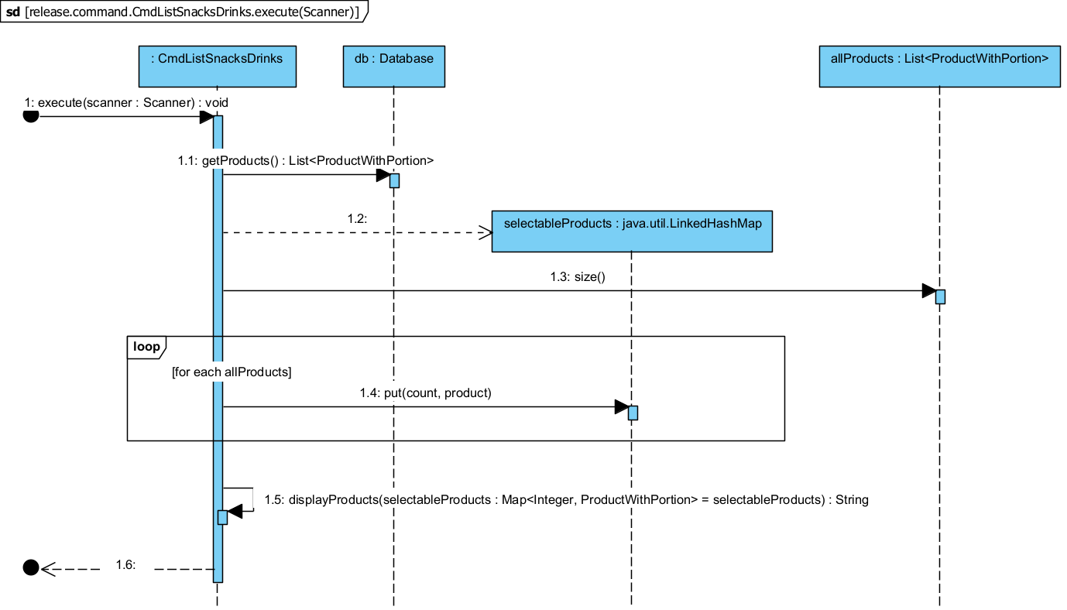

The UML sequence diagram illustrates the sequence of events for the execute method in the CmdListSnacksDrinks class. The method begins execution with a Scanner object as a parameter, which is used for subsequent operations. It then calls the getProducts method on the Database object, which returns a list of ProductWithPortion objects. This list represents all products that are available to the user. Next, a LinkedHashMap named selectableProducts is initialized to store the products with their corresponding selectable options. The size of the allProducts list is determined by calling the size method, which provides the number of products available. An iteration is performed over the allProducts list, where each product is added to the selectableProducts map along with a count that serves as the selectable option number.

Finally, the displayProducts method is called on the selectableProducts map, which returns a String representation of the selectable products. This String is used to display the products to the user, allowing them to view all available products.

## **5.5 Search Movies**

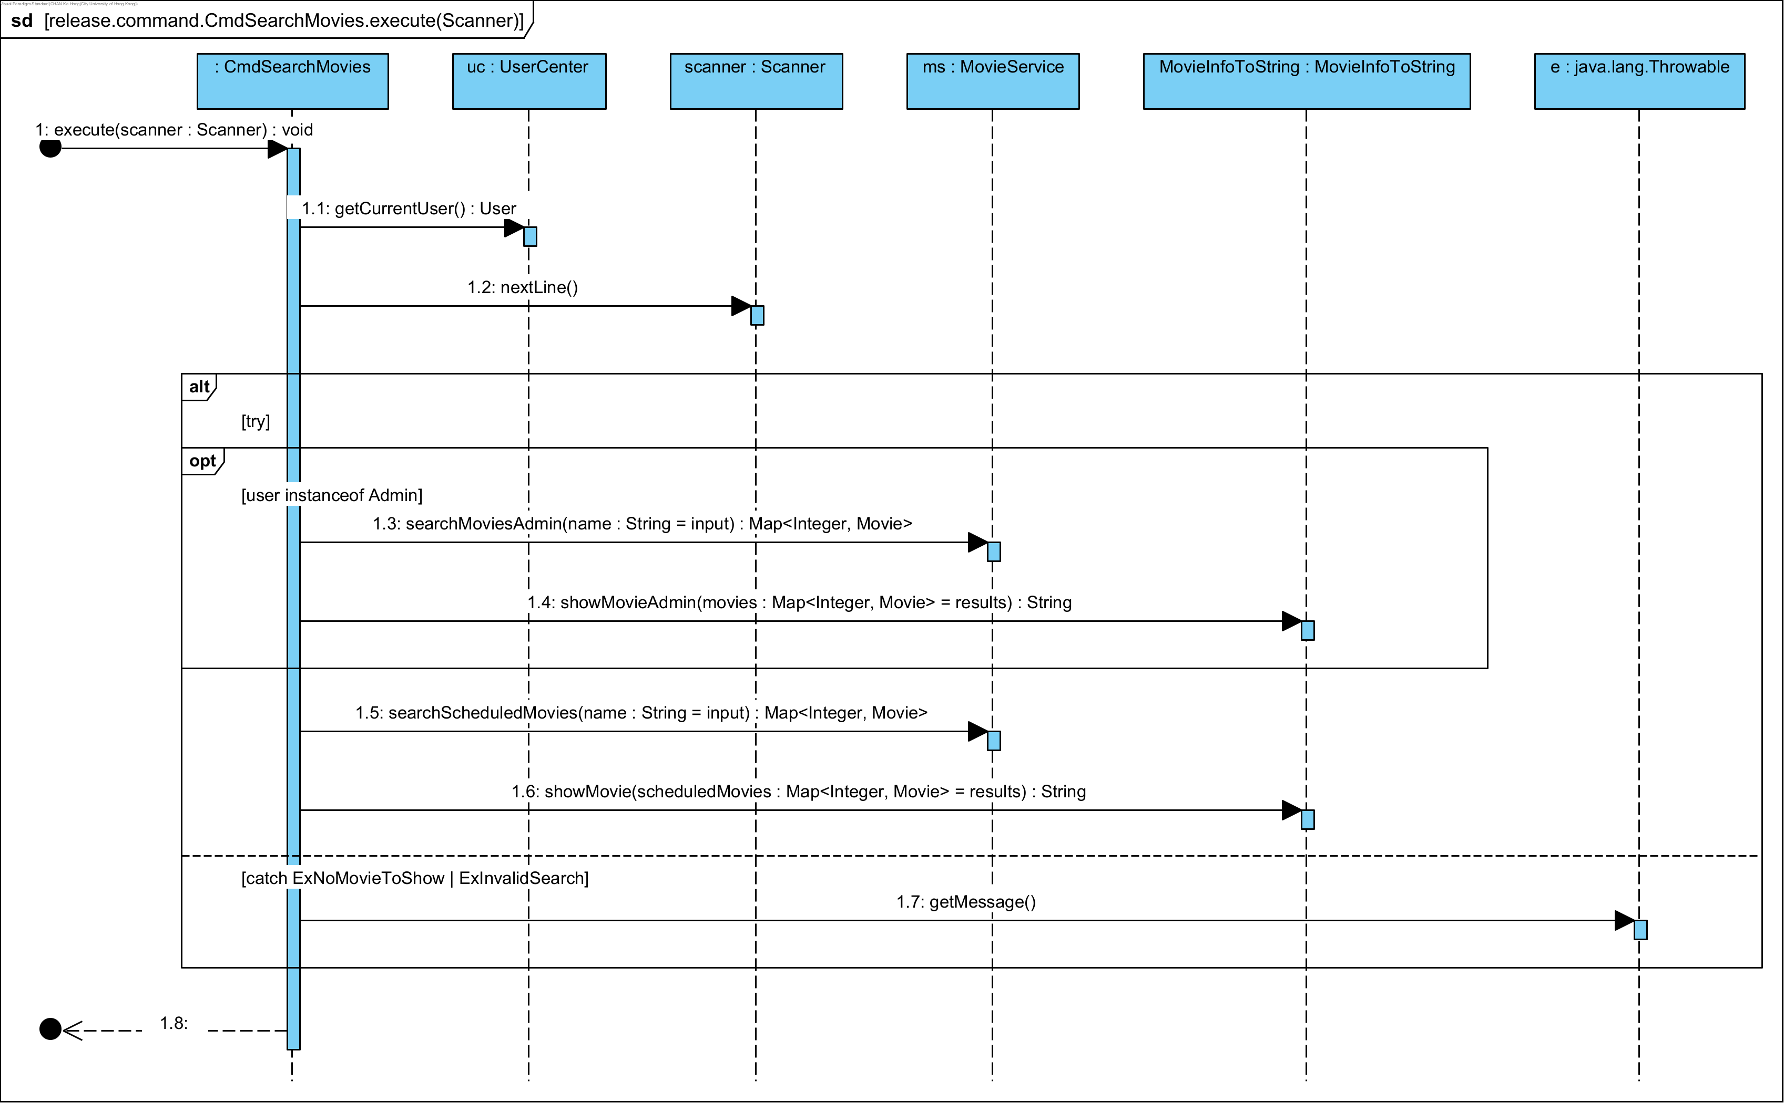

The UML sequence diagram illustrates the interactions within a system when executing the execute method of the CmdSearchMovies class. The sequence begins with the CmdSearchMovies object invoking the execute(Scanner scanner) method. This call initiates a series of operations where the CmdSearchMovies object first calls getCurrentUser() on the UserCenter object to retrieve the current user information. Following this, the UserCenter object calls nextLine() on the Scanner object to read the user's input.

The diagram features an alternative block (alt) that delineates two different scenarios based on the type of user. If the current user is identified as an instance of Admin, the system proceeds to call searchMoviesAdmin(name: String) on the MovieService object, passing the user's input as the search parameter. This method returns a Map<Integer, Movie> containing the search results, which are subsequently passed to the showMovieAdmin(Map<Integer, Movie> movies) method of the MovieInfoToString object. This method processes the results and returns a String representation.

In contrast, if the user is not an instance of Admin, the system calls searchScheduledMovies(name: String) on the MovieService object, again using the user's input as the search parameter. Similar to the previous scenario, this method returns a Map<Integer, Movie> with the search results, which are then passed to the showMovie(Map<Integer, Movie> scheduledMovies) method of the MovieInfoToString object to generate a String representation of the movies.

The diagram also includes an optional block (opt) to handle exceptions. If an ExNoMovieToShow or ExInvalidSearch exception occurs during the execution, the system calls getMessage() on the java.lang.Throwable object to retrieve the error message. This ensures that the system can handle errors correctly and provide meaningful feedback to the user.

## **5.6 Buy Movie Tickets**

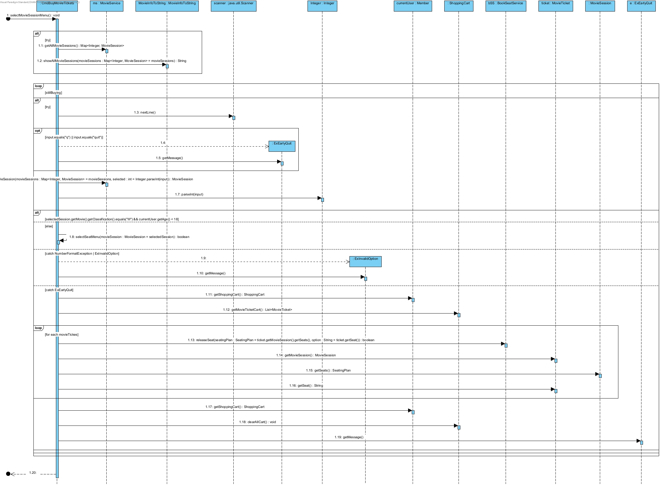

The process begins with the cmdDisplayMovieTickets object calling the listMovieSessions method on the ms: MovieService object, which processes the listMovieSessions request. It then calls the showAllSessions method, returning a string of available movie sessions. The scanner: java.util.Scanner object is used to read user input for selecting a movie session. The user input, which is a string, is parsed into an integer to represent the selected movie session. The system retrieves the selected movie session using the getMovieSession method and checks if the selected session is valid.

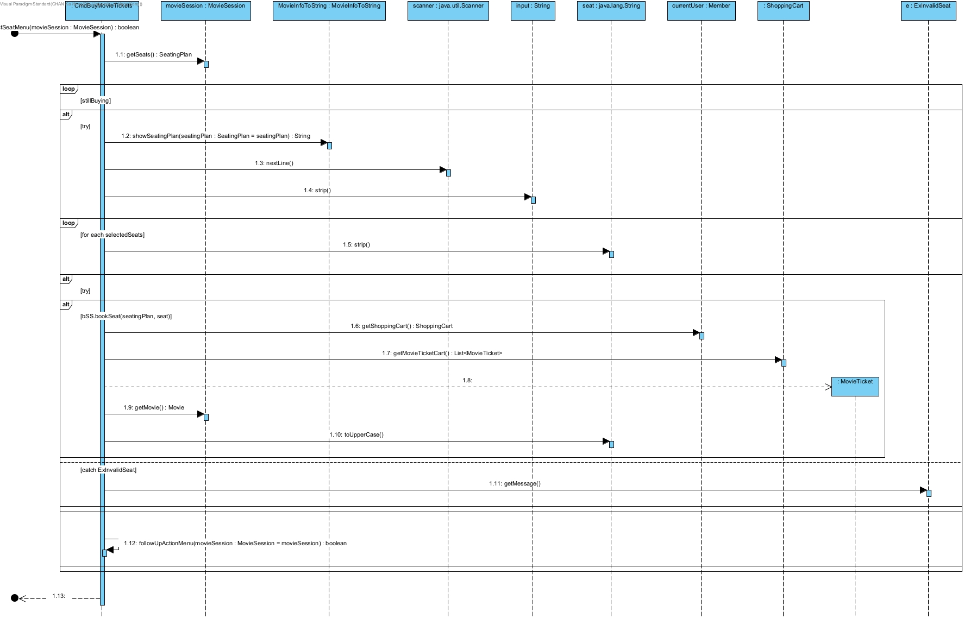

If the selected session is valid, the process continues with the CmdBuyMovieTickets object invoking the selectSeatMenu(movieSession: MovieSession) method. The CmdBuyMovieTickets object requests seat information by calling the getSeats() method on the movieSession object. The movieSession object returns a SeatingPlan object. The CmdBuyMovieTickets object then calls showSeatingPlan(seatingPlan: SeatingPlan) on movieSession, which returns a String representation of the seating plan. The CmdBuyMovieTickets object utilizes the scanner object to read user input via the nextLine() method. The input is processed by calling the strip() method on the input object. For each selected seat within the loop, the CmdBuyMovieTickets object processes each selected seat and books the seat by calling bookSeat(seatingPlan, seat) on the movieSession object. The BookSeatService object sets the selected movie session using the setSelectedMovie method.

Overall, the book movie ticket sequence diagram details the interactions required for a user to select and book movie tickets through the command line interface. It includes retrieving and displaying movie sessions, reading user input, validating selections, managing seats, and updating the shopping cart.

## **5.7 Buy Snacks/Drinks**

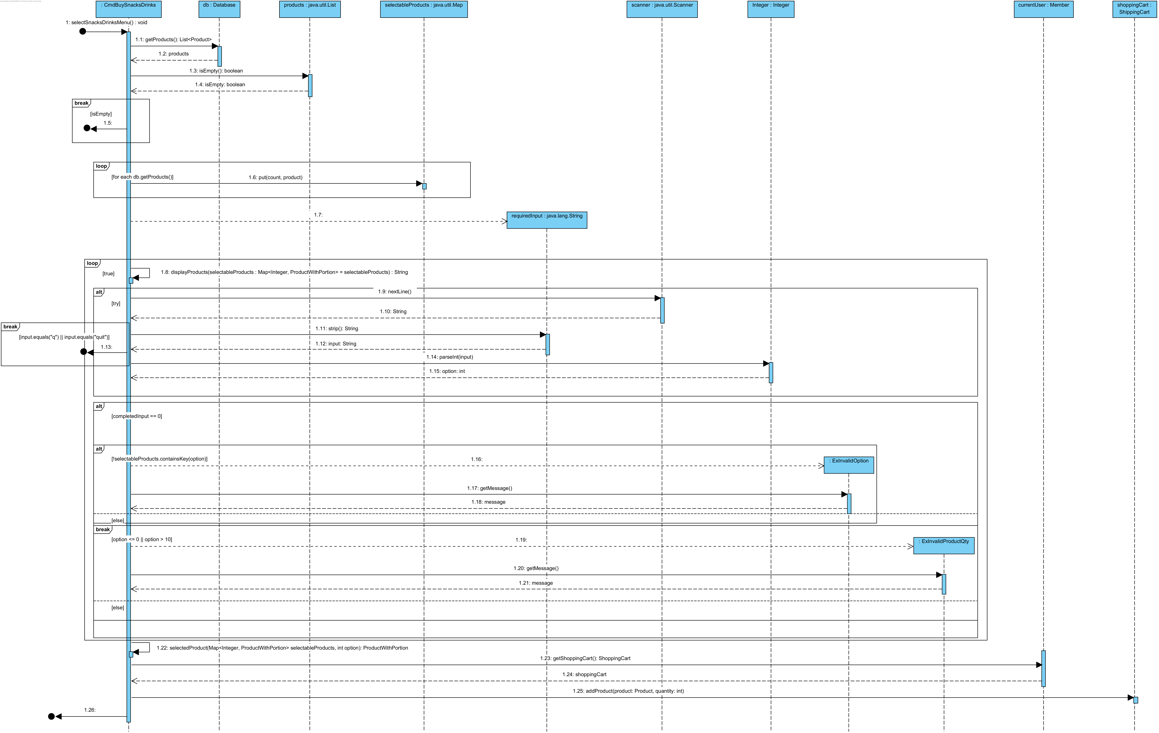

When the process starts, the system loads all the products from the database. If there are no products in the database, it prints out “[Exception] There are no snacks/drinks for selection” and stops the process. Then, it uses displayProducts() to format all the products and list them to the member. After that, it goes into an infinite loop and asks the member to choose the product and its quantity. The member can stop this process and return to the menu anytime by entering “q” or “quit”. If the member enters an invalid option for the product, the system will print out “[Exception] No such option” and ask the user to enter it again. When entering the quantity, if the user enters something that is not a number, the system prints out “[Exception] Invalid input format” and asks the user to enter again. If both inputs are valid, the system adds the corresponding product to the shopping cart and prints out the successful message.

## **5.8 Make Payment**



When the process starts, it makes a new CmdListShoppingCart object and calls its execute() method to list all the products in the shopping cart. Then, it calculates the total price of all the products in the shopping cart with discounts from the member's category. After that, it goes into an infinite loop. The system lists all the payment methods and asks the member to choose one to make the payment. If the member enters “q” or “quit”, the system stops the payment process and returns to the menu. If the member enters some invalid input, the system prints out “[Exception] Selected payment option is invalid” and asks the member to choose the appropriate payment option again. When the member chooses a valid payment option, it proceeds to make payment using that option by calling the corresponding doPayment() method. If the payment is successful, the system adds a new payment record to the member and clears their shopping cart. Then, it will print out the successful message and end the process. Otherwise, it will print out “[State] Sorry, you don't have enough money to pay with (the payment method that the member chosen)”. The system removes that method and asks the member to try another method. If all payments are unsuccessful, the system prints out, “[Remind] Sorry, you have failed all payment options. Exiting the payment menu”. It releases all the seats booked by the member and clears the shopping cart. It ends the process after doing so.

## **5.9 Personal Profile**

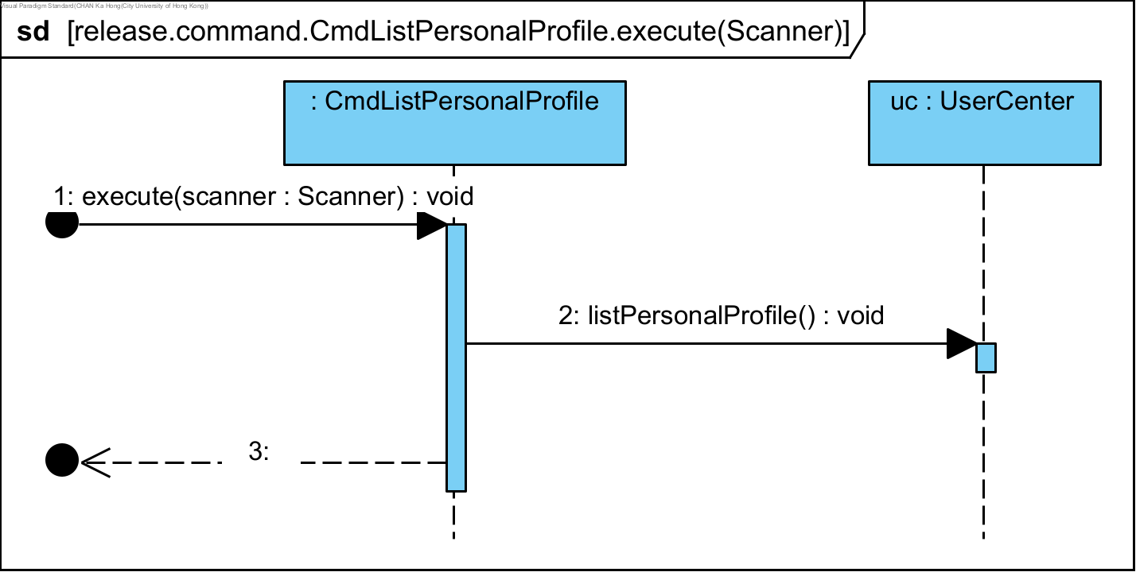

The CmdListPersonalProfile object's execute(scanner: Scanner): void method initiates the sequence by invoking the listPersonalProfile(): void method on the UserCenter object (uc). This call signifies the start of the process to retrieve and display the personal profile. The method execution completes and returns control to the CmdListPersonalProfile object.

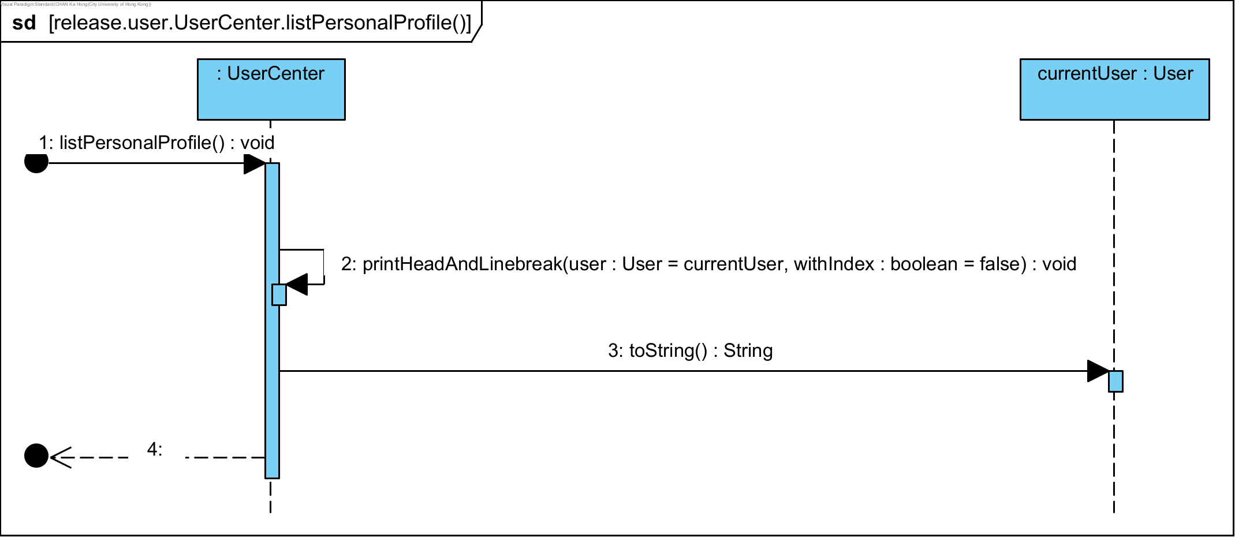

Following the initiation from the first sequence, the second sequence provides a detailed view of the listPersonalProfile method's internal operations within the UserCenter object. The process begins with a call to the printHeadAndLinebreak(user: User = currentUser, withIndex: boolean = false): void method, aimed at formatting the user profile's header. Subsequently, the toString(): String method is invoked on the currentUser object to generate a string representation of the user. This representation is then returned, completing the sequence.

## **5.10 List Payment Records**

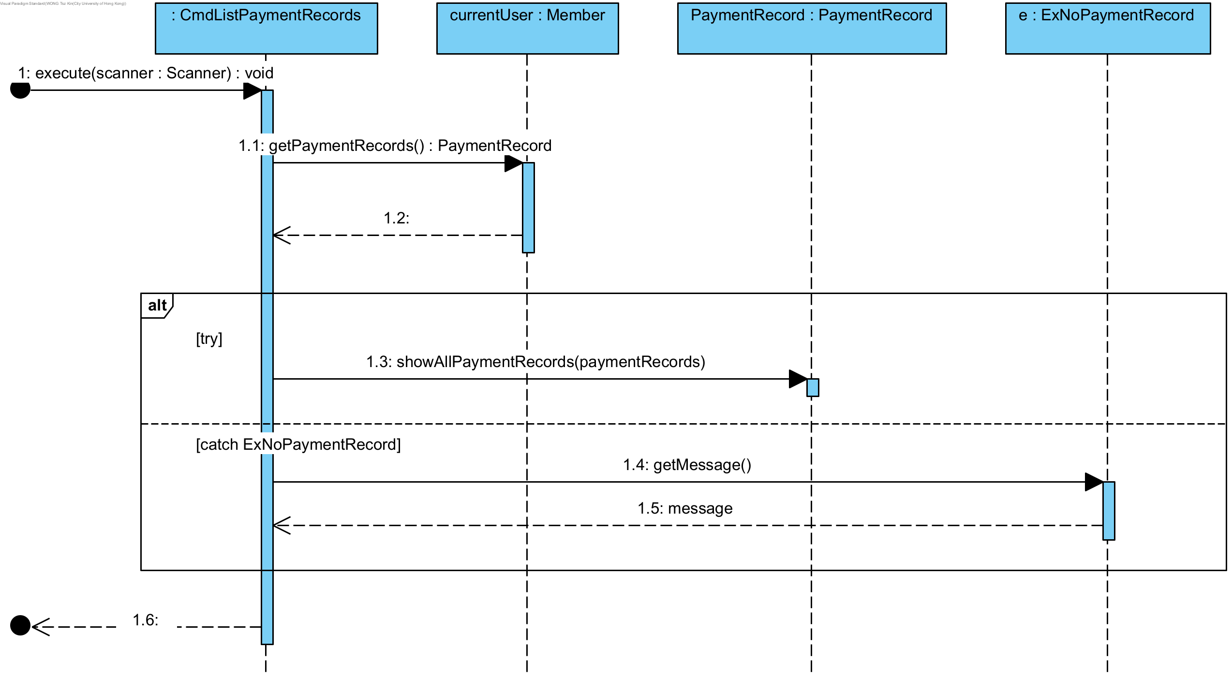

When the process starts, it calls the getPaymentRecords() to get all the current user's payment records. Then, it uses a static method in the PaymentRecord class, showAllPaymentRecords(), to format and print the records. If there are no payment records, an exception ExNoPaymentRecord is thrown and prints out “[Exception] There is no payment record to show”.

## **5.11 Reset Password**

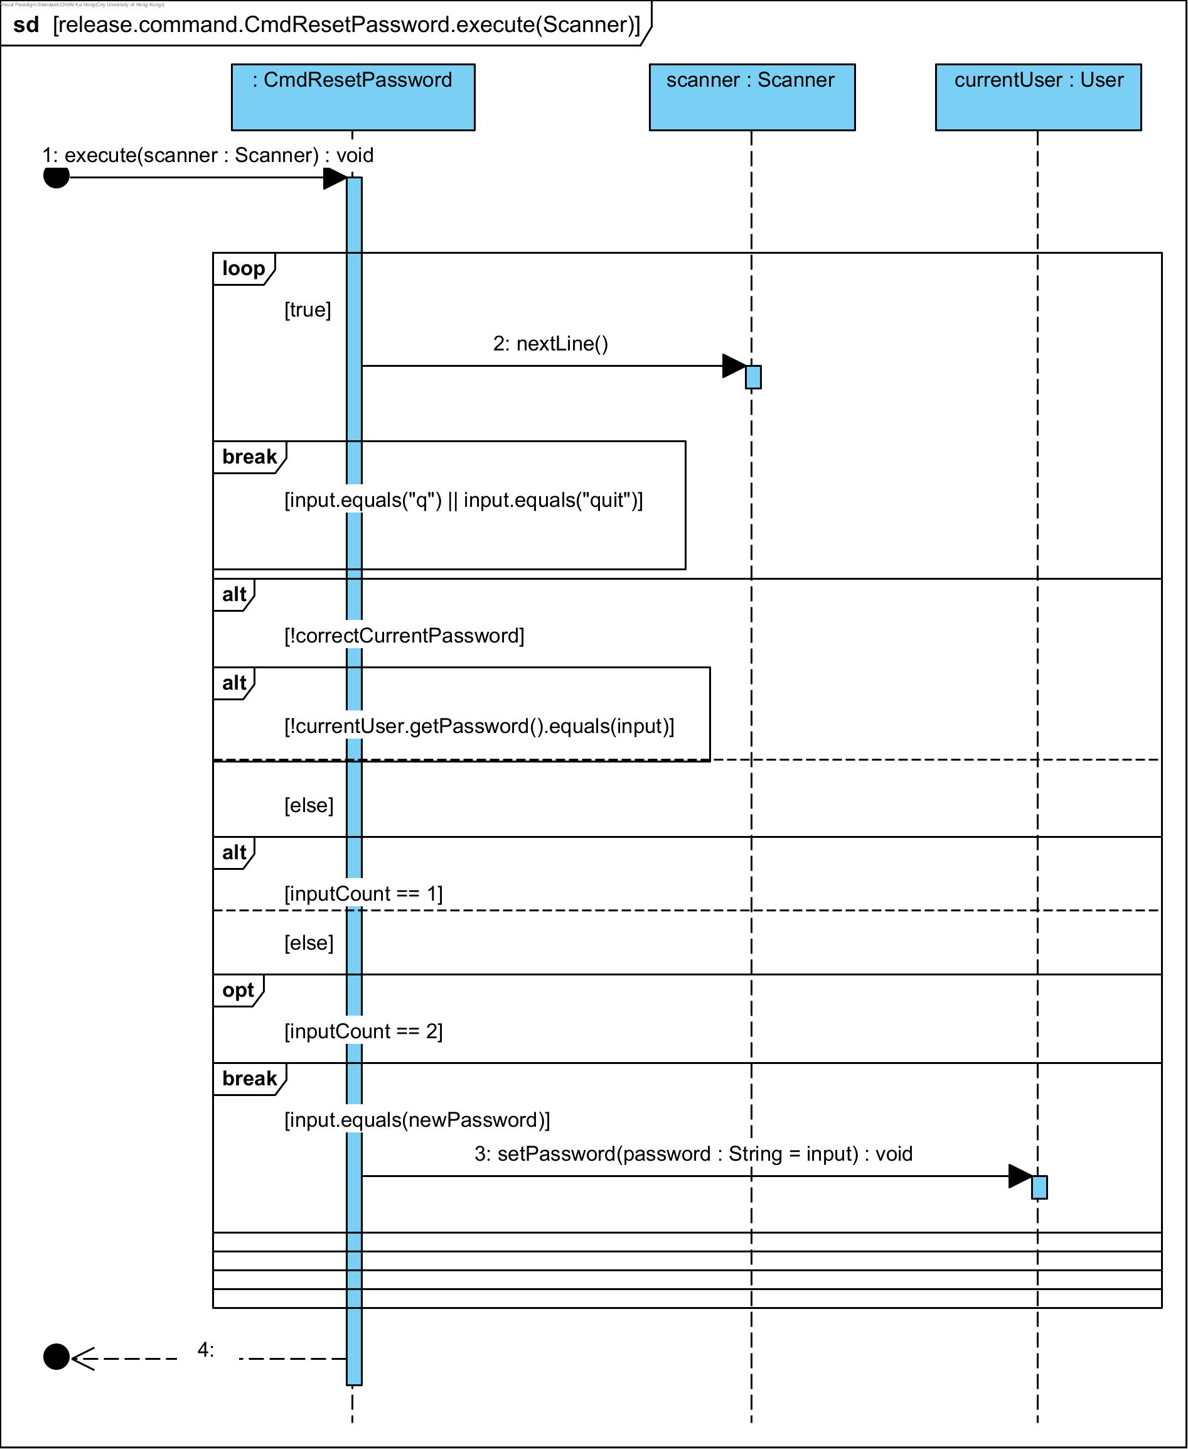

The process starts with an infinite loop ([true]), within which the scanner object calls the nextLine() method to read user input. This input undergoes several conditional checks. The first check determines if the input equals "q" or "quit", which would break the loop and terminate the process.

If the input is not a quit command, the next condition checks whether the input matches the current user's password using currentUser.getPassword().equals(input). If the password does not match ([!correctCurrentPassword]), the process continues to the next iteration of the loop.

If the input matches the current password, the process evaluates the value of inputCount. If inputCount equals 1, the process proceeds; otherwise, it checks if inputCount equals 2. If inputCount equals 2, an optional block (opt) is executed.

Finally, the process checks if the input equals the new password (input.equals(newPassword)). If this condition is met, the currentUser object calls the setPassword(password: String = input) method to update the password. The sequence then terminates, indicated by the final break in the loop.

## **5.12 Log out**

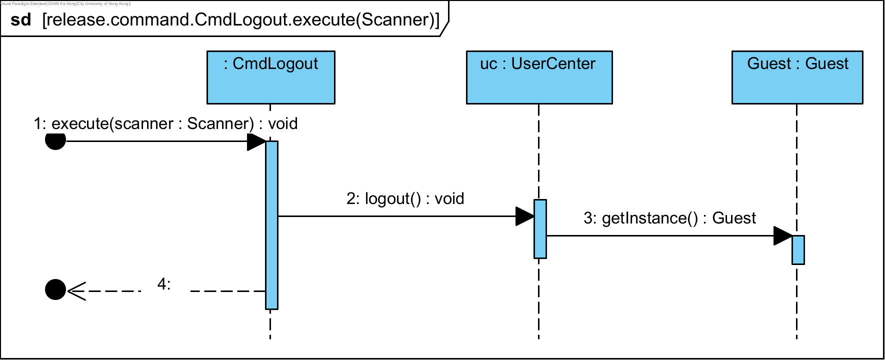

The sequence starts with the CmdLogout object invoking the execute(scanner: Scanner) method. Next, the CmdLogout object sends a message labeled 2: logout() : void to the UserCenter object, signaling the initiation of the logout process. The logout method in UserCenter is responsible for handling the user's logout request. Afterwards, the UserCenter object sends a message labeled 3: getInstance() : Guest to the Guest object. This message indicates that the getInstance method is called on the Guest object, which returns an instance of the Guest object, indicating that the user has been logged out and the system is now in a state where only guest access is allowed.

## **5.13 List All Users**

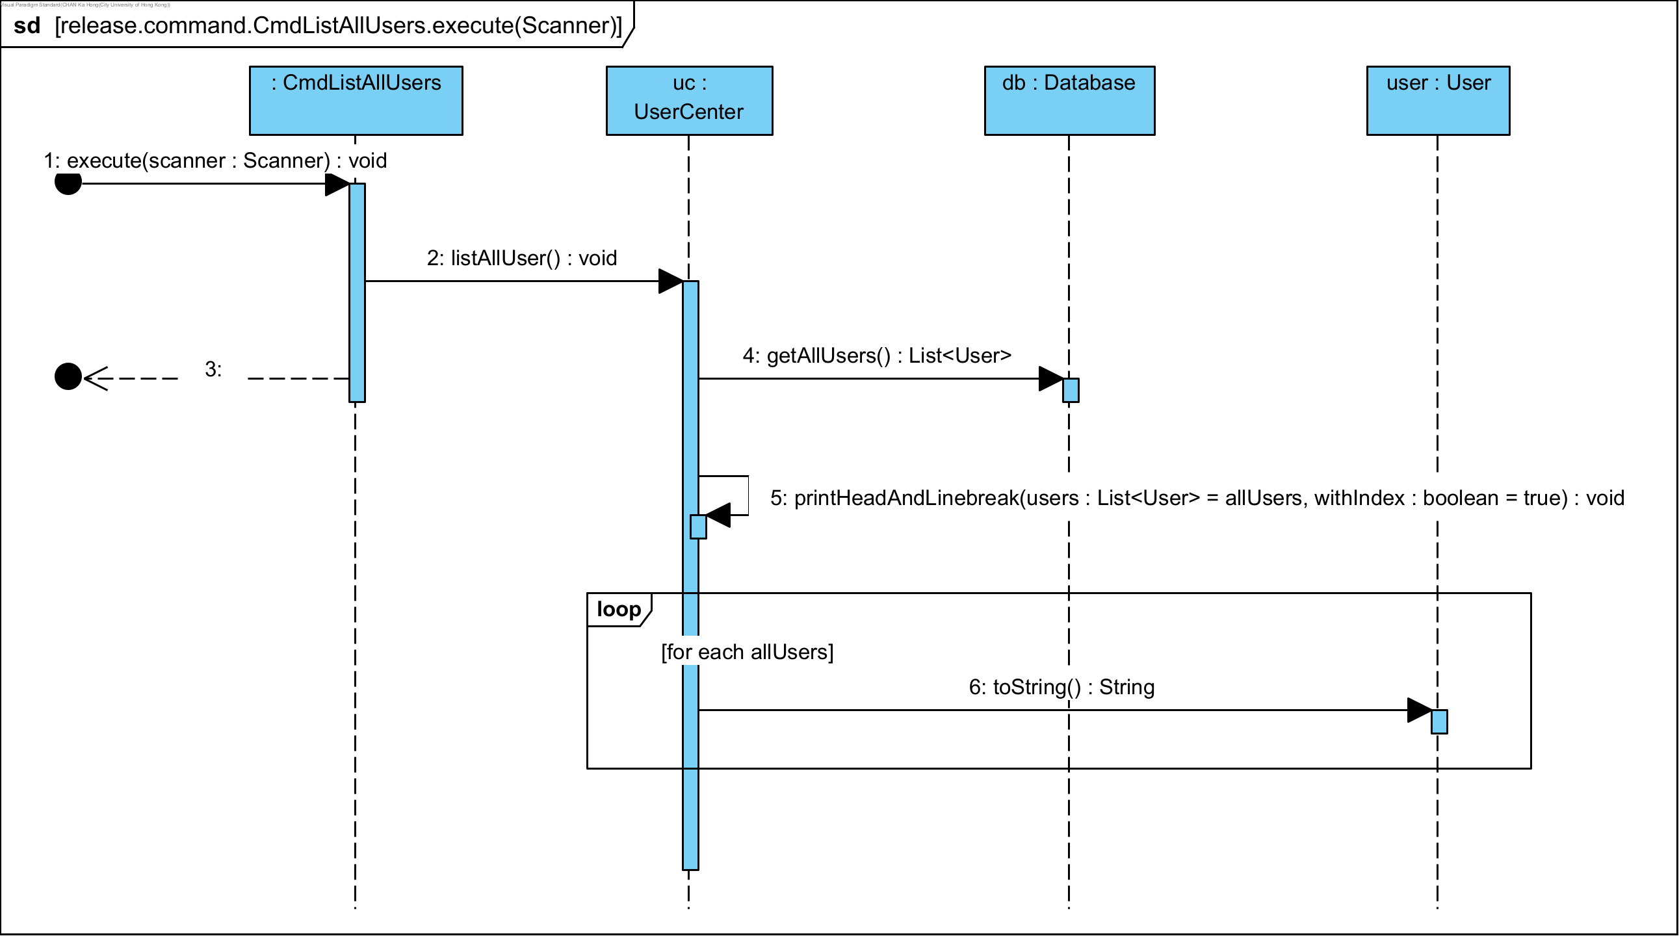

The above sequence diagram illustrates the execution of the CmdListAllUsers command, which is designed to list all users within a system. The sequence starts with the CmdListAllUsers object calling the execute(scanner: Scanner): void method. This method then triggers the UserCenter object's listAllUser(): void method to initiate the process of listing users.

The UserCenter object subsequently calls the Database object’s getAllUsers(): List<User> method to retrieve a list of all users. Once the list of users is obtained, the UserCenter object proceeds to print the header and line breaks using the printHeadAndLinebreak(users: List<User> = allUsers, withIndex: boolean = true): void method.

Following this, the system enters a loop that iterates over each user in the retrieved allUsers list. For each User object in the list, the toString(): String method is called to convert the user information into a string format suitable for display.

## **5.14 Search Users**

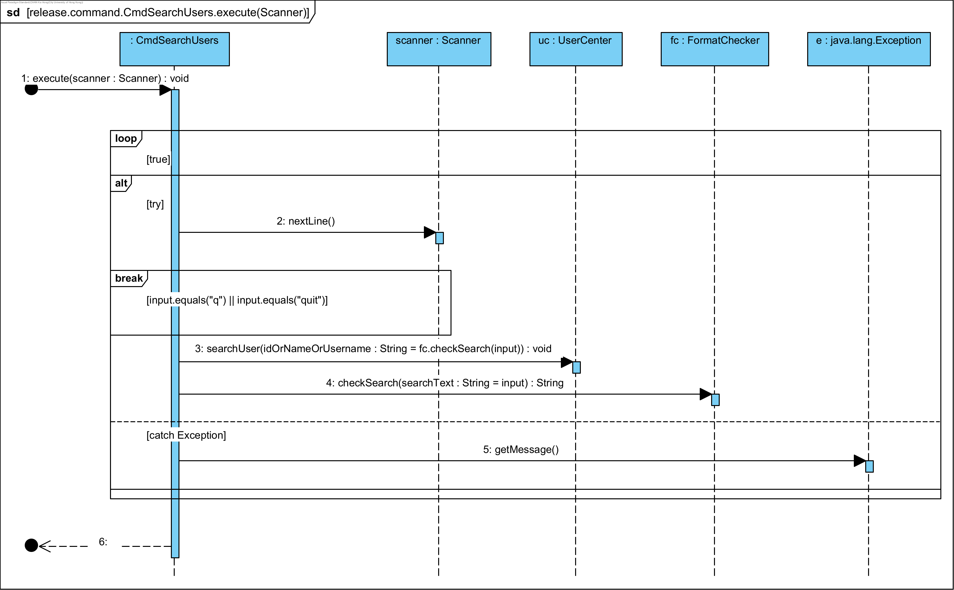

The sequence begins with the execute(scanner: Scanner) method being called on the CmdSearchUsers object. Within this method, a loop continues while the condition [true] holds, indicating an ongoing process for user input. The scanner object reads the next line of input through the nextLine() method. If the input equals "q" or "quit", the loop breaks, terminating the sequence.

If the input is not a quit command, the uc object's searchUser method is called with a parameter derived from the fc object's checkSearch method, which validates the input.

Throughout this sequence, exception handling is addressed. If an exception occurs, the getMessage() method is invoked on the e object to retrieve the error message. The process ends after either handling the exception or completing the user search.

## **5.15 Add User**

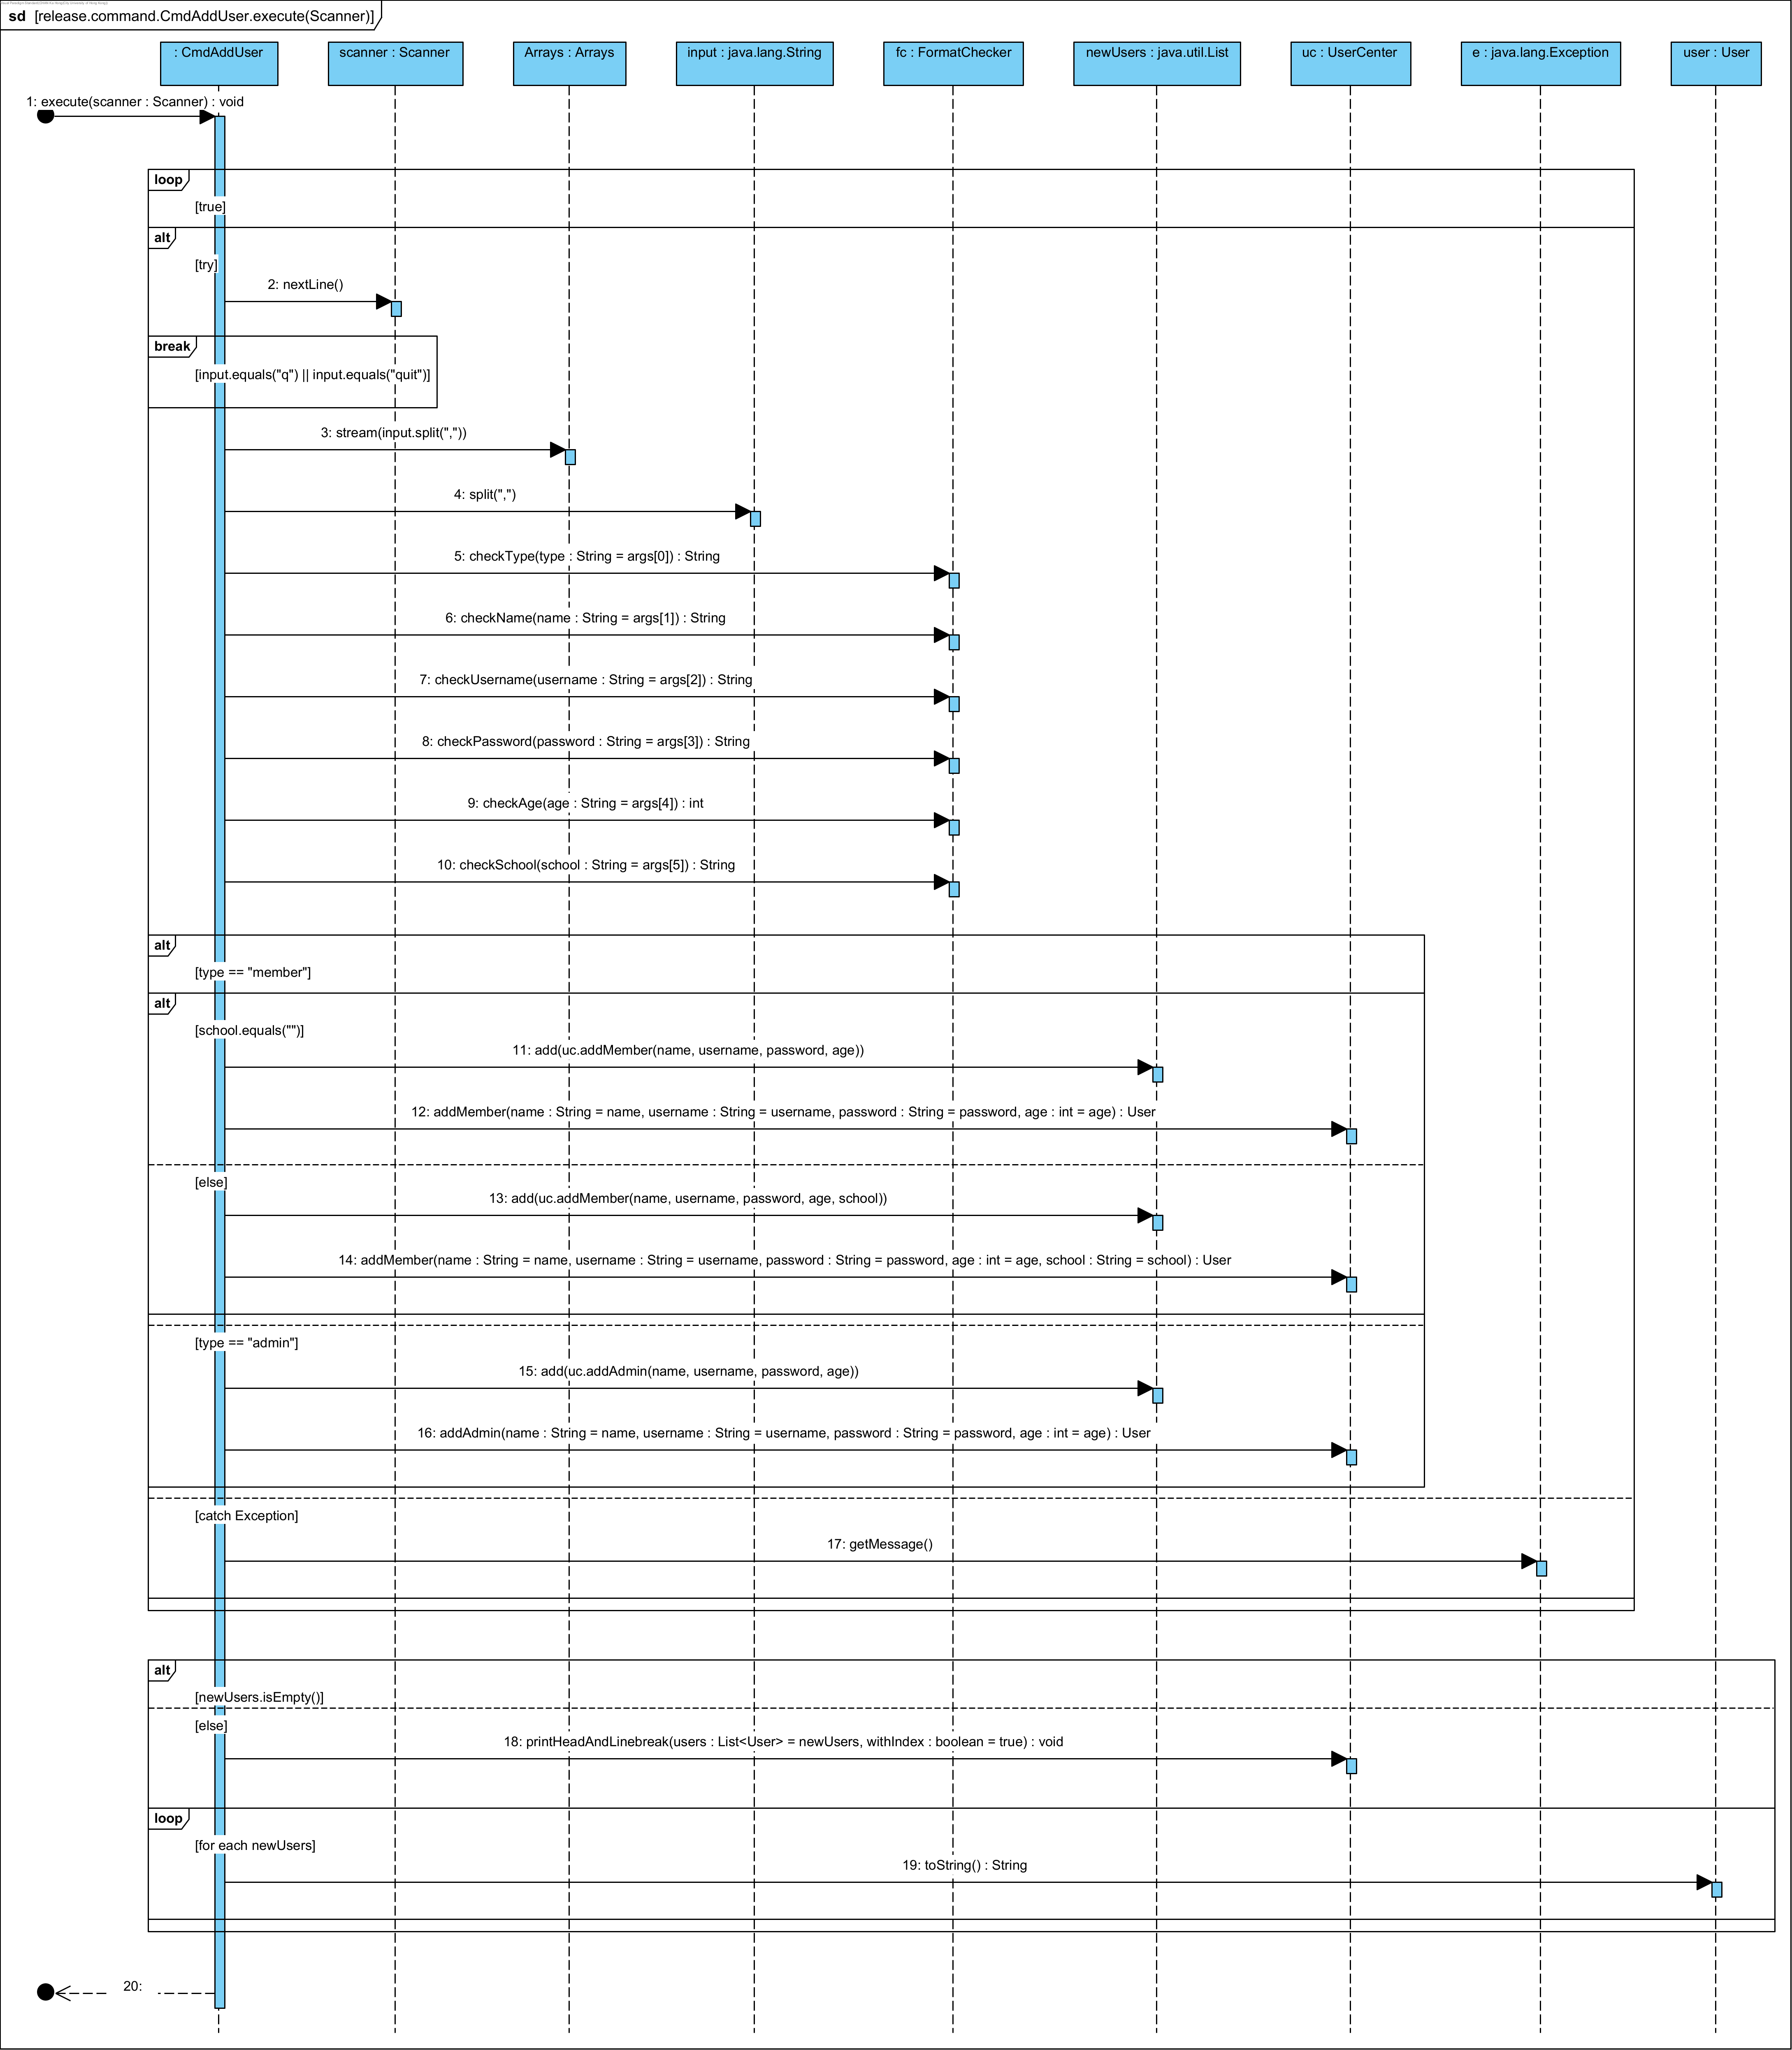

The sequence begins with the CmdAddUser object calling the execute(scanner: Scanner) method. The method reads user input using the Scanner.nextLine() method in a loop. If the input is "q", the loop breaks; otherwise, the input is processed by splitting it into an array of strings.

Various FormatChecker methods validate the user's type, name, username, password, age, and school. Depending on the user's type (either "member" or "admin"), the UserCenter class's addMember or addAdmin method is called to add the user to the system. If an exception occurs, the error message is retrieved using the Exception.getMessage() method.

If the list of new users (newUsers) is not empty, the UserCenter.printAndWriteBack(users: List<User> = newUsers) method prints and writes back the list of new users. The user information is then converted to a string using the toString() method and displayed to the screen.

## **5.16 Delete User**

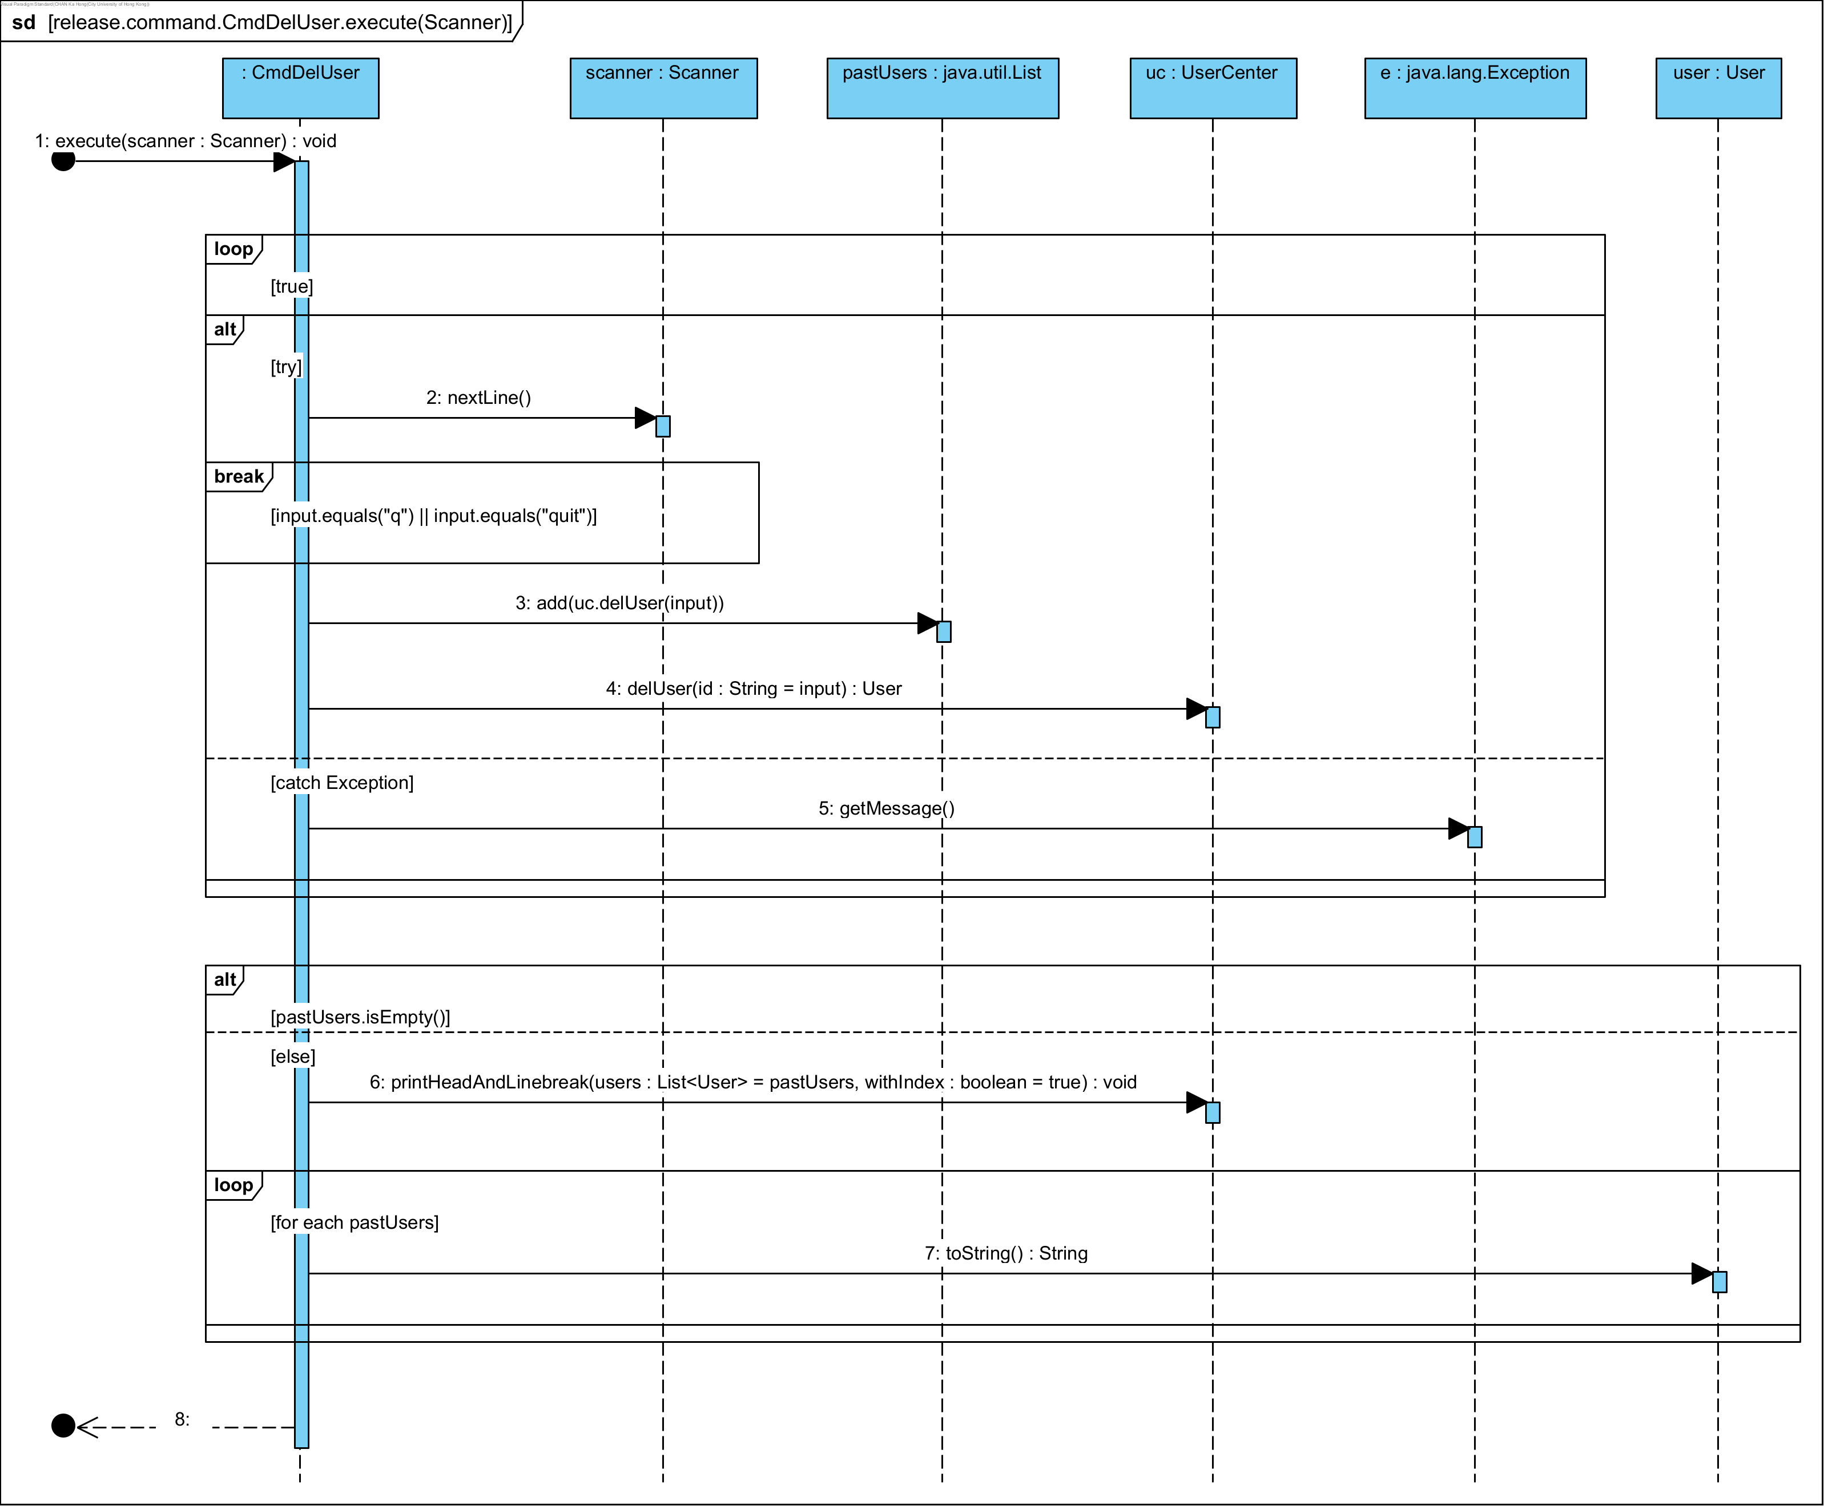

The sequence starts with the CmdDelUser object invoking the execute(scanner: Scanner) method. Within a loop, the method reads input using the scanner.nextLine() method. If the input equals "q" or "quit", the loop terminates.

If the input is not a quit command, the input is added to the pastUsers list, and the uc.delUser(input) method is called to delete the user, returning a User object. If an exception occurs, the error message is retrieved using the e.getMessage() method.

After the loop, the system checks if the pastUsers list is not empty. If it contains users, the printHeadAndLinebreak(users: List<User> = pastUsers, withIndex: boolean = true) method is called. Finally, the toString() method is invoked on each user object in the pastUsers list to convert user information into a string format for display.

## **5.17 Add Movies**

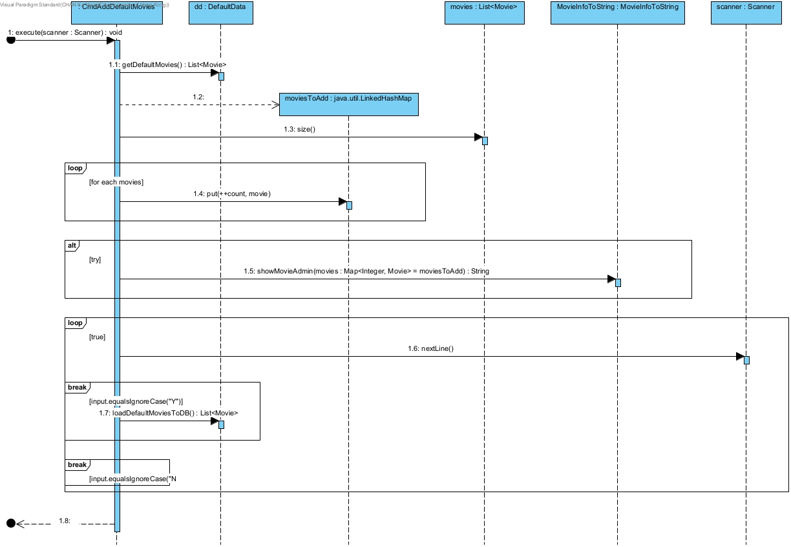

The CmdAddDefaultMovies Object first initiates the process by calling the execute(scanner: Scanner) method, which then calls getDefaultMovies() on the DefaultData object. This retrieves a list of default movies, returned as List<Movie>. The list of default movies is iterated where each movie is added to the moviesToAdd map with an incremented count using the put(++count, movie) method. Afterwards, the showMovieAdmin method is called with the moviesToAdd map as a parameter. This returns a string to display the movies to the admin user. The system then enters a loop, continuously calling the nextLine() method on the scanner object to read user input. If user input equals "Y" (ignoring case), the loadDefaultMoviesToDB() method is called, which loads the default movies into the database. However, if user input equals "N" (ignoring case), the loop breaks and the process ends.

This step-by-step interaction ensures that the system can efficiently manage the addition of default movies while providing a clear flow of control and user interaction.

## **5.18 Schedule Movies**

**(a) Profit Maximization Strategies:**

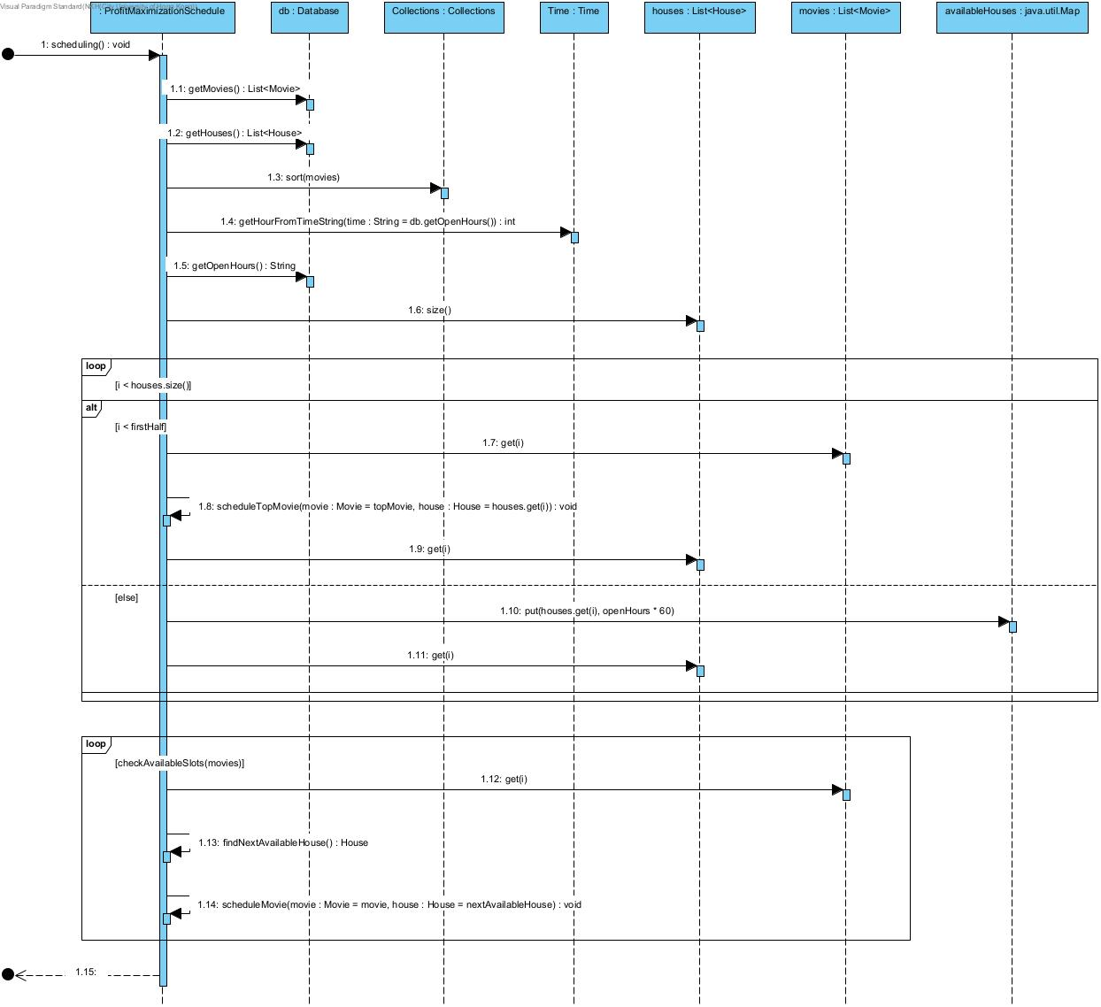Our first scheduling strategy is profiting maximization. Before the scheduling, we sort all the movies in decreasing order by their profit score. Then, we are first scheduling the top two profit movies by calling scheduleTopMovie() and allocating two exclusive movie theaters for these two movies throughout the whole day. The remaining movies in the database would take turns scheduling to the remaining available session slot. Here, we would call the checkAvailableSlots() to check whether there is the available movie session slot left before we schedule the movie to the new session slot.

**(b) Balanced Schedule Strategies:**

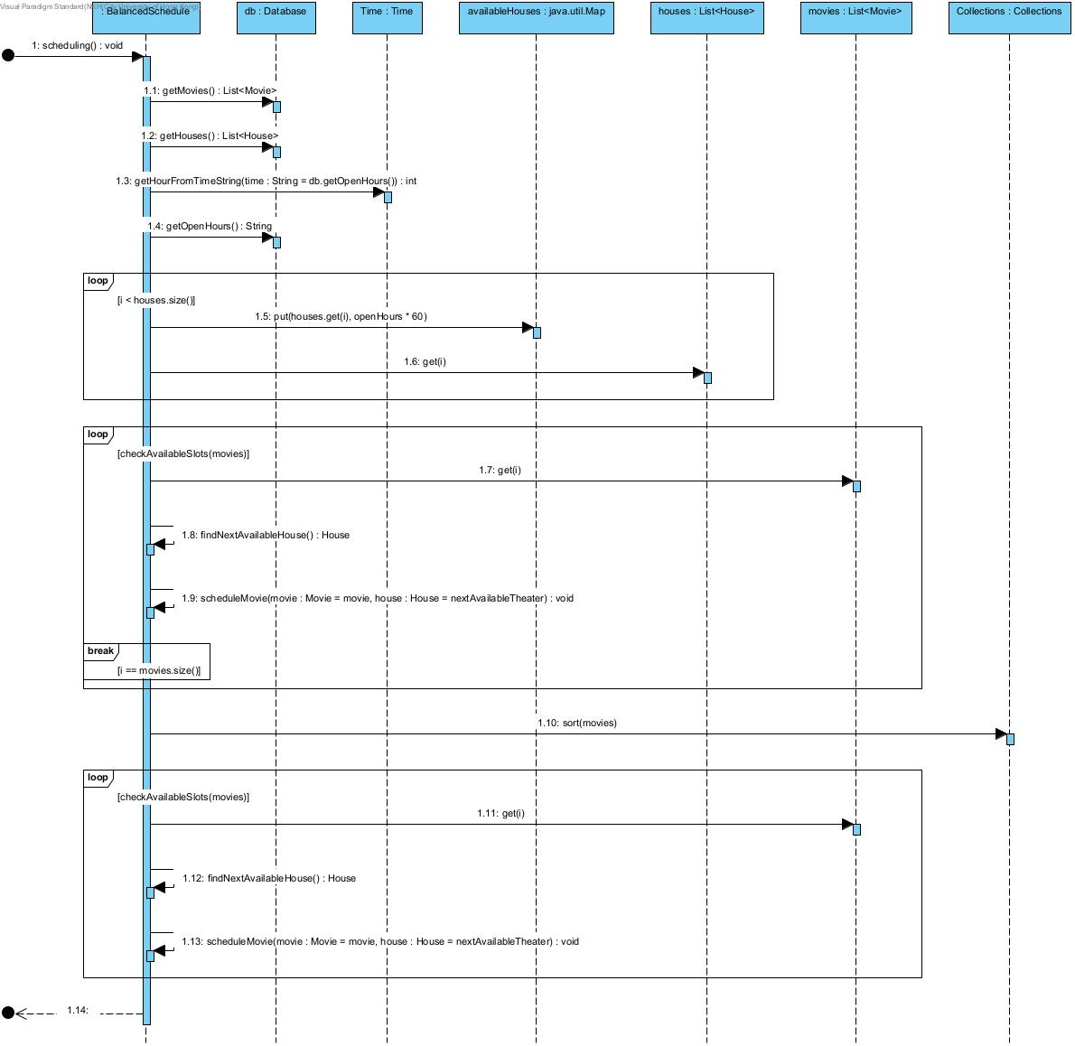Our second scheduling strategy is balanced scheduling. All the movies in the database would take turns scheduling to the available session slot. Then, we would sort all the movies in decreasing order by their profit score, and scheduling the movies to the remaining available session slot again based on the order.

## **5.19 Add Snacks/Drinks**



When the process starts, it asks the admin to choose whether to add a snack or drink. The admin can stop the process anytime by entering “q” or “quit”. The system prints out “[State] Add snacks/drinks process terminated!” if there are no snacks/drinks added. Otherwise, it prints out the snacks/drinks added to the database. It then stops the process after printing the information needed. If the input is invalid, it throws an ExInvalidOption and prints out "[Exception] Invalid option, please try again". The system asks the admin to choose again until the input is valid.

Then, the system asks the admin to enter the snack/drink data. After the admin has entered the input, it splits the string by comma and uses isValidProductData() to check whether the input is valid. If there are insufficient arguments, it throws an ExInsufficientArgs exception and prints "[Exception] 3 values must be provided". Then, it uses the FormatChecker object to check whether the name, portion and price are valid. If the length of the name of the snack/drink is not between 1 and 30, or the length of the string representing the portion of snack/drink is not between 1 and 14, it catches the ExInvalidInputLength exception thrown by the FormatChecker.checkInputDynamic() method and prints out the message. If the price is not between 0 and 500, it catches the ExInvalidPrice exception thrown by the FormatChecker.checkPrice() and prints out the messages. If neither happens, it creates a new snack/drink and uses isDuplicate() to check whether there is a duplicate snack/drink. If so, it prints out “[Exception] Duplicate product detected. Failed to add. Please try again” and restarts the process. Otherwise, it adds to the database and prints out a successful message. Then, the process will start again until the admin enters “q” or “quit”.

# **6. Design Principles and Patterns**

## **6.1 Design Principles**

### **6.1.1 Single Responsibility Principle**

The Single Responsibility Principle (SRP) states that a class should have only one reason to change, meaning it should have only one job or responsibility. Each class should only be responsible for a single part of the functionality provided by the program, and this responsibility should be entirely encapsulated by the class.

In our design, we have strictly adhered to this principle. For example, the Movie class only handles the attributes and construction of movie objects, while any other functionalities related to movies, we have created separate classes such as MovieService that are responsible for getting list of target movie objects during movie searching or listing, and BookSeatService that specifically handles any movie ticket and seat booking services. By adopting SRP, each class becomes smaller and more focused on a single task, making it easier to understand, modify, and maintain. Moreover, it makes testing easier thanks to fewer dependencies and more focused functionality. Unit tests can be written to cover the specific behavior of each class, leading to more effective and efficient testing.

### **6.1.2 Open-close Principle**

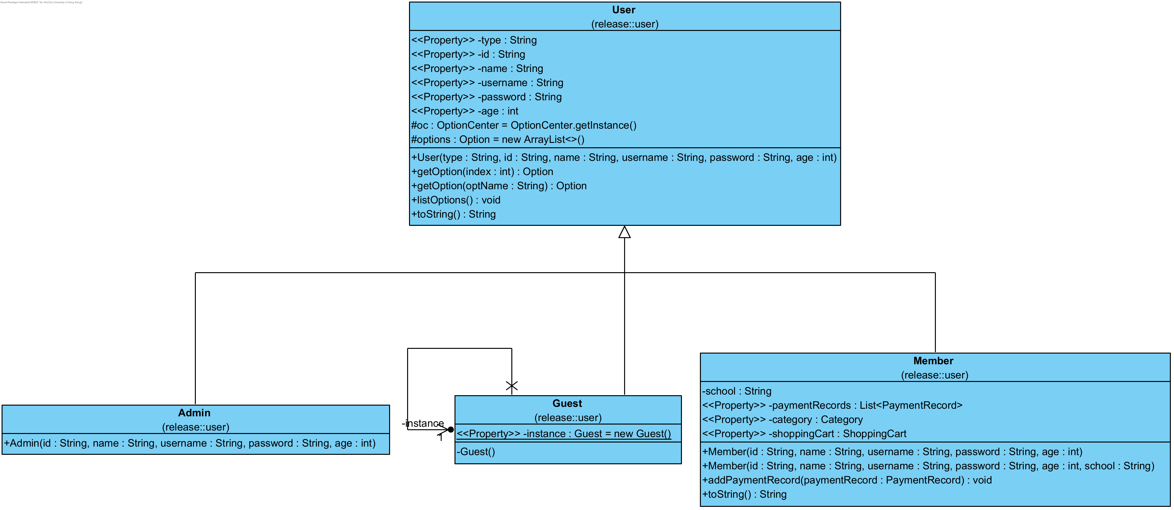

The Open-Closed Principle (OCP) describes that software entities such as classes, modules, and functions should be open for extension, but closed for modification, meaning a class's behavior can be extended without modifying its existing source code.

In our design, OCP can be easily exemplified by the User class. The User class serves as a super class that supports easy extension. In our project, we have multiple subclasses such as Guest, Member, and Admin that extends from the User superclass, with each subclass having their specific behavior. For example, Guest can only perform basic functions such as list movie sessions without the right to buy movie tickets; Member can not only list movie sessions but also buy movie tickets, snacks and drinks, whereas Admin has the right to add movies and schedule them automatically to different time slots and houses. Yet, once their behaviors and functionalities are defined, they are not subject to further modifications. By following OCP, changes to existing code can be minimized, thus reducing the risk of creating buggy codes. OCP also encourages the use of polymorphism, interfaces and abstract classes, which makes the system more flexible and adaptable to change.

### **6.1.3 Liskov Substitution Principle**

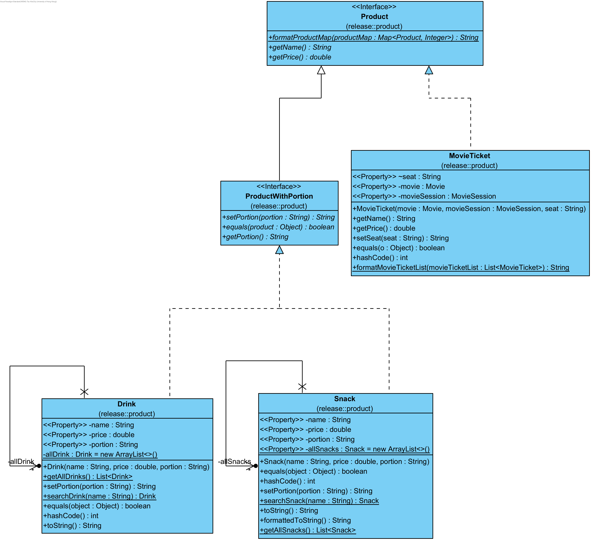

Liskov Substitution Principle states that the subclass must be completely substitutable for their parent class. To achieve this, the parent class should not have some methods that cannot be suited to all situations.

In our design, the products that are sold by the movie management system are separated into two interfaces, Product and ProductWithPortion. The interface ProductWithPortion also implements the interface Product. The reason for having two interfaces for the product is that not all products need the portion. If there is only one Product interface that handles all Products, and there is a method “getPortion()” to get the portion of the product, it cannot handle some products that do not need to have portion stated, for example, movie tickets. Also, if a new item is added to sold in the system and does not need to state its portion, then it is unsuitable for implementing Product class directly, as some methods will not be required. Separating the product with and without portions into two different interfaces can solve the problem of having unrelated methods, and the subclass can be fully substituted to the parent class, which can follow the Liskov Substitution Principle. Also, it can ensure that more products can be added in the future without modifying the original code, which is not preferred.

### **6.1.4 Interface Segregation Principle**

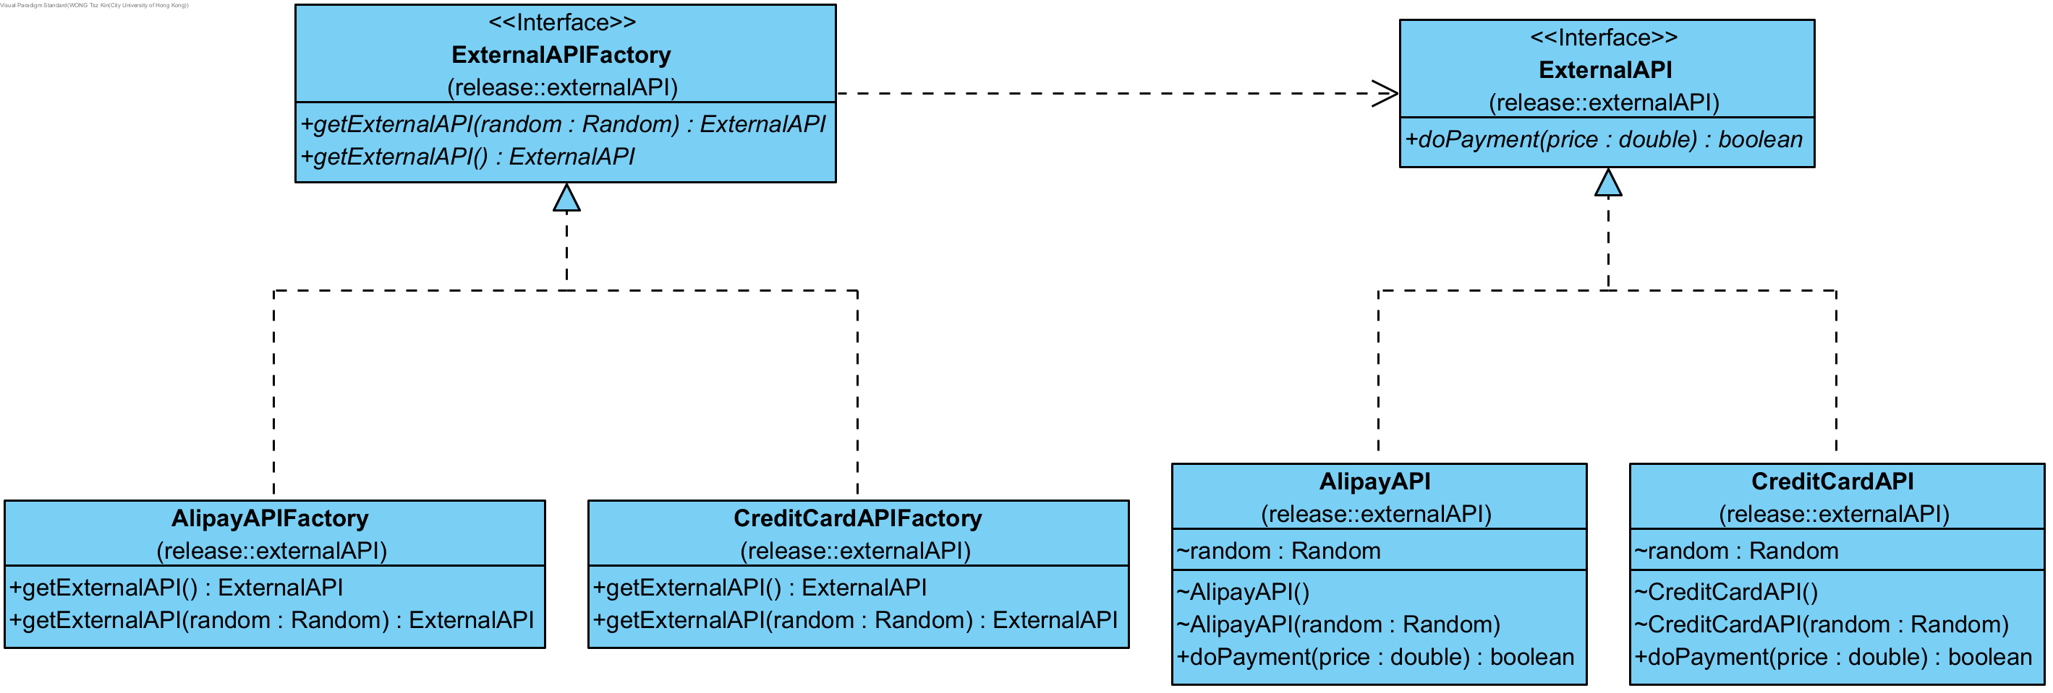

The Interface Segregation Principle (ISP) states that no client should be forced to depend on methods it does not use, which translates to practice that it would be better to have multiple small, specific interfaces instead of a single, large, general-purpose interface. By following this principle, it helps to reduce the impact of changes and makes the code more modular and easier to maintain. In addition, implementing classes can ensure that they only need to be concerned with the methods that are relevant to them.

In our design, the ExternalAPI and ExternalAPIFactory interfaces have followed the ISP. For the ExternalAPI interface, it has a single method doPayment(double price), which focuses on a single responsibility i.e. to simulate the payment process. It does not force any implementing class to depend on methods it does not use. As for the ExternalAPIFactory Interface, it has two methods, namely getExternalAPI() and getExternalAPI(Random random). Both methods are related to creating instances of ExternalAPI. It adheres to the ISP by ensuring that the interface is specific to the creation of ExternalAPI objects and does not include unrelated methods.

Overall, both interfaces are small, purpose-specific, and do not force implementing classes to depend on methods they do not need, thus adhering to the ISP.

### **6.1.5 Dependency Inversion Principle**

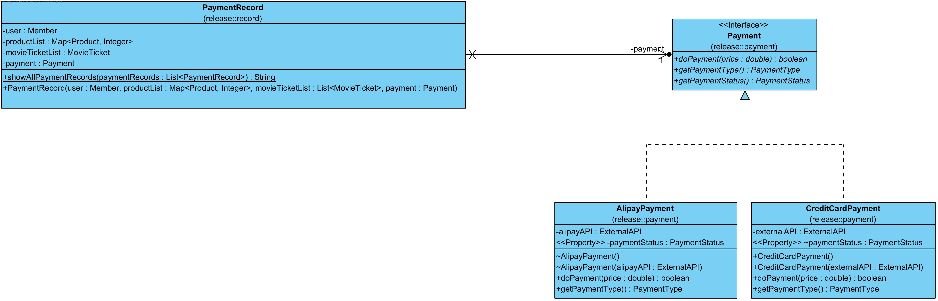

Dependency Inversion Rule (DIP) states that high-level modules should depend on abstractions instead of low-level modules, which means that classes should use the abstractions of other modules instead of using their implementation directly. If there are new classes that implement the abstractions, the higher-level class can still work without modifications.

In our design, the class PaymentRecord applies this principle. It is a class for creating records for payment, so it stores the payment instance. As there are different payment methods, it is not suitable for the record class to handle different payment methods independently. Therefore, it depends on the Payment interface, which is the abstraction of all payment methods. Instead of checking the payment types and calling their corresponding methods, it uses the methods in the interface, which calls the corresponding methods dynamically in the runtime. If there are new payment methods in the future, the PaymentRecord class can store this new payment method without modification.

## **6.2 Design Patterns**

### **6.2.1 Singleton Design Pattern**

The Singleton design pattern is a creational pattern that ensures a class has only one instance and provides a global point of access to that instance. It is particularly useful in scenarios where a single instance of a class is needed to coordinate actions across the system. In our design, there are multiple instances where singleton is used.

For example, the Database class implements the singleton design pattern since we would like it to serve as a global point of access for many other classes to retrieve centralized resources, such as the list of users, movies, products, etc. thus simplifying the management of shared resources.

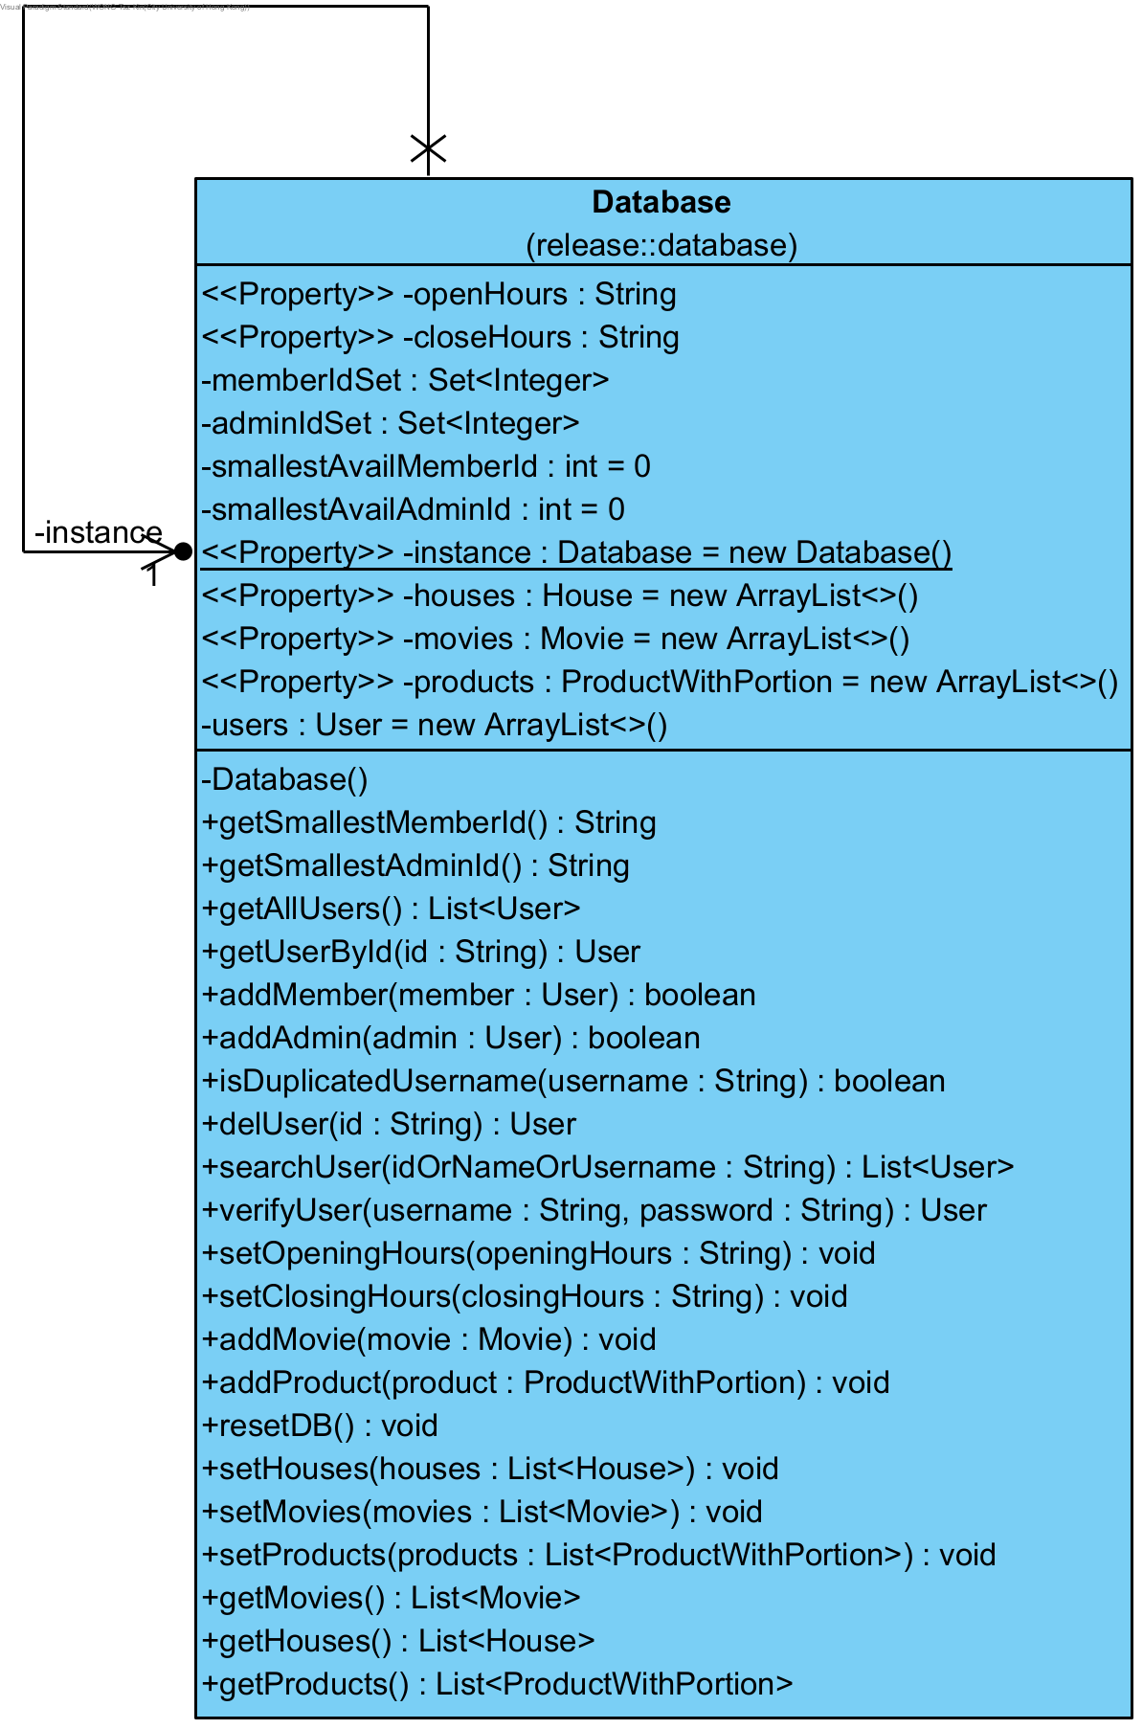

Another example is the Guest class that extends the superclass, User. Originally, Guest was not designed to be a singleton object. Each time when a registered user logs out, a new Guest object would be created. However, since the current program is single-threaded, the Guest object can thus be shared by any logged out user as it makes no difference if a singleton Guest object is provided, or a new Guest object is constructed for each log out situation. What differs and perhaps helps with the overall performance is that by making Guest singleton, it saves the memory and resource overhead of calling the Guest constructor to create a new Guest object every time a user logs out, and this is the primary reason why we refactored Guest to a singleton class.

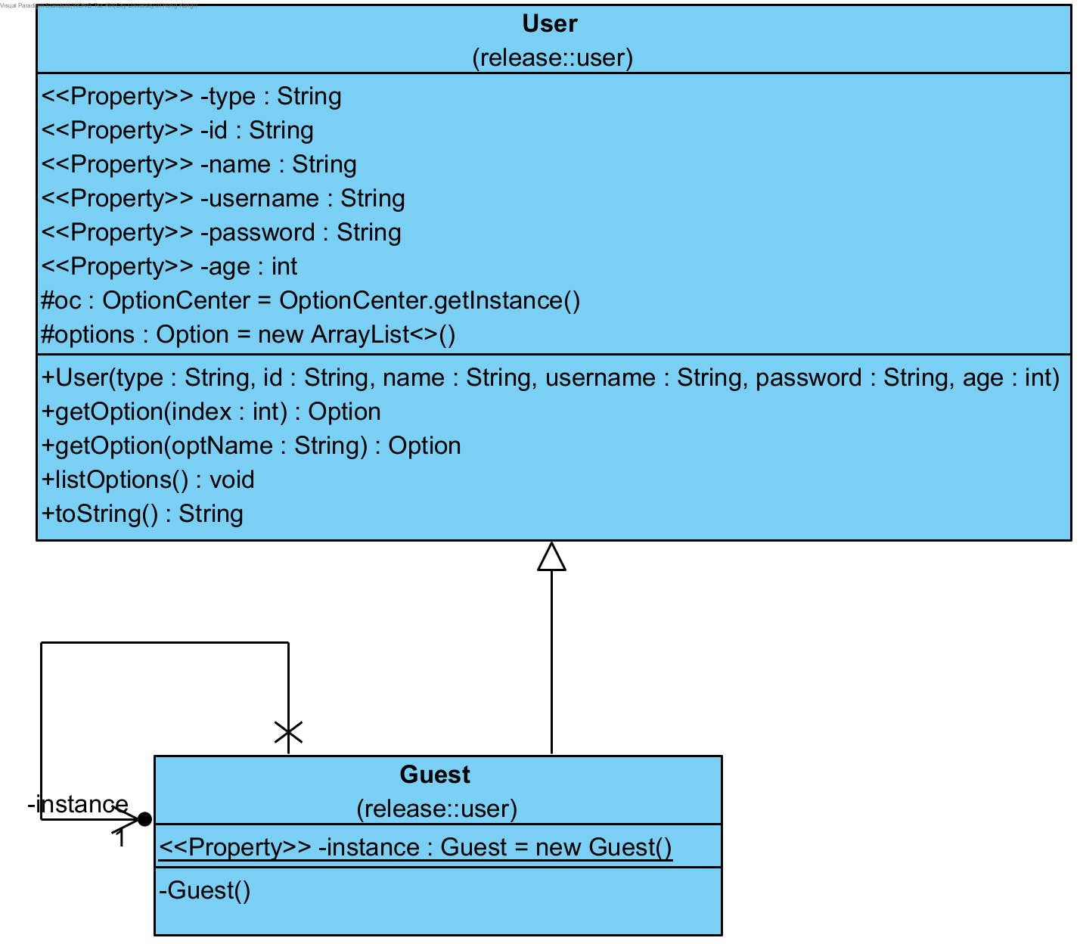

### **6.2.2 State Design Pattern**

### State design pattern allow an object to change its behavior when its internal state changes. The state is easy to change.

We implemented different categories for members to handle different discounts for different population groups. The category is determined by the age (<= 12: Child; >12 && <65: Adult; >65: Elder), while if the school is specified, the category will be Student.

**6.2.3 Command Design Pattern**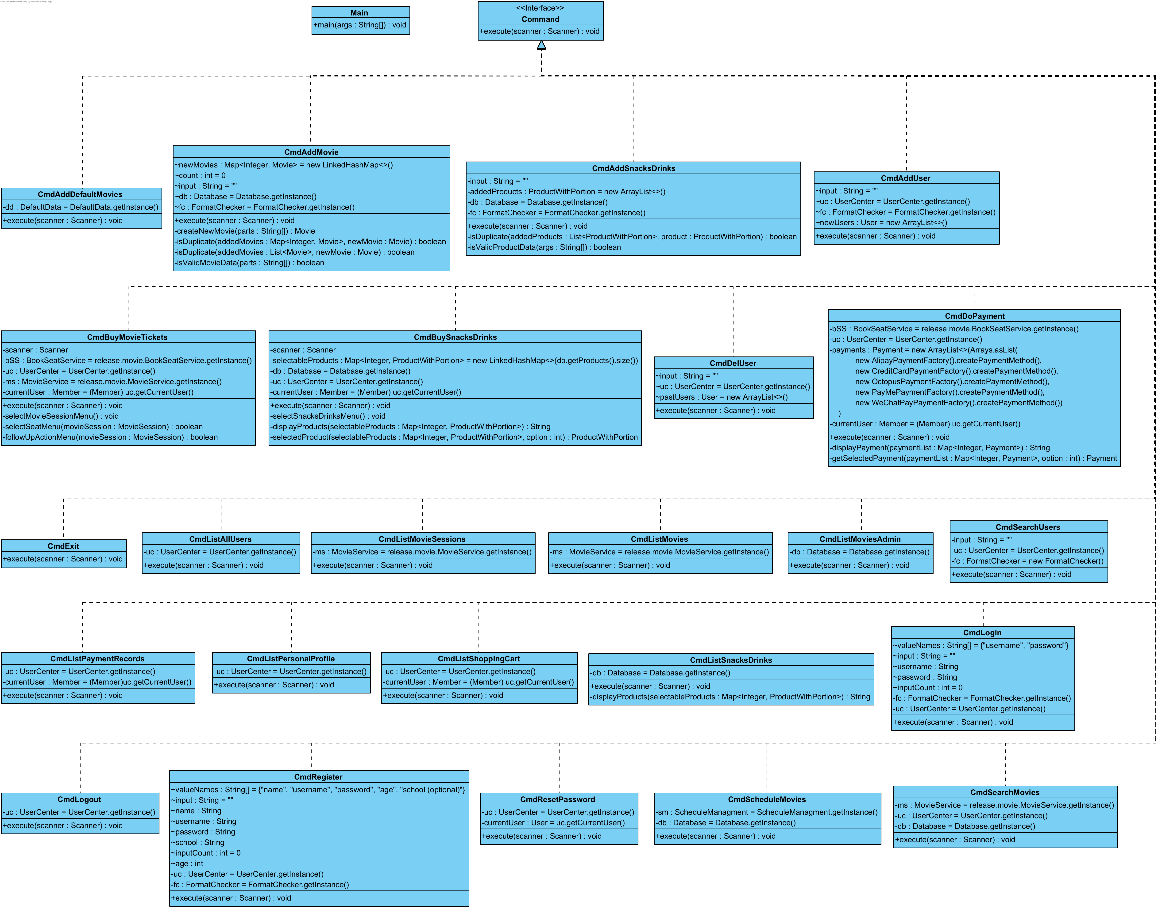

Command design pattern can encapsulate all method call needed for a process (e.g., login) into an object. Main class can issue requests without knowing process details. Allow users to easily issue various requests.

In our system, 24 options/commands are provided. In the option selection page – main(), user can choose different options available for his/her user type – Guest/Member/Admin; after user provide an integer - option index or a string – option name, if which is correct, a class which is type of Class will be return to main() and use that class to create a new command instance; finally, call the execute() of that instance, the program flow will temporarily pass to the command instance and return to main() after process finished.

### **6.2.4 Strategy Design Pattern**

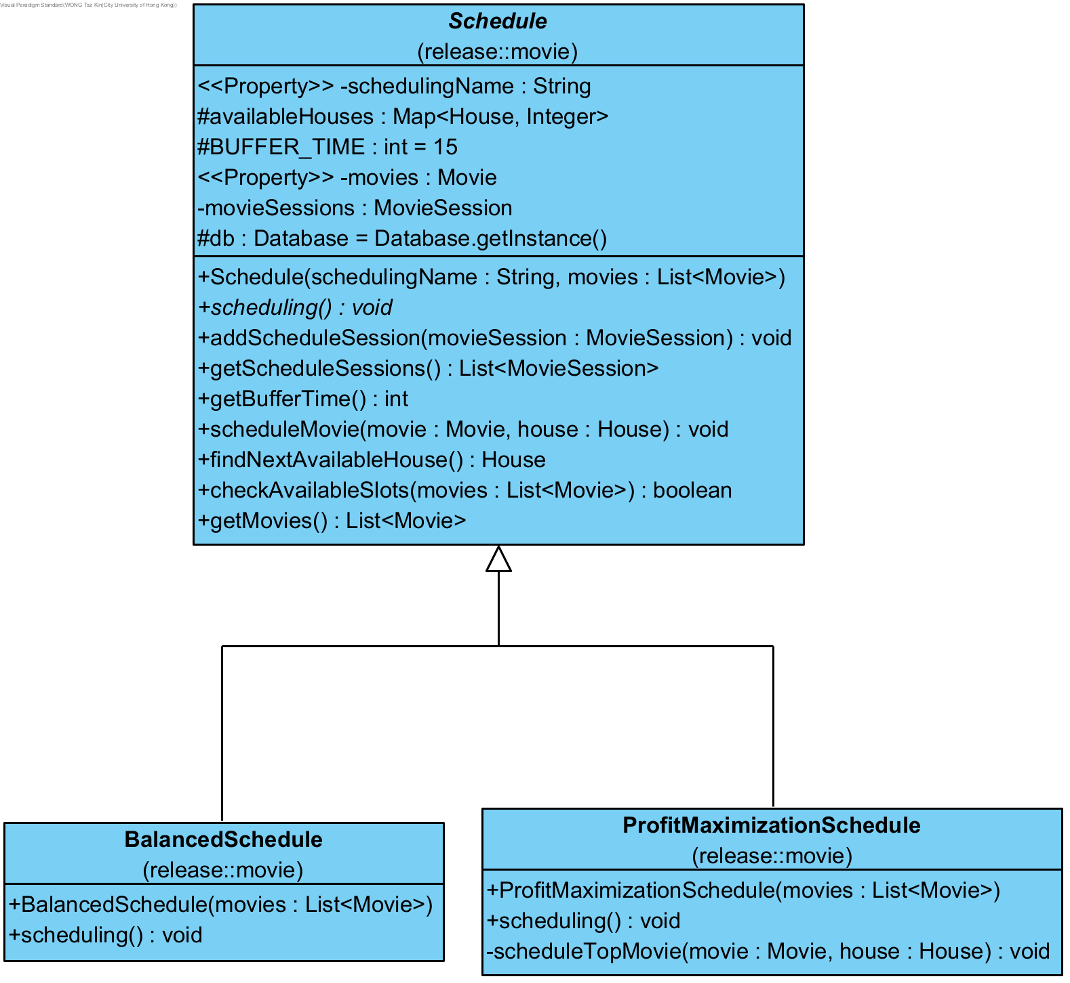

The Strategy design pattern is a behavioral design pattern that allows an object to change its behavior by changing the algorithm it uses at runtime. This pattern is particularly useful in scenarios where we have multiple algorithms for a specific task, and you want the object to be able to switch between these algorithms seamlessly.

In our system, the strategy interface is Schedule() which is for the algorithms (strategies) that the object can use. Then, the concrete strategies are ProfitMaximizationSchedule() and BalancedSchedule(), they are the implementations of the strategy interface, each providing a different scheduling algorithm. The Strategy pattern in our system allows us to introduce new scheduling strategies without modifying the existing code. We can add new algorithms by creating new concrete strategy classes. Moreover, this pattern allows the user to change the scheduling algorithm used by an object at runtime, making the movie system more flexible and adaptable

### **6.2.5 Factory Method Design Pattern**

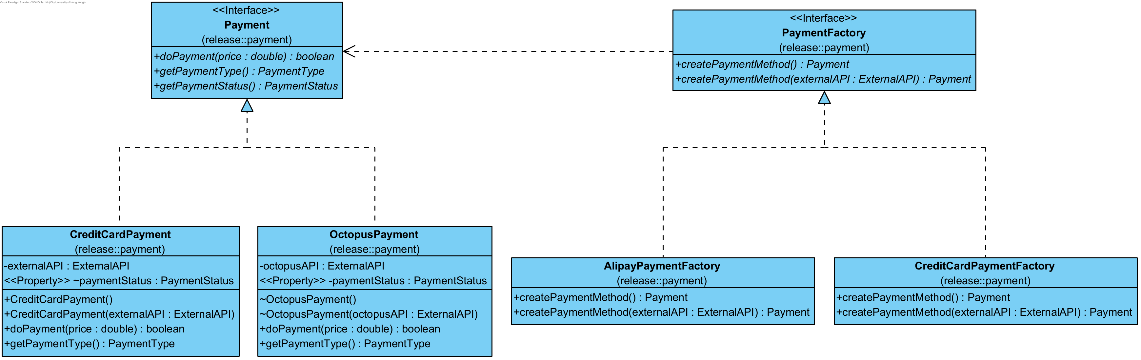

The factory method provides an interface for creating an object and allows the subclass of that interface to decide which class to create. It is used for the classes on payment and simulating the external API in the package Payment and ExternalAPI, respectively. As they have a similar design, the following part will use classes in the Payment package as an example to demonstrate the design and structure of the Payment and ExternalAPI packages. In the package, Payment and PaymentFactory are two interfaces for the classes used in making payments and building the payment instance, respectively. All the constructors for making payments are package-private, meaning that they cannot be accessed by other classes that are not in the same package. All payment classes and their corresponding factory classes are stored in the same package, so the factory classes can still access the constructor of the corresponding payment class and create an instance of them. If other classes need to create the objects for payment, they will need to use the factory provided for that payment method and create the object. Using the factory method, it is easy to add the new payment method in the future by simply creating two new classes to implement the new payment method and its corresponding factory method, respectively. Also, the code for other payment methods does not need to be modified when creating a new payment method, which is preferred.